
Positive Relationships Policy 2025 (Behaviour Policy)

DOCUMENT CONTROL
Name of Policy/Procedure
Author | Susan Tarpey
Version | November 25
Applicable to | All members of the community
Approved by:
Approved on:
Review Cycle | Two years
Date of next review | 2027
Website Publication yes/no | Yes

Positive Relationship Policy and Implementation

- Introduction
Our relationships policy is based on an expectation of valued behaviour and positive relationships within a secure, caring and inclusive environment supported by a therapeutic approach. In this policy, we will emphasise the ways in which we can foster such a prosocial atmosphere, stressing the need for mutual respect, tolerance and understanding of every member of our school community.
Whilst factors, such as pupils’ home backgrounds, affect their behaviour, school-based influences are also very important. Our Positive Relationships Policy follows both the Thrive approach and the Cambridgeshire Therapeutic Thinking approach (previously named Steps therapeutic approach) to supporting children.
This policy should be read alongside the Prosocial Physical Support and Touch Policy.

- Principles
- Everyone should give and receive respect
- Everyone has a contribution to make by setting a personal example
- Everyone should try their best in lessons
- Everyone is an individual and that individuality must be seen as an essential and important part of each person
- An individual’s valued behaviours should be praised and developed
- Everyone should be treated with fairness and consistency of approach in all situations
- Children should be taught how to behave, and this should be modelled by adults around them

- Achieving our expectations
Good communication is essential for good discipline. It is by parents, staff and children talking and listening to each other that we can understand how each feel and the reason for certain behaviour. We believe that all behaviour is a form of communication and as such, we should listen and respond to what is being shared with us. We will achieve expectations by making clear to all stakeholders what these expectations are and having a consistent approach, ensuring continuity. We will include all stakeholders in formulating rules to reflect the policy, and we have consulted our pupils, staff, parents and governors when developing this policy.

- Rights and Responsibilities

Staff
Rights | Responsibilities
- to be treated with respect  - to be supported by peers and managers  - to be listened to  - to share opinions  - to be treated courteously by all members of the school community  - to be made fully aware of the school’s systems/policies/expectations  - to receive appropriate training to increase skills in promoting positive behaviour and regular attendance | - to ask for support when needed  - to offer support to colleagues and managers  - to listen to others  - to give opinions in a constructive manner  - to model courteous behaviour  - to recognise and acknowledge positive behaviour in others  - to seek information and use lines of communication  - to support others in developing their skills in promoting positive behaviour and regular attendance  - to acknowledge areas of own skills which could be developed  - to try new approaches

Pupils
Rights | Responsibilities
- to be treated with respect by adults and peers  - to be safe  - to learn  - to make mistakes  - to be listened to | - to behave respectfully to others  - to attend school regularly  - to be willing to learn  - to allow others to learn  - to take responsibility for their own mistakes  - to allow others to make mistakes  - to give opinions in a constructive manner  - to listen to others

Parents/Carers
Rights | Responsibilities
- to be treated with respect  - to be kept informed about their child’s progress  - to be listened to  - to have access to information on the school’s approach to behaviour and attendance  - to have concerns taken seriously | - to behave respectfully to one another  - to behave respectfully to staff  - to make sure their child attends School regularly  - to talk to their child about what he/she does in school  - to talk to teachers if they have any concerns about their child’s learning or wellbeing  - to listen to others  - to absorb information and share concerns  - to share concerns constructively

- Our Agreed Approach
The objectives of our policy are to encourage valued behaviour and discourage and not give attention to detrimental (difficult and dangerous) behaviour. As teachers and adults in school, it is our responsibility to ensure that our own and the children’s expectations become practice. Constant awareness and interpretation will help to make the expectations an implicit part of our school ethos. All staff understand that all behaviour is communication; it is up to us to listen to and evaluate what that behaviour is telling us, and therefore how best to support it. We believe all detrimental behaviours are due to a lack of emotional regulation or a lack of shared values.

  - Examples of Valued behaviours are:
      - Working well with others
      - treating others with courtesy and consideration
      - setting a good example
      - giving your best in work and play
      - displaying our school values: integrity, respect, determination, resilience, kindness, equity
      - hard work
      - good humour

  - Encouragement of Valued behaviours:
      - Recognition and praise by teachers and parents
      - Use positive points and school value postcards as rewards
      - Establishment of high standards of order, organisation and presentation
      - Clear expectations and a shared understanding of them

  - Ideas for valued behaviour support-adult ideas

    - reframing physical proximity
    - use of proximity praise
    - invite, model and expect respect
    - separating behaviour from the person
    - allowing the consequence to do the teaching
    - use private rather than public reprimands
    - take pupils aside to focus on what they should be doing
    - re- establish the relationship as soon as possible after restart
    - use pupil’s name
    - give take up time
    - use related consequences
    - use broken record technique
    - put yourself in their shoes
    - catch them getting it right
    - give a limited choice
    - use partial agreements
    - remember certainty rather than severity
    - use least to most intrusive intervention
    - use rule reminders
    - avoid sarcasm
    - remember that all behaviour is a form of communication
    - use positive language
    - adopt the no-blame approach
    - be consistent
    - Use non-verbal gestures
    - Stay calm
    - be aware of your own behaviour
    - body language
    - tone of voice
    - posture
    - eye contact

  - Examples of Detrimental (difficult or dangerous) behaviours:
      - Stealing taking the property of others
      - Bullying – consistently targeted, misusing size, strength or words to hurt or intimidate others (see Appendix 1)
      - Vandalism- damaging the property of others
      - Bad language – not thinking before you speak
      - Truancy – missing school without good reason
      - Lack of punctuality – poor timekeeping
      - Distressed behaviours – shouting, running indoors, destroying resources and objects around them

  - Discouragement of Detrimental behaviours will be: Firm reminders of the boundaries of acceptable behaviour
      - Consider the reason behind the behaviour
      - For a one-off incident begin with a discussion with the class teacher
      - For the few serious occasions or for children whose behaviour patterns cause concern, documented incidents (date, time, place, details) will highlight any patterns and/or triggers
      - An ISP or Therapeutic Plan will be written to support the child where there is a pattern of behaviour using the CTT toolkit
      - Use of positive scripts-phrases to support the child who is distressed

- Promoting Valued Behaviours

  - Whole-School level
All staff understand and demonstrate the school’s core beliefs about behaviour valued out-of-class behaviour is promoted by agreed routines and clear systems. School Collective Worship and PSHE sessions are used to develop children’s social, emotional and behavioural skills.
Valued behaviour in corridors, playgrounds and the dining hall is noted and celebrated parents/carers are aware of, and contribute to, the school’s positive behaviour ethos. There are clear, consistently used systems for dealing with detrimental behaviour. There are opportunities for staff to discuss and contribute to the development of systems underpinning valued behaviour. Expected behaviour is clearly stated and understood by all.

  - Classroom Level
Adults model controlled, respectful verbal and non-verbal behaviours. Teaching routinely incorporates activities designed to promote children’s social skills and emotional development. Lessons are structured to be interesting and appropriately challenging. Appropriate behaviours are taught and reinforced on a regular basis. Children are taught the language of sharing and cooperation, choice and consequences. Children are encouraged to identify their own and others’ strengths and to recognise and value the diversity within their classroom. There are clear classroom routines (e.g. for entry and exit, moving around the classroom, sharing equipment) to reduce uncertainty and promote an appropriate climate for learning.
There are classroom rules or a classroom charter, devised through discussion with children, which are based on the school values and promote valued social and learning behaviours. Children sign up to these rules. Classroom rules are displayed in a way which can be understood by all children (photographs, diagrams, cartoons).
Appropriate behaviour is quickly noticed and genuinely celebrated by staff and peers. Adults use Arbor to log valued behavioural incidents by awarding positive points and school value postcards. There are clear systems, understood by all, for dealing with detrimental behaviour (see flowchart, Appendix 2). Children are to be given opportunities to perform the desirable skill that they previously were not showing. Adults use Arbor to log detrimental behavioural incidents as listed below.

  - Individual Child Level
All children’s strengths are recognised and celebrated by staff. Systems are in place for noticing and drawing attention to valued or improved behaviour. There are systems which allow all children to be “special” at times. Where a child experiences difficulties in developing or sustaining appropriate behaviour, there are systems which give additional support and attention. Behavioural intervention groups are offered to children who are displaying detrimental behaviours more frequently than desired.

In the everyday running of the school the children should be encouraged to:

    - Model expected behaviour
    - Move quietly around the school - always walk - stand aside to let others pass - hold doors open - lend a helping hand
    - Always speak politely to everyone
    - Respect other people by not hurting them or spoiling their possessions
    - Look after each other – do not “tell tales “Just to get others into trouble, but if a situation needs help, always get an adult
    - Listen to each other and adults and do not interrupt when others are talking. Wait patiently
    - Take pride in their classroom and school, taking care of everything around them Assume and enjoy the responsibilities they are given, treating them with the respect they deserve
    - Remove themselves from potentially difficult situations
    - Developing self-discipline is the aim
    - Feel able to ask for help and advice
    - Clear non-negotiables shared with pupils as part of our expectations for positive behaviour (drawn up by staff and pupils together)

In order for our policy to succeed we need to:

    - Model expected behaviour
    - Spend time every day building valued working relationships
    - Provide consistent, clear encouragement for valued behaviour
    - Be clear in our expectations of behaviour, i.e. high standards of order, organisation and presentation
    - Make each learning session a “fresh start”
    - Take account of the individual needs of the children
    - With the children, discuss and agree our rules
    - Involve parents
    - Be consistent
    - Regularly exchange information about children so that all staff catch those having trouble
    - Make a clear set of whole school ground rules to display in each class and around the building
    - Children will sign this agreement to show support and give ownership
    - Explicitly teach and explain what the rules mean in practice and our expectations of children
    - Use PSHE, assemblies, circle time, etc. to discuss, model and practise valued behaviour and raise pupils’ self-esteem
    - Try and make requests and instructions positive, e.g. “walk please” rather than “don’t run”
    - Encourage all families to read and sign the Home/School Agreement together at the start of the year and refer to this throughout the year.
    - It is important for all staff to teach and model appropriate behaviour
    - When pupils behave appropriately this should be noticed and praised
    - Early intervention and consistency with which rewards and consequences are distributed is essential
    - Assess the reason for behaviour and decide outcome accordingly
    - Lessons must be structured to be interesting and appropriately challenging
    - Non-negotiables of behaviour expectations are included as an appendix to this policy (Appendix 3). These were written collaboratively with staff and pupils from School parliament and will be shared with all children and expected to be adhered to by all adults and children alike.

- Outdoor Behaviours
  - Playtimes-adults on duty assume full responsibility for all pupils and:

- Model expected behaviour
- Seek out children who may experience difficulty and talk with them briefly
- Be aware of potential “hot spots” and try to diffuse them before they start
- Class Teachers should tell adults on duty of any pupils who have had a difficult session prior to playtime so an extra “eye” can be kept on them
- Maintain a high profile – be visible – staying in one spot(ish) makes it easier for us to find each other if we need to be found
- Deal with any problems as they arise
- Anything considered to be significant: - report to the Class Teacher, stating problem and action taken and record the incident on Arbor
- Notice those who find playtimes difficult
- When parents are also staff on duty can we endeavour to make sure children are dealt with by other staff when possible – especially at lunch times

  - Around school
- Talk to children you meet around the school – comment on and praise pleasing behaviour
- Remind children of the need to talk quietly etc. We each have a responsibility for all children, not just for those in our own class, as they move around the school
- Adults should model positive relationships throughout the school, with pupils and other adults alike.

  - Lunchtimes – lunchtime provision for engaging in play
Activities will be set up for all children to join in, particularly for those struggling socially or with anxiety. There will be different sporting activities on offer each day on the playground for both lower and upper school. A calmer space is designated in the quiet area of the playground to offer a place to regulate. A support room is available in Lower School from 12:30-1:00 and in Upper School from 1:00-1:30pm each lunchtime for children that need a quieter indoor space or for children that need a protective consequence to keep them and others safe. Staff will be trained in conflict resolution, and children in years 3-6 will be trained as Peer Mediators to support other children with minor difficulties at playtime. These children will work as Peer mediators for one lunchtime per week, so that there are at least six Peer Mediators operating on the playground. Pupils having minor disagreements can seek out the Peer Mediators for support, and Mediators themselves will be vigilant to support where issues arise. They will wear Peer Mediator bibs and badges to signify their role. Peer Mediators will also assume a Play Leader role and actively help children to play and understand how to play successfully.

- Lunchtimes supervisors will assume responsibility in the knowledge that the Head or Assistant Head or Heads of Upper and Lower School are around for support
- Class Teachers will tell supervisors of any child that has caused concern during the session prior to dinner time, so that a special “eye” can be kept on them
- Always be visible. There should always be someone for children to turn to. Supervision at lunchtime will involve at least two people for each playground who move around a lot so children can find an adult and all children remain visible
- Report any significant problems to the Class Teacher at the end of the lunch-time session and report on Arbor
- Seek the immediate assistance of the Head of Upper or Lower School if any major behavioural difficulties arise. Heads of Upper and Lower School will seek guidance from Deputy Head or Head Teacher if necessary.
- Follow the behaviour flowchart (Appendix 2.)

- Consequences
There will be clear expectation that pupils are expected to behave at school – any valued behaviour will be praised but any detrimental behaviour will be supported.
In the first instance staff use praise of another pupil to emphasise that someone else isn’t doing as they should, i.e. “Well done X for…. listening”. It will be recognised that all incidents will be treated on an individual basis, considering the personal circumstances of the child and the context of the situation.
Different circumstances and contexts should include age, maturity, home circumstances, risk factor of the child to others and themselves, level of intent, number of previous incidents and level of contrition. If an accident involves several children, staff will endeavour to be fair and consider all opinions. Consequences may be required in behaviour related or work-related situations.
Consequences are to be used as a teaching tool to allow the child to learn how to behave in a valued manner- this may be an educational consequence where the child is taught and practices the appropriate behaviour for the context, or a protective consequence where it is deemed unsafe for the child to return to the activity until they are more able to respond in a positive way. Both require explicit teaching and time to practice the appropriate behavioural response.

  - Consequence Options
The consequences applied will depend on the level of detrimental behaviour, frequency, etc.
Consequences are to be used as a teaching tool in two ways:

- Educational Consequences - to help the child learn the socially acceptable behaviour choice for the situation:

- Contact with parents to allow parents to discuss a situation with continuity
- Individual behavioural strategies- recorded in an Individual ISP Plan or a Therapeutic Plan and reviewed following an incident
- Attend a behavioural intervention if appropriate
- Restorative conversation to highlight which value has been lacking or identify an emotional response which could look different next time
- Restorative conversation to help a child repair any relationship damage caused

- Protective Consequences - until it is deemed safe for the child, or for the pupils around them, to return to the activity where the issue took place. The socially acceptable behaviour choice will need to be explicitly taught and practiced with the child before reinstating the activity:

- Contact with parents to allow parents to discuss a situation with continuity
- Remove child from the situation into their partner class and discuss the detrimental behaviour when both adult and child are emotionally ready through a restorative conversation
- Use support rooms available during lunchtime as a quiet space to minimise overstimulation. Educational conversations can take place during this time.
- Adult supervision during outside play
- Individual behavioural strategies- recorded in an Individual ISP Plan or a Therapeutic Plan and reviewed following an incident
- Recording of major incidents on MyConcern if an individual has been hurt, a racist comment has been made, derogatory language has been used, or behaviour is clear bullying. SLT will decide next steps.
- A part time timetable may need to be implemented
- A school exclusion might be necessary if all other options have been explored. An exclusion is used for cases of safety and where time is needed to ensure a child can return to school safely.

  - The Restart Approach
- A restorative discussion is held with the adult and pupil, to think about their actions, decide if they were inappropriate, why they are inappropriate and given a positive example of what they should be doing or could do next time. This will be a supportive conversation with a ‘no blame’ approach. Where appropriate a discussion could consider which school value has not been adhered to

- After the intervention and the offering of advice the pupil will be expected to get on with their work or play and can put into practice what they should be doing. If pupils do not know what they should be doing or are “stuck” with their work, this intervention will allow further Teacher/TA support. It may be deemed suitable to put into place a specific intervention to practice the valued behaviour before the child can be expected to do this independently.

  - Consequences during lessons where learning has been interrupted or where detrimental behaviour has taken place
If a pupil chooses not to work, then on the second occasion the pupil will be told what the consequence will be if they continue. On the third occasion, the Teacher will inform the pupil by using a phrase like: “You have chosen not to work so….” In class: the pupil may then be moved to a quiet space and expected to finish the task within the room, and this usually involves being seated on another table. Another class: if required, the pupil may be escorted by an adult or child with work in another class for blocks of time, e.g. until the end of the session. The other Class Teacher will send the child back on completion of the work or when the child is emotionally ready to complete it in class. This is known as a restart and is followed up with a restorative conversation with the adult involved, discussing what happened and how we could have acted differently. This conversation is calm, non-blaming and constructive. See Appendix 2 for visual flowchart. Neutral ground or Head Teacher: if a pupil’s behaviour continues to be disruptive or threatening in class, the pupil may also be asked to take some time away from the rest of the class until he or she calms down and is able to work sensibly again with others. Any pupil removed should always be supervised by a TA or sent to a Head of School.

  - Finishing work
Pupils may be asked to complete their work at other times and in other places during the school day. This could include in the library at lunch and play times. In such circumstances children would not be deprived of their lunch or toilet break. Work may also be sent home to finish if this is appropriate.

  - Consequences at playtimes, lunchtimes, before or after schools
A child may be removed from the situation/game to spend time alone or to calm down restart, sitting at the bench for a period of about 5 minutes and then approached again when discussion about what happened and what they should do in the future occurs. If the behaviour continues, their Head of school will be notified, and a restart will happen with them. The support room can be used as protective support. After playtime and lunchtime, the staff on duty/lunchtime staff will report incidents to the Class Teacher via Arbor so that the child can discuss what happened in a supportive/restorative way with their teacher. If, after three restarts with the Head of Upper/Lower School, the behaviour continues, then a further restart will take place with a member of SLT. This will be during the pupil’s lunchtime. Following a restart with SLT, pupils may also have a protective consequence which removes them from the playground for a predetermined period to ensure the safety of themselves or others (1 playtime to several days). If detrimental behaviour persists, pupils may lose privileges or ultimately not be allowed to school events, activities or lunchtime sessions (protective consequences). They will still be given opportunities to demonstrate the expected valued behaviour. Interventions will be put into place to allow the pupil to learn and practice the desired valued behaviour. Please refer to Appendix 2- flowchart for a visual representation of this system.

- Parental involvement
    - Make every effort to attend consultation
    - Understand school policies and methods
    - Alert the School immediately to any serious behavioural problems with their child
    - Be prepared to come to School to discuss behaviour problems in the classroom
    - Accept their share of responsibility for their child’s punctuality
    - Ensure that their child comes to school in suitable clothing and is equipped for games and PE
    - Bring grievances to the Class Teacher, Head Teacher or a Parent Governor
    - Always telephone or email before 9.15am if their child is absent from School.
    - Support the school to implement any behaviour plans or strategies undertaken

- SEND
Children with Special Educational Needs are subject to the same rules as all other children. The only difference may be in the way they are handled by the staff. Some children may be experiencing issues with their Social, Emotional and Mental Health. This could be a short-term issue, perhaps caused by trauma, or longer-term difficulties. This can present as distressed behaviours, or with internalising behaviours. For these children, the adult approach will be addressed in their one-page profile, ISP or Therapeutic plan, which outline specific strategies that are applicable to that individual pupil. This may also include specific arrangements for the individual child around Touch and Positive Physical support, if needed. Please see the school’s Positive Physical Support and Touch Policy for more information.

- Behavioural Intervention support
Children identified as repeatedly displaying detrimental difficult behaviours will be identified by class teachers, SEND, Behaviour Lead, and SLT through discussions and/or monitoring of behaviour logs. These children will have a supportive plan (ISP or Therapeutic Plan) created through analysis of their behaviours and needs assessed by the CTT Toolkit AND will have behavioural intervention support. These will be small group or 1:1 session which are bespoke to their needs and run by a trained adult.

- Extreme cases in behaviour
A Therapeutic Plan should be drafted using the CTT Toolkit if children need extra support. This document is used and shared by any member of staff that could encounter the child. It is a guide on how to approach, talk with and deal with the child. This may include Educational and/or Protective consequences. It is the responsibility of the class teacher to complete and share, with support from the SENDCo and it is the responsibility of all staff to become familiar with it.
- De-escalation
All staff have been trained to follow a de-escalation script to help with children who are showing distressed behaviours. These will form part of the child’s Therapeutic plan.
- Safety
Children’s safety is paramount in all situations. If a pupil’s behaviour endangers the safety of others or themself, the Class Teacher will stop the activity and prevent the pupil from taking part until it is safe to recommence. If a pupil threatens, hurts or bullies another pupil, the Class Teacher or supervising adult records the incident, and the child receives consequences using the consequences outlined above. This is outlined further in Appendix 1. If a child repeatedly acts in a way that disrupts or upsets others, the school will contact the child’s parents and seek an appointment to discuss the situation, with a view to improving the behaviour of the child.

- Bullying
The school does not tolerate bullying of any kind. If we discover that an act of bullying or intimidation has taken place, we act immediately to stop any further occurrences of such behaviour. While it is very difficult to eradicate bullying, we do everything in our power to ensure that all children attend school free from fear. Please refer to Appendix 1. for strategies to support children who are victims of bullying or bully other children.

- Restraint
All members of staff are aware of the regulations regarding the use of force by Teachers, as set out in DfEE Circular 10/98, relating to section 550A of the Education Act 1996: The Use of Force to Control or Restrain Pupils. Staff only intervene physically to restrain children to prevent injury to a child, or if a child is in danger of hurting him/herself. The actions that we take are in line with government guidelines on the restraint of children and the school uses the Therapeutic Thinking approach as described in the Prosocial Physical Support and Touch Policy.

- Persistent Detrimental Behaviours
In case of severe or persistent detrimental behaviour pupils will ultimately not be allowed to school events/activities. We will consult the County Exclusion Policy should there be need for exclusion.

- Fixed term and Permanent Exclusion
We ensure that exclusions only occur when all other options have been exhausted and are therefore left with the last resort to maintain the safety of the child and/or those around them. Only the Head Teacher (or the Acting Head Teacher) has the power to exclude a pupil from School. The Head Teacher may exclude a pupil for one or more fixed periods, for up to 45 days in any one School year. The Head Teacher may also exclude a pupil permanently. It is also possible for the Head Teacher to convert a fixed-term exclusion into a permanent exclusion if the circumstances warrant this.
If the Head Teacher excludes a pupil, he or she will inform the parents immediately, giving reasons for the exclusion. At the same time, the Head Teacher will make it clear to the parents that they can, if they wish, appeal against the decision to the Governing Body. The school will inform the parents how to make any such appeal, outlined in a written letter.
The Head Teacher will inform the LA and the Governing Body about any permanent exclusion and about any fixed-term exclusions.
The Governing Body itself cannot either exclude a pupil or extend the exclusion period made by the Head Teacher.
The Governing Body has a discipline committee, which is made up of between three and five members. This committee considers any exclusion appeals on behalf of the Governors.
When an appeals panel meets to consider an exclusion, they consider the circumstances in which the pupil was excluded, any representation by parents and the LA, and whether the pupil should be reinstated.
If the Governors’ appeals panel decides that a pupil should be reinstated, the Head Teacher must comply with this ruling.

- Monitoring
The Head Teacher monitors the effectiveness of this policy on a regular basis. He or she also reports to the Governing Body on the effectiveness of the policy and, if necessary, makes recommendations for further improvements. The school keeps a variety of records of incidents of detrimental/dangerous behaviour. When necessary, the Class Teacher records repeated classroom incidents using Arbor or MyConcern. The supervisors always report incidents of detrimental/dangerous behaviour and other problems to the Class Teacher. These logs are monitored by the Senior Leadership team and adjustments to support are made in response to changes/escalations in need. The Head Teacher keeps a record of any pupil who is suspended for a fixed-term, or who is permanently excluded. It is the responsibility of the Governing Body to monitor the rate of suspensions and exclusions, and to ensure that the school policy is administered fairly and consistently.

- Review
The Governing Body reviews this policy every two years. The Governors may, however, review the policy earlier than this if the government introduces new regulations, or if the Governing Body receives recommendations on how the policy might be improved.

Appendix 1. Anti-Bullying

Definition of Bullying
Bullying can be defined as ‘behaviour by an individual or a group, repeated over time that intentionally hurts another individual either physically or emotionally’. DfE ‘Preventing and Tackling Bullying’

Bullying can be experienced in many forms, these may, but not exclusively include;
• racist bullying (Local Authority definition of racist behaviour is defined as any incident perceived to be racist by the victim or any other person. This includes incidents that may involve derogatory name-calling, verbal threats, insults, racist jokes, and physical assaults)
• homophobic or gender variant bullying.
• bullying of children who may be vulnerable to experiencing bullying behaviours (e.g. children with SEND, SLCN, EAL)
• cyber-bullying.
Bullying can include physical and emotional abuse such as name calling, taunting, mocking, making offensive comments, kicking, hitting, taking belongings, producing offensive graffiti, gossiping, peer isolation (e.g. excluding people from groups) and spreading hurtful and untruthful rumours.

The same unacceptable behaviours can be expressed online; this is sometimes called online bullying or cyberbullying. Specifically this can include sending offensive, upsetting and inappropriate messages by phone, text, instant messenger, through gaming, websites, social media sites and apps, and sending offensive or degrading photos or videos.

Buckden CE Primary recognise that bullying can be emotionally abusive and can cause severe and adverse effects on children’s emotional development. Bullying is recognised by Buckden as being a form of peer-on-peer abuse; children can abuse other children.
Abuse is abuse and it should never be tolerated or passed off as “banter”, “just having a laugh” or “part of growing up”.
We recognise that even if there are no reports of bullying, it does not mean it is not happening, and it may be the case that it is just not being reported.

All victims will be taken seriously and offered appropriate support, regardless of
where the abuse takes place.

Forms and Types of Bullying

Bullying can happen to anyone. This policy covers all types and forms of bullying including but not limited to:
- Bullying related to physical appearance
- Bullying of young carers, children in care or otherwise related to home circumstances
- Bullying related to physical/mental health conditions
- Physical bullying
- Emotional bullying
- Sexualised bullying/harassment
- Bullying via technology, known as online bullying or cyberbullying
- Prejudiced-based and discriminatory bullying (against people/pupils with protected characteristics) which may include:
▪ Bullying related to race, religion, faith and belief and for those without
faith
▪ Bullying related to ethnicity, nationality or culture
▪ Bullying related to Special Educational Needs or Disability (SEND)
▪ Bullying related to sexual orientation (homophobic/biphobic bullying)
▪ Gender based bullying, including transphobic bullying
▪ Bullying against teenage parents (pregnancy and maternity under the
Equality Act).

School Ethos

Buckden CE Primary academy community recognises that all forms of bullying, especially if left unaddressed, can have a devastating effect on individuals; it can create a barrier to learning and have serious consequences for mental wellbeing. By effectively preventing and tackling bullying our school can help to create a safe and disciplined environment, where pupils are able to learn and fulfil their potential.

Our Community:

- Understands the importance of challenging inappropriate behaviours between peers.
- Monitors and reviews our anti-bullying policy and practice on a regular basis.
- Supports staff to promote positive relationships to help prevent bullying.
- Recognises that some members of our community may be more vulnerable to bullying and its impact than others; this may include children with SEND. Being aware of this will help us to develop effective strategies to prevent bullying from happening and provide appropriate support, if required.
- Will intervene by identifying and tackling bullying behaviour appropriately and promptly.
- Ensures our pupils are aware that bullying concerns will be dealt with sensitively and effectively; that everyone should feel safe to learn and abide by the anti-bullying policy.
- Requires all members of the community to work with the school to uphold the antibullying policy.
- Recognises the potential impact of bullying on the wider family of those affected so will work in partnership with parents/carers regarding all reported bullying concerns and will seek to keep them informed at all stages.
- Will deal promptly with grievances regarding the school response to bullying in line with our complaints policy.
- Seeks to learn from good anti-bullying practice elsewhere.
- Utilises support from the Local Authority and other relevant organisations when appropriate.

Responding to Bullying Concerns

The following steps will be taken when dealing with any incidents of bullying reported to the
school:
- If bullying is suspected or reported, the incident will be dealt with immediately by the member of staff who has been approached or witnessed the concern.
- The school will provide appropriate support for the person being bullied – making sure they are not at risk of immediate harm and will involve them in any decision-making, as appropriate.
- The DSL will be informed of all bullying concerns, especially where there may be safeguarding issues and logged on ‘My Concern’.
- The headteacher, Designated Safeguarding Lead (DSL) or another appropriate member of leadership staff will interview all parties involved.
- A clear and precise account of bullying incidents will be recorded by the school in accordance with existing procedures. This will include recording appropriate details regarding decisions and action taken.
- The school will speak with and inform other staff members, where appropriate.
- The school will ensure parents/carers are kept informed about the concern and action taken, as appropriate and in line with child protection and confidentially policies.
- Appropriate sanctions and support, for example as identified within this policy and child protection policy, will be implemented in consultation with all parties concerned.
- If necessary, other agencies may be consulted or involved, for example the police if a criminal offence has been committed, and / or Early Help if a child is felt to be at risk of significant harm.
- Where the bullying of or by pupils takes place off school site or outside of normal school hours (including cyberbullying), the school will ensure that the concern is fully investigated and responded to in line with this policy. If required, the DSL will collaborate with DSLs at other settings.

Cyberbullying

When responding to cyberbullying concerns, the school will:
- Act as soon as an incident has been reported or identified.
- Provide appropriate support for the person who has been cyberbullied, and work with the person who has carried out the bullying to ensure that it does not happen again.
- Encourage the person being bullied to keep any evidence (screenshots) of the bullying activity to assist any investigation.
- Take all available steps where possible to identify the person responsible. This may include:
▪ looking at use of the school systems
▪ identifying and interviewing possible witnesses
▪ Contacting the service provider and the police, if necessary.
- Work with the individuals and online service providers to prevent the incident from spreading and assist in removing offensive or upsetting material from circulation. This may include:
▪ Support reports to a service provider to remove content if those involved are unable to be identified or if those involved refuse to or are unable to delete content.
▪ Confiscating and searching pupils’ electronic devices, such as mobile phones, in accordance with the law and the school searching and confiscation policy. (We will access the DfE ‘Searching, screening and confiscation at school’ and Childnet cyberbullying guidance to ensure that the school’s powers are used proportionately and lawfully).
▪ Requesting the deletion of locally held content and content posted online if they contravene school behavioural policies.
- Where an individual can be identified, the school will ensure that appropriate sanctions are implemented to change the attitude and behaviour of the bully, as well as ensuring access to any additional help or support they may need.
- Inform the police if a criminal offence has been committed.
- Provide information to staff and pupils regarding steps they can take to protect themselves online. This may include:
▪ advising those targeted not to retaliate or reply.
▪ providing advice on blocking or removing people from contact lists.
▪ helping those involved to consider and manage any private information they may
have in the public domain.

Supporting Pupils

Pupils who have been bullied will be supported by:

- Reassuring the pupil and providing immediate pastoral support.
- Offering an immediate opportunity to discuss the experience with their teacher, the DSL or a member of staff of their choice. Referral to Pastoral Lead or school counsellor or drawing and talking therapy
- Being advised to keep a record of the bullying as evidence and discuss how to respond to any further concerns.
- Working towards restoring self-esteem and confidence.
- Providing ongoing support. This may include working and speaking with staff, offering formal counselling, engaging with parents and carers.
- Where necessary, working with the wider community and local/national organisations to provide further or specialist advice and guidance; this could include support through
- Early Help or Integrated Children Services or support through the Children and Young People's Mental Health Service (CYPMHS).

Pupils who have perpetrated bullying will be helped by:

- Discussing what happened, establishing the concern and the need to change.
- Informing parents/carers to help change the attitude and behaviour of the child.
- Providing appropriate education and support regarding their behaviour or actions.
- If online, requesting that content be removed and reporting accounts/content to service provider.
- Sanctioning, in line with this policy. This may include:
▪ official warnings
▪ detentions/internal exclusions
▪ removal of privileges (including online access when encountering
cyberbullying concerns)
▪ in extreme or repeated cases, fixed term or permanent exclusions.
- Where necessary, working with the wider community and local/national organisations to provide further or specialist advice and guidance; this may include involvement from the Police or referrals to Integrated Children Services or Early Help or support through the Children and Young People's Mental Health Service (CYPMHS).

Supporting Adults
Our school takes measures to prevent and tackle bullying among pupils; however, it is equally important to recognise that bullying of adults, including staff and parents, whether by pupils, parents or other staff members, is unacceptable. Please refer to our Mentally Healthy School Policy for how these members of the school community will be supported.

The whole school community will:
- Create and support an inclusive environment which promotes a culture of mutual respect, consideration and care for others, which will be upheld by all.
- Recognise that bullying can be perpetrated or experienced by any member of the community, including adults and children (peer on peer abuse).
- Recognise the potential for children with Special Educational Needs and Disabilities (SEND) to be disproportionally impacted by bullying and will implement additional pastoral support as required.
- Recognise that bullying may be affected and influenced by gender, age, ability and culture of those involved.
- Openly discuss differences between people that could motivate bullying, such as children with different family situations, such as looked after children or those with caring responsibilities, religion, ethnicity, disability, gender, sexuality or appearance related difference.
- Challenge practice and language (including ‘banter’) which does not uphold the school values of agape, non-discrimination and respect towards others.
- Be encouraged to use technology, especially mobile phones and social media, positively and responsibly.
- Work with staff, the wider community and outside agencies to prevent and tackle concerns including all forms of prejudice-based and discriminatory bullying.
- Actively create “safe spaces” for vulnerable children and young people.
- Celebrate success and achievements to promote and build a positive school ethos.

Support

The whole school community will:
- Provide a range of approaches for pupils, staff and parents/carers to access support and report concerns.
- Regularly update and evaluate our practice to consider the developments of technology and provide up-to-date advice and education to all members of the community regarding positive online behaviour.
- Take appropriate, proportionate and reasonable action, in line with existing school policies, for any bullying bought to the schools’ attention, which involves or effects pupils, even when they are not on school premises; for example, when using school transport or online, etc.
- Implement appropriate disciplinary sanctions; the consequences of bullying will reflect the seriousness of the incident, so that others see that bullying is unacceptable.
- Use a variety of techniques to resolve the issues between those who bully, and those who have been bullied.

Education and Training

The school community will:
- Train all staff, including teaching staff, support staff (e.g. administration staff, lunchtime support staff and site support staff) and pastoral staff, to identify all forms of bullying and take appropriate action, following the school’s policy and procedures, including recording and reporting incidents.
- Consider a range of opportunities and approaches for addressing bullying throughout the curriculum and other activities, such as through displays, assemblies, peer support, the school/student council, etc.
- Collaborate with other local educational settings as appropriate, and during key times of the year, for example during transition.
- Ensure anti-bullying has a high profile throughout the year, reinforced through key opportunities such as anti-bullying week
- Provide systematic opportunities to develop pupils’ social and emotional skills, including building self-esteem.

Involvement of Pupils

We will:
- Involve pupils in policy writing and decision making, to ensure that they understand the school’s approach and are clear about the part they play in preventing bullying.
- Regularly canvas pupils’ views on the extent and nature of bullying.
- Ensure that all pupils know how to express worries and anxieties about bullying.
- Ensure that all pupils are aware of the range of sanctions which may be applied against those engaging in bullying.
- Involve pupils in anti-bullying campaigns in schools and embedded messages in the wider school curriculum.
- Utilise pupil voice in providing pupil led education and support
- Publicise the details of internal support, as well as external helplines and websites.
- Offer support to pupils who have been bullied and to those who are bullying to address the problems they have.

Useful Links and Supporting Organisations

The following links may provide additional support to children, staff or families.

• Anti-Bullying Alliance: www.anti-bullyingalliance.org.uk

• Childline: www.childline.org.uk

• Family Lives: www.familylives.org.uk

• Kidscape: www.kidscape.org.uk

• MindEd: www.minded.org.uk

• NSPCC: www.nspcc.org.uk

• PSHE Association: www.pshe-association.org.uk

• Restorative Justice Council: www.restorativejustice.org.uk

• The Diana Award: www.diana-award.org.uk

• Victim Support: www.victimsupport.org.uk

• Young Minds: www.youngminds.org.uk

• Young Carers: www.youngcarers.net

Cyberbullying

• Childnet: www.childnet.com

• Internet Watch Foundation: www.iwf.org.uk

• Report Harmful Content: https://reportharmfulcontent.com/

• UK Safer Internet Centre: www.saferinternet.org.uk

• The UK Council for Internet Safety (UKCIS): www.gov.uk/government/organisations/ukcouncil-for-internet-safety

• DfE ‘Cyberbullying: advice for headteachers and school staff’:
www.gov.uk/government/publications/preventing-and-tackling-bullying

• DfE ‘Advice for parents and carers on cyberbullying’:
www.gov.uk/government/publications/preventing-and-tackling-bullying

SEND

• Changing Faces: www.changingfaces.org.uk

• Mencap: www.mencap.org.uk

• Anti-Bullying Alliance Cyberbullying and children and young people with SEN and
disabilities: www.anti-bullyingalliance.org.uk/tools-information/all-about-bullying/atrisk-groups/sen-disability

• DfE: SEND code of practice: www.gov.uk/government/publications/send-code-of-practice-0-
to-25

Race, Religion and Nationality

• Anne Frank Trust: www.annefrank.org.uk

• Kick it Out: www.kickitout.org

• Report it: www.report-it.org.uk

• Stop Hate: www.stophateuk.org

• Tell Mama: www.tellmamauk.org

• Educate against Hate: www.educateagainsthate.com

• Show Racism the Red Card: www.srtrc.org/educational

LGBTQ+

• Barnardo’s LGBTQ Hub: www.barnardos.org.uk/what_we_do/our_work/lgbtq.htm

• Metro Charity: www.metrocentreonline.org

• EACH: www.eachaction.org.uk

• Proud Trust: www.theproudtrust.org

• Schools Out: www.schools-out.org.uk

• Stonewall: www.stonewall.org.uk

Sexual Harassment and Sexual Bullying

• NSPCC ‘Report Abuse in Education’ Helpline: 0800 136 663 or help@nspcc.org.uk

• Ending Violence Against Women and Girls (EVAW): www.endviolenceagainstwomen.org.uk

• Disrespect No Body: www.gov.uk/government/publications/disrespect-nobody-campaignposters

• Anti-bullying Alliance: Preventing and responding to Sexual Bullying: www.antibullyingalliance.org.uk/tools-information/all-about-bullying/sexual-and-sexist-bullying

• Anti-bullying Alliance: advice for school staff and professionals about developing effective
anti-bullying practice in relation to sexual bullying: https://anti-bullyingalliance.org.uk/toolsinformation/all-about-bullying/sexual-and-sexist-bullying/investigating-and-respondingsexual

• Childnet Project DeShame (Online Sexual Harassment and Bullying):
www.childnet.com/our-projects/project-deshame

Appendix 2.
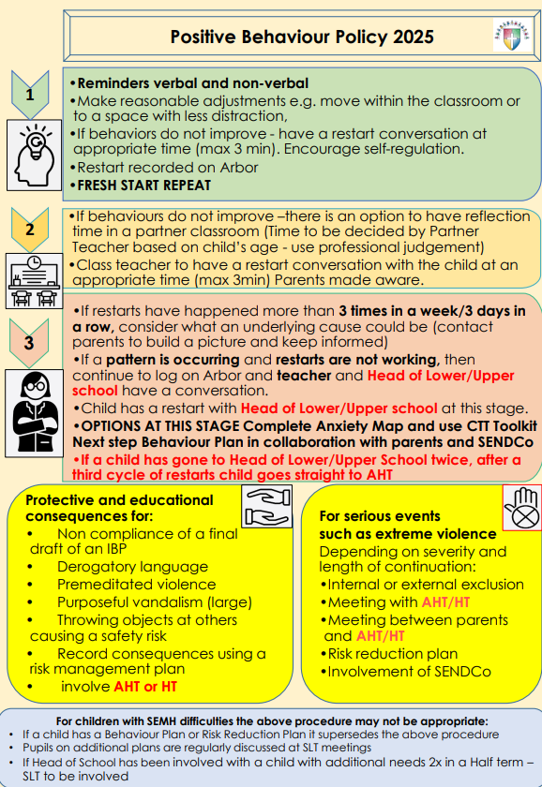

CHILD FRIENDLY
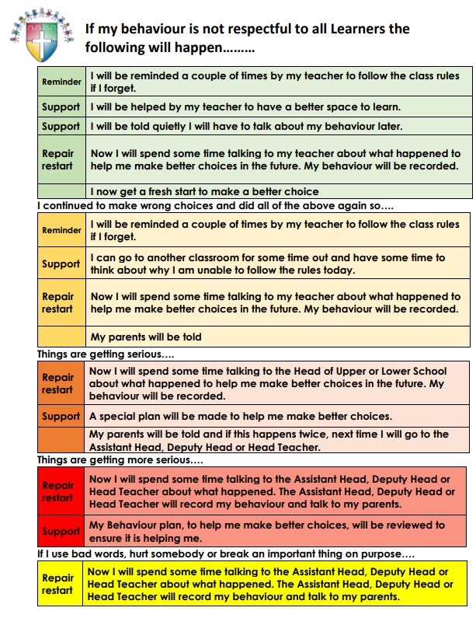

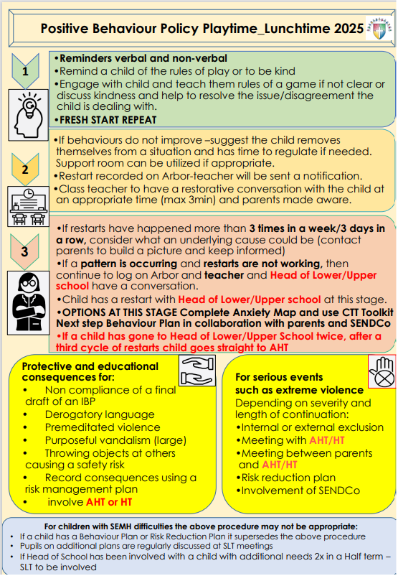

CHILD FRIENDLY
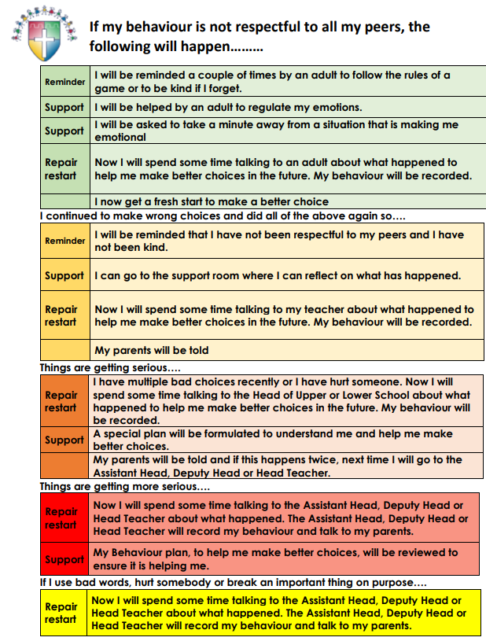

Appendix 3.
Non- Negotiables of Behaviour
Detrimental Dangerous
- Violence
- Purposeful vandalism (large)
- Throwing objects at others

Detrimental Difficult
- Derogatory language
- Purposeful vandalism (small)
- Defacing school property
- Throwing objects

Detrimental Behaviours (low level)
- Manners (lack of)
- Not listening
- Answering back
- Refusal
- Time wasting
- Sharing
- Calling out
- Needless wandering
- Talking over others
- Fidgeting
- Whispering
- Gossiping
- Unkindness
- Not minding your own business

Corridor non-negotiables – created by school parliament

- Walk –don’t run
- No animals in school – except school dogs
- Look after property when moving about
- Respond when an adult gives you a direction
- Quiet voices only – no shouting
- Only talk when adults have given you permission
- Polite words only- no use of unkind words
- Keep hand and feet to yourself- no pushing
- Go directly to where you need to be – don’t wander around without permission
- Stay still when lining up for the hall

Playground non-negotiables – created by school parliament

- Look after our wildlife – don’t climb on plants/trees or other living things
- Only play games on your designated day- always check the rota
- Walk around games that are already happening- don’t interfere or interrupt others
- Play in the areas that are designated for use – don’t play near bike shed/nature area/ quiet area/sheds
- Always clear up after yourself- don’t drop litter and use the bins outside
- Only play games such as football in the areas designated
- Treat other kindly and with respect – don’t hurt others physically or emotionally
- Allow other sports to be played- not just your own choice
- Use kind words to others
- Use the climbing equipment safely- Don’t climb up the building/gates/tables/benches or flower beds
- Always let others join in with your games- don’t isolate others
- Be careful with sports resources- look after our things and put things away
- When the whistle blows- stop and listen straight away- then walk to your class line

