Sylvia Earle
Week beg 09.11.20
What a busy week we have had! We’ve discovered how to use a force meter in Science. We were trying to establish whether different surfaces impacted the amount of force needed in a push or pull. We all made predictions and were correct.
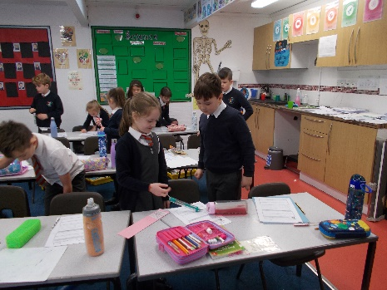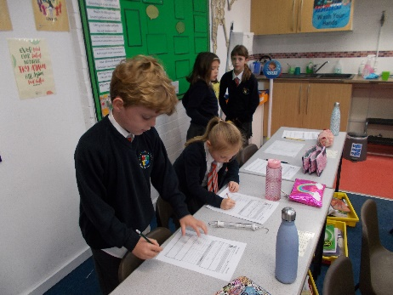

In English, we wrote a script about Ug and the type of cookery channel he might present. We had some very interesting combinations, from mammoth and leaf burgers, worm pies, apple and fish kebab to animal cotton candy. Once we had written our scripts, we performed them. There was lots of humour, laughter and persuasive language involved.
During maths, we have been focussing on bar models and how to use them in word problems. We found it quite tricky but persevered and now have a better understanding. Next week, we will begin our module on multiplication and division.
We have continued sewing and have really enjoyed the process. We will continue until everyone has finished their bookmark.
In PE we have developed our passing skills further. We now know how to use three different passes and had a real giggle when we tried to combine them into a fast paced game.
In music this week, the children looked at rhythm and really enjoyed their lesson. They listened to the rhythm and had to clap it back accurately. Mrs Farmer was very impressed.
In RE, we have been looking at The Baptism of Christ. We looked at Bonnell and Verrocchio and compared similarities and differences. Then we created our own art work. We will finish them next week.
We hope you have a lovely weekend.

Sylvia Earle class

