Wk beg 16.11.20
Talk homework: Talk about the different types of bullying and who you would speak to if you needed to.
Daily reading 15-20 minutes
NESSY 40 minutes a week, if appropriate
TT Rockstars/Abacus/ Mathsframe/Topmarks (Hit the button) – as often as possible.
This week, I have included a list of our learning as I have been asked by a few parents. Any additional reading and support would be welcomed.
English – Ug, boy genius of The Stone Age
Maths – Multiplication and division
Science – Forces and magnets
SDG – Industry, Innovation and Infrastructure – linked to The Industrial Revolution and train development
RE – The Holy Trinity
Good afternoon all,
We hope you are well.
This week has been a busy one, with lots of learning. Joshua has enjoyed learning multiplication and division this week. We have made a great start.
In RE this week, we continued with our leaning on The Holy Trinity and chose either The Father, The Son or The Holy Spirit to write a kenning on. Charlie really enjoyed this and everyone wrote a fantastic poem.
In PE, Remy enjoyed netball. We have now added pivoting to the list of skills covered and we had a great giggle learning how to throw, land pivot and then pass.
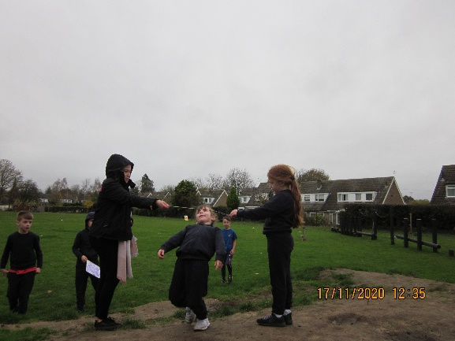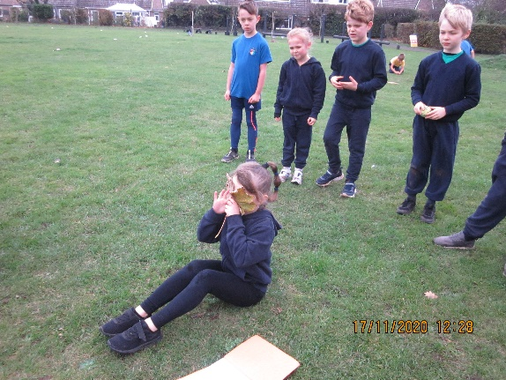

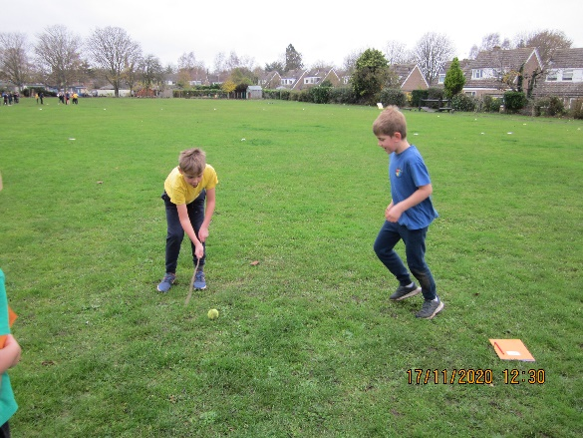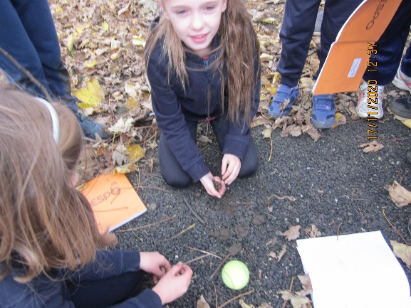

Seb enjoyed writing our instructions in English. We devised new games that would or could have been played during The Stone Age. The best part was going outside to play them and check that they worked. See above.
In Art this week, Finn enjoyed using watercolours to finish his painting on The Holy Trinity. What a great job!
We hope you have a lovely weekend.

Sylvia Earle class

