This week’s learning 04.01.21

Mathematics – Power Maths – Please log on to Power Maths (Same as Abacus) and view your allocated lessons, school code kmm7. Access the textbook first and work through the powerpoint (just like in lesson time) and then access the practise book and complete the questions.

Textbook – Please complete the textbook first (it will look similar to this).

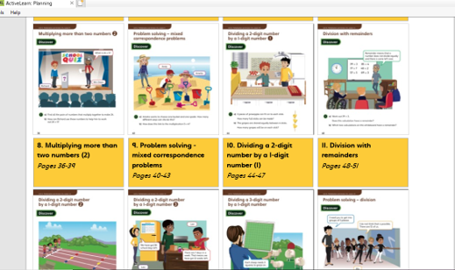
Monday – Textbook followed by Practise book - Unit 6, lesson 5 - Multiply a 3 digit number by a 1 digit number.
https://www.activelearnprimary.co.uk/login?c=0&l=0

Tuesday – Textbook followed by Practise book Unit 6, lesson 5 – Problem solving multiplication
https://www.activelearnprimary.co.uk/login?c=0&l=0

Wednesday – Textbook followed by Practise book Unit 6, lesson 7 – Multiply more than two numbers
https://www.activelearnprimary.co.uk/login?c=0&l=0

Thursday – Textbook followed by Practise book Unit 6, lesson 8 – Multiply more than two numbers (part 2)
https://www.activelearnprimary.co.uk/login?c=0&l=0

Friday – Textbook followed by Practise book Unit 6, lesson 9 – Problem solving, mixed correspondence problems

https://www.activelearnprimary.co.uk/login?c=0&l=0
Arithmetic (20 minutes a day) - Make sure you are practising your times tables as much as you can.
Times Table Rock Star
https://play.ttrockstars.com/auth/school/student/76329
https://www.topmarks.co.uk/maths-games/7-11-years/times-tables
https://www.timestables.co.uk/

English – Pobble 365 – follow the links and complete the activities.
Lesson 1 – The Author
https://pobble365.b-cdn.net/pdf-attachment/resource/attachment/226/226_theauthor.pdf

Lesson 2 - The Curiosity Shop
https://pobble365.b-cdn.net/pdf-attachment/resource/attachment/351/351_curiosityshop.pdf
Lesson 3 – On repeat 2
https://pobble365.b-cdn.net/pdf-attachment/resource/attachment/38/038_onrepeat2.pdf
Lesson 4 – SPAG – Contractions
https://classroom.thenational.academy/lessons/to-use-apostrophes-for-contraction-6rukje
Lesson 5 – The Stampede
https://pobble365.b-cdn.net/pdf-attachment/resource/attachment/228/228_stampede.pdf

Reading
Keep reading!
Read a magazine/newspaper article.

Remember to read EVERYDAY.
The Accelerated Reader (AR) programme is also accessible from home during this time too, so once you’ve finished your books make sure you log on and take a quiz. https://ukhosted43.renlearn.co.uk/2152328/default.aspx

Nessy (20 minutes a day)
https://www.nessy.com/uk/

Global learning (Geography, History, DT, Art, Music)

Research what are sewers and why are they important?

https://swiggle.org.uk/?q=What%20are%20sewers%3F&type=web

Think about how you would make muddy water clean. Now design an experiment to help you clean the water.

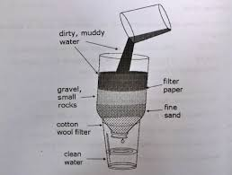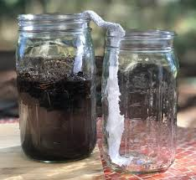

Science – Solids liquids and gases

Go through the powerpoint attached and now draw an image that represents how solid, liquid and gas particles behave.

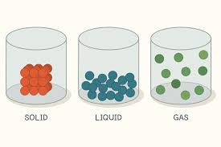

RE – What is a pilgrimage?

https://www.youtube.com/watch?v=GkhHBbvtjV8

Which the above clip and tell an adult what a pilgrimage is.

Mind Up
https://mindup.org.uk/families/

Skills builder
https://www.skillsbuilder.org/homelearning

PE

Visit youtube and do a Joe Wicks session 5 times a week.

https://www.youtube.com/watch?v=BDigyoBrHms

