Year 4- Live lessons
In order to find live lessons please go to the channel labelled with that day of the week. The channels can be found down the left hand side of the teams screen. See red area below.
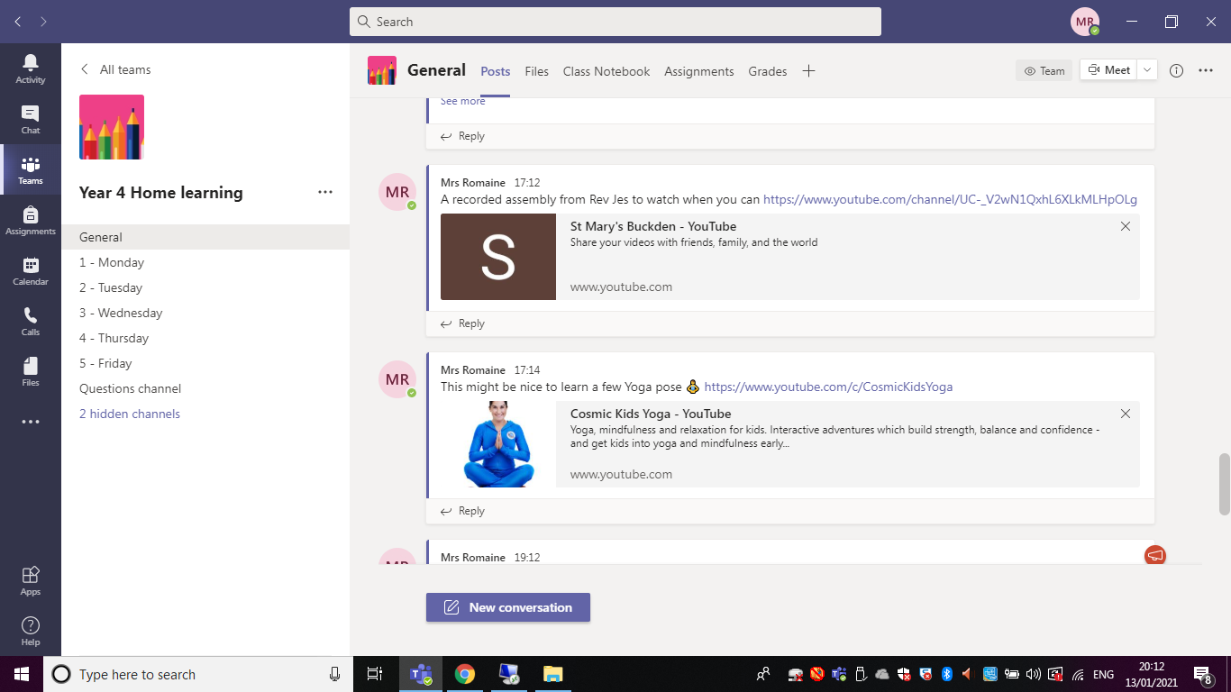
Once you are on the channel, scroll up or down to access the correct lesson. Maths is daily at 10.30 AM, English is daily at 12.00 AM and then another curriculum subject each day at 1.30 PM. These will be at the top of each day in the daily channel. The live lessons are also pinned.
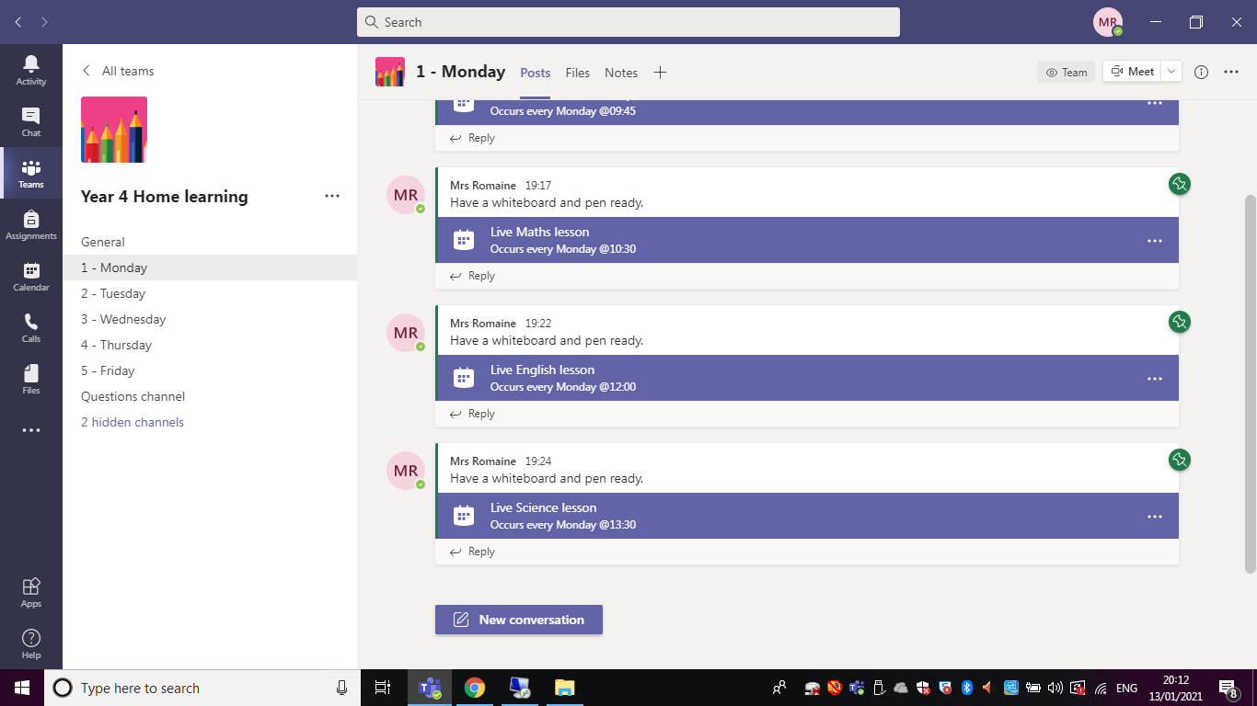

If you click on the blue box for the lesson you want, you should be able to view the meeting details.
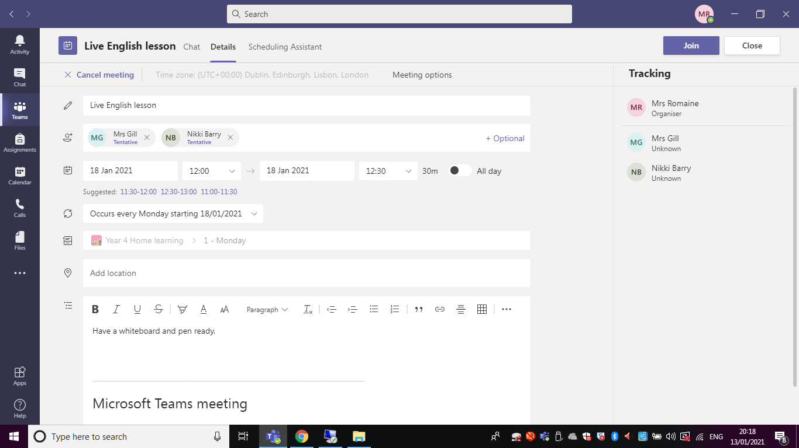
You will need to click on the ‘Join’ button in the top right hand corner in order to join a live lesson. Please see the area in red above.
You will be presented with the screen below. Please ensure your microphone is muted by clicking the button in red and then click the join button at the bottom.
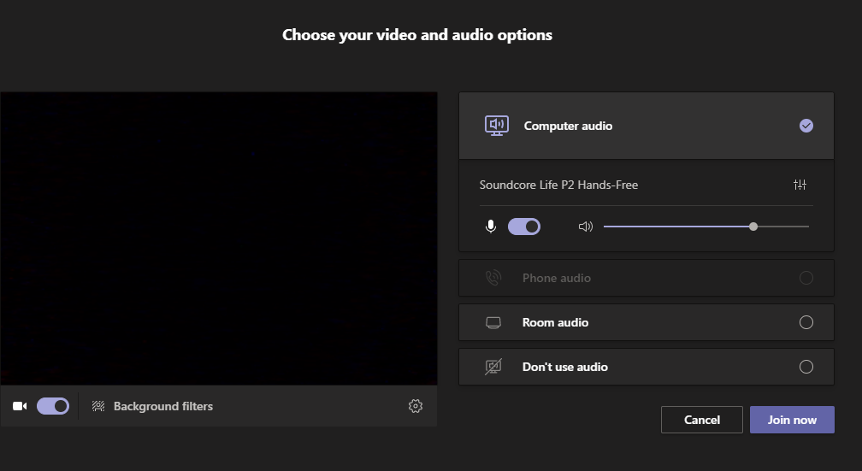

Once you have done this you will be in a live lesson. If you are unable to attend the live lesson the you can always watch the recording afterwards. This can be found underneath the scheduled sessions and you will need to download this to watch it. Once you click download you may need to do into your computer files- downloads, to find the video. It should appear as below.


