This week’s learning 18.01.21
Daily PE Live with Miss Lizell at 9AM every weekday!
https://www.youtube.com/channel/UCo1Ce6-TzdWlBNvvJEF1K5w

Mathematics – Power Maths – Please log on to Power Maths (Same as Abacus), school code kmm7.
18.01.21
Maths – Live lesson at 10.30 AM Textbook
Independent work - Practice book 4B –Problem Solving – division, Unit 6, lesson 15, page 48-50. Hand in assignment with work attached.
English Live lesson at 12.00 PM
Independent work – In role as Oliver write a note to explain what has happened, where you have gone or going. Hand in assignment with work attached.
Science Live lesson at 1.30 pm.
Independent task – Plan a fair test – How could you help to find the best temperature for melting chocolate. Remember to include your equipment, method and how you have made it a fair test. Hand in assignment with work attached.

19.01.21
Maths– Live lesson at 10.30 AM Textbook
Independent work - Practice book 4B – What is area? Unit 7, lesson 1, pages 54 – 56. Hand in assignment with work attached.
English Live lesson at 12.00 PM
Independent work – Draw a picture of Iris and list on one side words to describe her appearance and on the other side, main character traits. Hand in assignment with work attached.
RE - Live lesson at 1.30 pm.
Independent work – Draw a Venn diagram in your topic book and complete it by sorting the vocabulary underneath. Hand in assignment with work attached.
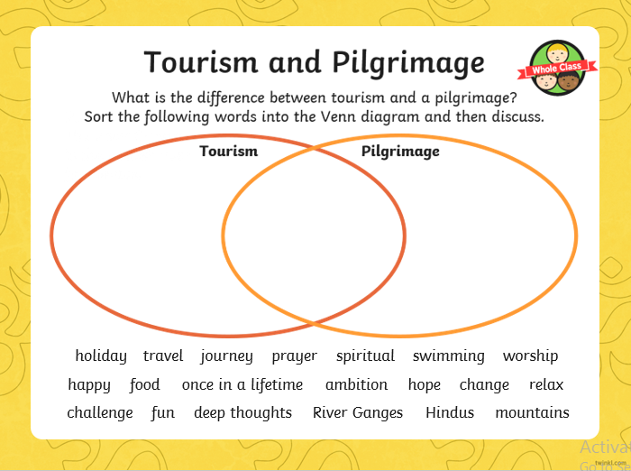
----------------------------------------------------------------

20.01.21
Maths Live lesson at 10.30 AM Textbook
Independent work - Practice book 4B – Counting squares (1), Unit 7, lesson 2, pages 57 – 59. Hand in assignment with work attached.
English Live lesson at 12.00 PM
Independent work – Design your own seawig. Think about what treasures you might have collected out at sea. Remember to label your seawig items. Hand in assignment with work attached.
Skills builder - Live lesson at 1.30 pm.
Independent work – Own choice – Spellings/Nessy/Reading/TT RockStars/physical activity.
------------------------------------------------------------------
21.01.21
Maths Live lesson at 10.30 AM Textbook
Independent work - Practice book 4B - Counting squares (2), Unit 7, lesson 3, pages 60 – 62. Hand in assignment with work attached.
English– Live lesson at 12.00 PM
Independent work – Found in files, 21.01.21 English Independent work. Answer the questions in your English book or save the document in your own files and amend. Hand in assignment with work attached.
Global learning Live lesson at 1.30 pm.
Independent learning – Now you have listened to the poem, draw a positive and negative image from the poem in your topic books. Hand in assignment with work attached.
--------------------------------------------------------------------

22.01.21
Maths Live lesson at 10.30 AM Textbook
Independent work - Practice book 4B – Making shapes, Unit 7, lesson 4, pages 63 – 65. Hand in assignment with work attached.
English Live lesson at 12.00 PM https://youtu.be/635uup08DLU David Attenborough clip.
Independent work –https://drive.google.com/file/d/1rI3Ek928IjZ0xiLUHv4ACQAsggwV6nEq/view Complete the question using the clip. Hand in assignment with work attached.
PE Live lesson at 1.30 pm.
--------------------------------------------------------------------Arithmetic (20 minutes a day)
Make sure you are practising your times tables as much as you can.
Times Table Rock Star
https://play.ttrockstars.com/auth/school/student/76329
https://www.topmarks.co.uk/maths-games/7-11-years/times-tables
https://www.timestables.co.uk/

Spellings
Practice your spellings in which every creative way you like. I have uploaded the spelling menu to give you some ideas.
Spellings
This week’s spelling rule - ‘g’ and ‘k’ sound
1) Rogue
2) Tongue
3) Antique
4) Unique

Reading
Keep reading!
Read a magazine/newspaper article.

Remember to read EVERYDAY.
The Accelerated Reader (AR) programme is also accessible from home during this time too, so once you’ve finished your books make sure you log on and take a quiz. https://ukhosted43.renlearn.co.uk/2152328/default.aspx

Nessy (20 minutes a day)
https://www.nessy.com/uk/

Mind Up
https://mindup.org.uk/families/
GenR8
Please use the below link or download the video as required.
https://youtu.be/4Pk6-khf21g
Other GenR8 Reflect videos can be found at https://genr8.org/prayer-spaces Along with other Inspire Prayer Space resources specifically for use at home.
GenR8 Connect videos can be found at https://genr8.org/videos
Rev Jes
Assembly now uploaded on to 'St Mary's Buckden' YouTube channel. St Mary's Buckden - YouTube

Visit youtube and do a Joe Wicks session/Cosmic kids/Go noodle

Submitting your work
Type your work or take photos of any work you would like us to see and upload them in the assignment for that lesson.

