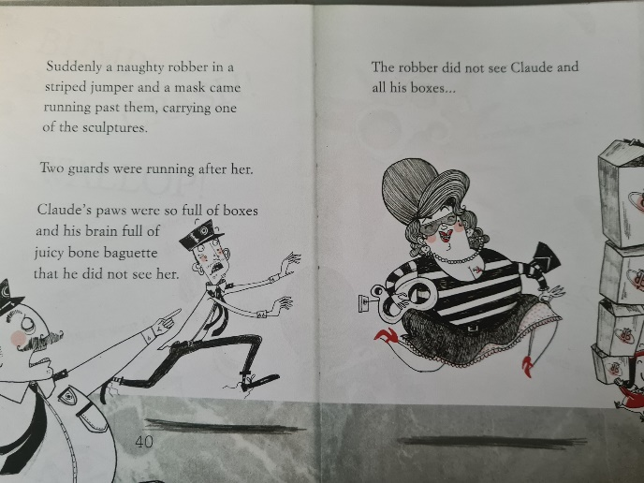
Good Morning,

Today, Wednesday 20th January is as follows:

English-
Look at the images on pages 40 and 41. What is happening here? Who are these new Characters? How could we describe the lady in the mask if we wanted to tell others about her?

Write a description of the lady in the picture. Remember to use adjectives and don’t forget to use capital letters and full stops.

Maths- Text book pages 56-59. Practice book pages 41-43
Addition and subtraction facts to 20-
Phonics- Todays phonics is ‘c’ in mice.
Follow the link below and click on today’s date.
Wednesday 20th January: Lesson 13 c mice
https://lettersandsounds.org.uk/for-home/year-1

Please then complete one activity from the challenge sheet in the file section.

Phonics play is also free throughout January so you could explore some of the games on there.
https://www.phonicsplay.co.uk/
username: jan21
password: home

PE- Miss Lizell will join you live for a PE lesson. You do not need to bring anything. The lesson is pinned at the top of Wednesday’s channel.

Story- If you would like to share a story together log on and find out which book we will read this week.

