This week’s learning 01.02.21
Daily PE Live with Miss Lizell at 9AM every weekday!
https://www.youtube.com/channel/UCo1Ce6-TzdWlBNvvJEF1K5w

Mathematics – Power Maths – Please log on to Power Maths (Same as Abacus), school code kmm7.
01.02.21
Maths – Live lesson at 10.30 AM Textbook
Independent work - Practice book 4B – Unit 8, lesson 5, Simplifying fractions, pages 83-85. Hand in assignment with work attached.
English Live lesson at 12.00 PM
Independent work – Draw a picture of Iris, Oliver, the Thurlstone and the boy who was looking down. Then, write a thought bubble next to each of them and write what they are thinking.
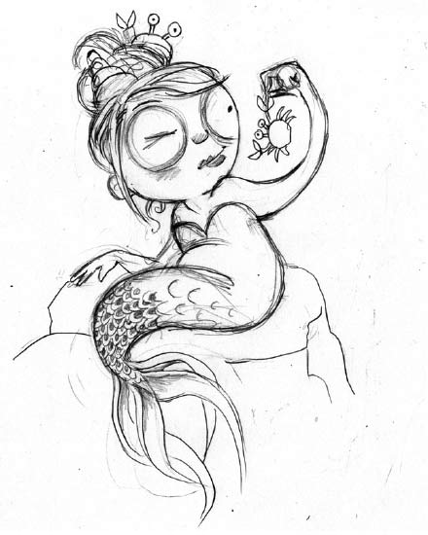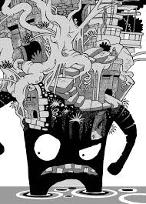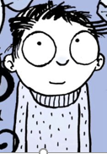

Hand in assignment with work attached.
Science Live lesson at 1.30 pm.
Independent task – Evaporation – Write up an evaporation experiment, if you can carry it out please do so.
https://www.bbc.co.uk/bitesize/topics/zkgg87h/articles/zydxmnb
https://www.youtube.com/watch?v=ed_WYiaujT0

---------------------------------------------------------------------------

02.02.21
Maths– Live lesson at 10.30 AM Textbook
Independent work - Practice book 4B – Unit 8, lesson 6, Fractions greater than 1 (1), pages 86-88. Hand in assignment with work attached.
English Live lesson at 12.00 PM
Independent work – Answer these questions in full sentences.
- What is your first impression of Stacey de Lacey? What makes you think this way?
- Why does he become so angry so quickly when Oliver and Iris speak with him?
- Why has an he developed such an irascible (easily angered) personality?
- How does he treat the sea monkeys when he discovers them? Do you think Oliver would have behaved like this? Would you? Why, or why not?
- Once Stacey de Lacey has an army of sea monkeys, what drives him? What is his ambition? What does this tell you about him?
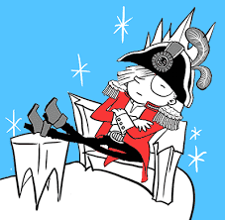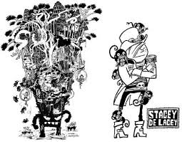
Hand in assignment with work attached.
RE - Live lesson at 1.30 pm.
Independent work – Jewish Pilgrimages – Imagine you have completed the same journey to Jerusalem. Write a letter to your parents explain what happened. Use the Jewish Pilgrimage word mat to help you with some key vocabulary.
Hand in assignment with work attached.
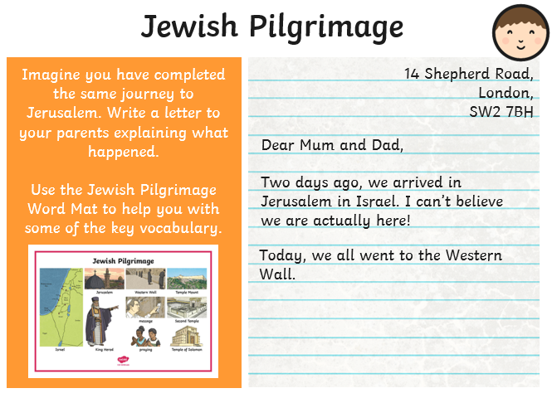
----------------------------------------------------------------
03.02.21
Maths Live lesson at 10.30 AM Textbook
Independent work - Practice book 4B – Unit 8, lesson 7, Fractions greater than 1 (2), pages 89-91.
Hand in assignment with work attached.
English Live lesson at 12.00 PM
Independent work – Write instructions on how to care and train a sea monkey.
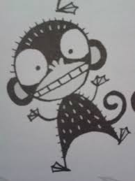
Hand in assignment with work attached.
PE Live lesson at 1.30 pm.
------------------------------------------------------------------

04.02.21
Maths Live lesson at 10.30 AM Textbook
Independent work - Practice book 4B - Unit 9, lesson 1, Adding Fractions, pages 94-96. Hand in assignment with work attached.
English– Live lesson at 12.00 PM
Independent work – SPAG – Complete the pronouns sheet https://buckdenprimary.sharepoint.com/:b:/s/Year4/EbWL43br9l9Cu3Kt3fNhCmYBdHQaAsO-T9-vb5Db3XiXAQ?e=1zSaPO
in the Thursday channel in the files section at the top. https://www.bbc.co.uk/bitesize/topics/zwwp8mn/articles/z37xrwx
Hand in assignment with work attached.
Global learning Live lesson at 1.30 pm.
Independent work – Research how the Roman empire impact on the British sanitation system and create a fact file to explain. Don’t forget to add facts and pictures. Maybe you can create a timeline too. https://swiggle.org.uk/?q=how%20did%20the%20Roman%20empire%20impact%20on%20the%20British%20sanitation%20system.&type=web
https://www.bbc.co.uk/bitesize/topics/zqtf34j/articles/z2dr4wx
https://vimeo.com/164710804

Hand in assignment with work attached.
--------------------------------------------------------------------

05.02.21
Maths Live lesson at 10.30 AM Textbook
Independent work - Practice book 4B – Unit 9, lesson 2, Subtracting fractions, pages 97-99. Hand in assignment with work attached.
English Live lesson at 12.00 PM
Independent work – Comprehension – Deep Sea explorers text. https://buckdenprimary.sharepoint.com/:b:/s/Year4/ERizo0soIAdHq8hNPdDol_gB_T22TRJXWjs7PpCl__3I9g?e=Eip9WN
Complete the quiz.
https://forms.office.com/Pages/ResponsePage.aspx?id=WWP7dCZlx0CYxtFo2XQsHE2yuTaVqEVEogH--g2LAStUNU1NUDQ3RDJGWjFSS1VMSjREOFVUTjhKMC4u

Skills builder afternoon
--------------------------------------------------------------------------------
Arithmetic (20 minutes a day)
Make sure you are practising your times tables as much as you can.
Times Table Rock Star
https://play.ttrockstars.com/auth/school/student/76329
https://www.topmarks.co.uk/maths-games/7-11-years/times-tables
https://www.timestables.co.uk/
Spellings
Practice your spellings in which every creative way you like. I have uploaded the spelling menu to give you some ideas.
Spellings
This week’s spelling rule - homophones
1) affect
2) effect
3) ball
4) bawl
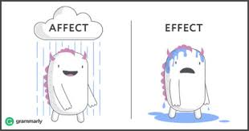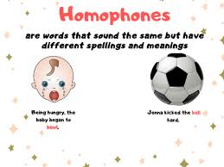
Reading
Keep reading!
Read a magazine/newspaper article.

Remember to read EVERYDAY.
The Accelerated Reader (AR) programme is also accessible from home during this time too, so once you’ve finished your books make sure you log on and take a quiz. https://ukhosted43.renlearn.co.uk/2152328/default.aspx

Nessy (20 minutes a day)
https://www.nessy.com/uk/

Mind Up
https://mindup.org.uk/families/

GenR8
Please use the below link or download the video as required.
https://youtu.be/4Pk6-khf21g
Other GenR8 Reflect videos can be found at https://genr8.org/prayer-spaces Along with other Inspire Prayer Space resources specifically for use at home.
GenR8 Connect videos can be found at https://genr8.org/videos
Rev Jes
Assembly now uploaded on to 'St Mary's Buckden' YouTube channel. St Mary's Buckden - YouTube

Visit youtube and do a Joe Wicks session/Cosmic kids/Go noodle

Young Artists' Summer show – This is something fun and creative to take part in if you wish.
As a school we have registered for the Young Artists' Summer show. This is an opportunity for the children to explore and create a piece/s of artwork overtime and at their own pace. The Young Artists’ Summer Show is a free, open submission exhibition for young artists aged 5 - 19 years studying in the UK and British schools overseas. To take part, students or their parents/guardians can submit artworks. These artworks are then judged by a panel of artists and arts professionals with selected artworks displayed online and on-site at the Royal Academy of Arts. https://youngartists.royalacademy.org.uk/get-involved Artworks can be submitted until 26 April 2021 at 5pm.

Submitting your work
Type your work or take photos of any work you would like us to see and upload them in the assignment for that lesson.

