This week’s learning 08.02.21
Daily PE Live with Miss Lizell at 9AM every weekday!
https://www.youtube.com/channel/UCo1Ce6-TzdWlBNvvJEF1K5w

Mathematics – Power Maths – Please log on to Power Maths (Same as Abacus), school code kmm7.
08.02.21
Maths – Live lesson at 10.30 AM Textbook
Independent work - Practice book 4B – Unit 9, lesson 3, Subtracting (2) fractions, pages 100-102. Hand in assignment with work attached.
English Live lesson at 12.00 PM
Independent work – divide your page in half, on one side write the reasons why Cliff should stay where he is and settle. On the other side, write the reasons why he should follow the others to the Hallowed Shallows.
Hand in assignment with work attached.
Science Live lesson at 1.30 pm.
End of unit quiz. Independent task – Complete the quiz independently. https://forms.office.com/Pages/ResponsePage.aspx?id=WWP7dCZlx0CYxtFo2XQsHE2yuTaVqEVEogH--g2LAStUNzRZT1M5QzdXU1BaOTNSU0RJNVZSS1Q5Wi4u

---------------------------------------------------------------------------

09.02.21
Maths– Live lesson at 10.30 AM Textbook
Independent work - Practice book 4B – Unit 9, lesson 4, Problem solving adding and subtracting (1) fractions, pages 103-105. Hand in assignment with work attached.
English Live lesson at 12.00 PM
Independent work – create a sea monkey chant. You could add a dance if you would like to.
Hand in assignment with work attached.
RE - Live lesson at 1.30 pm.
Independent work – Make a Chinese New Year card to give to a friend or family, you do not need to submit this.


10.02.21
Live News/catch up meeting 9AM – These will be held on our Class Teams NOT the Year 4 home learning Team.
Maathai with Mrs Romaine – In the live meeting channel
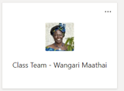
Ceesay with Mrs Gill – In the catch up channel
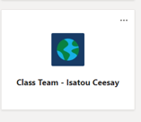
Maths Live lesson at 10.30 AM Textbook
Independent work - Practice book 4B – Unit 9, lesson 5, Problem solving adding and subtracting (2) fractions, pages 106-108. Hand in assignment with work attached.
English Live lesson at 12.00 PM
Independent work – write a diary entry in role as Iris. Don’t forget it will be in the past tense and you are Iris so you will write in the first person, I.
Hand in assignment with work attached.
PE Live lesson at 1.30 pm.
------------------------------------------------------------------

11.02.21
Maths Live lesson at 10.30 AM Textbook
Independent work - Practice book 4B – Unit 9, lesson 6, Calculating fractions of a quantity, pages 109-111. Hand in assignment with work attached.
English– Live lesson at 12.00 PM
Independent work – SPAG – Create your own pronouns poster in your English books.
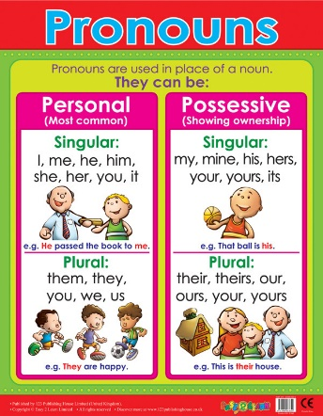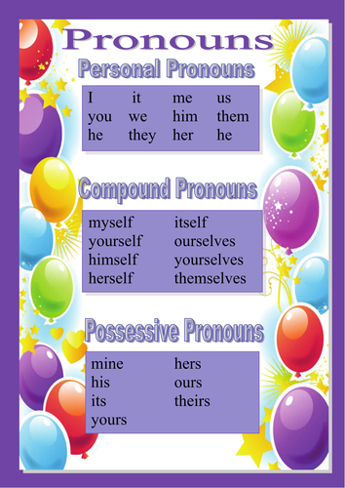
Hand in assignment with work attached.
Global learning Live lesson at 1.30 pm.
Independent work – Build your own Aqueduct out of anything you can find at home. Be as creative as you can, maybe you could use items from the cupboard, paper, card or playdough.
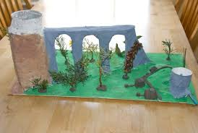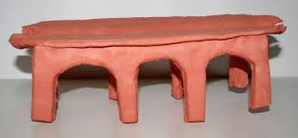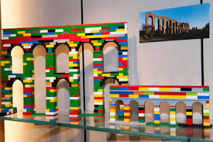
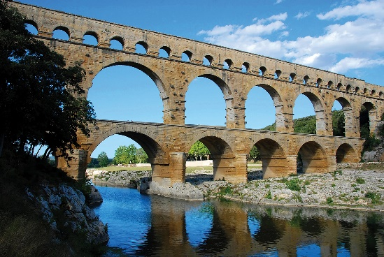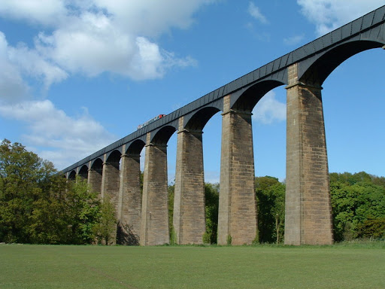

Hand in assignment with a photo attached.
--------------------------------------------------------------------

12.02.21
Maths Live lesson at 10.30 AM Textbook
Independent work - Practice book 4B – Unit 9, lesson 7, Problem solving - fractions of a quantity, pages 112-114. Hand in assignment with work attached.
English Live lesson at 12.00 PM
Plastic pollution - Find a copy of the text here - https://buckdenprimary.sharepoint.com/:b:/s/Year4/ETqEvukocwtKjLl0TG4NEsMBPdwvg1VxY2yaH5ec_4Ye3Q?e=KeR6jp
Independent work – Comprehension Quiz – https://forms.office.com/Pages/ResponsePage.aspx?id=WWP7dCZlx0CYxtFo2XQsHE2yuTaVqEVEogH--g2LAStUQlU4SzVUNFZUS0JUME1ZWjRWM1pXNFkzWS4u

Skills builder afternoon
Find this in the Friday channel, files tab at the top of the page.
--------------------------------------------------------------------------------
Arithmetic (20 minutes a day)
Make sure you are practising your times tables as much as you can.
Times Table Rock Star
https://play.ttrockstars.com/auth/school/student/76329
https://www.topmarks.co.uk/maths-games/7-11-years/times-tables
https://www.timestables.co.uk/

Spellings
Practice your spellings in which every creative way you like. I have uploaded the spelling menu to give you some ideas.
Spellings
This week’s spelling rule - homophones
1) berry
2) bury
3) knot
4) not
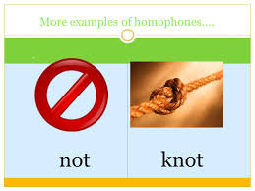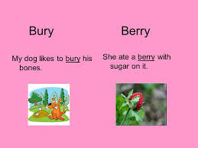
Reading
Keep reading!
Read a magazine/newspaper article.

Remember to read EVERYDAY.
The Accelerated Reader (AR) programme is also accessible from home during this time too, so once you’ve finished your books make sure you log on and take a quiz. https://ukhosted43.renlearn.co.uk/2152328/default.aspx

Nessy (20 minutes a day)
https://www.nessy.com/uk/

Mind Up
https://mindup.org.uk/families/

GenR8
Please use the below link or download the video as required.
https://youtu.be/4Pk6-khf21g
Other GenR8 Reflect videos can be found at https://genr8.org/prayer-spaces Along with other Inspire Prayer Space resources specifically for use at home.
GenR8 Connect videos can be found at https://genr8.org/videos
Rev Jes
Assembly now uploaded on to 'St Mary's Buckden' YouTube channel. St Mary's Buckden - YouTube

Visit youtube and do a Joe Wicks session/Cosmic kids/Go noodle

Young Artists' Summer show – This is something fun and creative to take part in if you wish.
As a school we have registered for the Young Artists' Summer show. This is an opportunity for the children to explore and create a piece/s of artwork overtime and at their own pace. The Young Artists’ Summer Show is a free, open submission exhibition for young artists aged 5 - 19 years studying in the UK and British schools overseas. To take part, students or their parents/guardians can submit artworks. These artworks are then judged by a panel of artists and arts professionals with selected artworks displayed online and on-site at the Royal Academy of Arts. https://youngartists.royalacademy.org.uk/get-involved Artworks can be submitted until 26 April 2021 at 5pm.

Submitting your work
Type your work or take photos of any work you would like us to see and upload them in the assignment for that lesson.

