Wk beg 22.02.21
Talk homework: What makes a city sustainable?
Daily reading 15-20 minutes
NESSY 40 minutes a week, if appropriate
TT Rockstars/Abacus/ Mathsframe/Topmarks (Hit the button) – as often as possible.
Here is this week’s learning. Any additional reading and support would be welcomed.
English – Varmints
Maths – Telling the time
Science – Plants
SDG –Sustainable cities and communities– What makes a city sustainable?
RE – Christianity - Salvation
Next week, we are celebrating World Book Day. Please see the ideas below for things you might like to do:
- create a poem of your favourite book character
- find an interesting place to read a book and take a photo of you reading in that space.
- create your favourite book character using interesting objects you can find from on walks or from around your house.
Here is a picture that you might want to attach for the 3rd one as an idea:

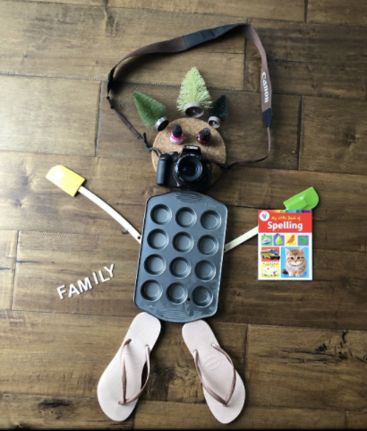
Good afternoon all,
What a busy first week back.
In Maths, we have been learning how to use a ruler, how to measure accurately, convert measure and work out perimeter!
In English, we started our new book ‘Varmints’. We discussed the contrast between what a varmint is and the illustration on the front cover. We also drew our interpretation of what a varmint is.
In our global learning, we have had great discussions this week about what makes a sustainable city. We also looked into counties, used our map work skills to identify as many English counties as we could.
In Science, we are learning about plants. This week, we labelled the basic parts of a plant and their functions.
In RE, we are learning about Christianity and the concept of ‘Salvation’. The children drew images of what they thought various concepts in Christianity meant to them.
We are looking forward to a lovely weekend.
From
Sylvia Earle

