This week’s learning 11.10.21
Monday
Maths – Place value workbook – complete as many questions as you can.
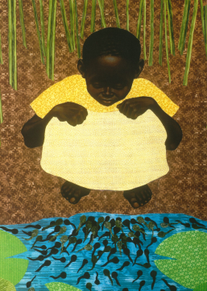
English – Look at these images and compare the differences. What is the illustrator showing us in these images / where are we in the story.
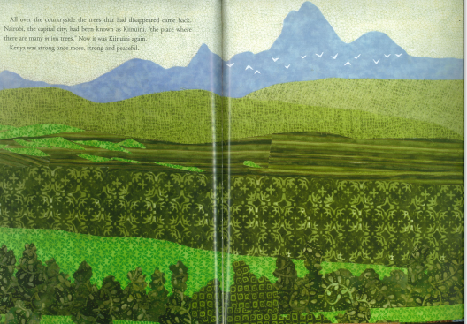

Play Practice - Learn your lines for the play – think about your expression when saying your lines.

Tuesday
Maths – Addition / subtraction recap
Do you know the meaning of these words:
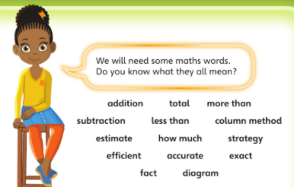
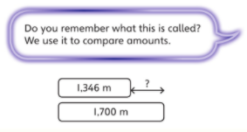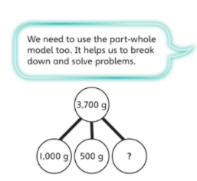
English – What feelings does this image evoke? What do you think has happened?
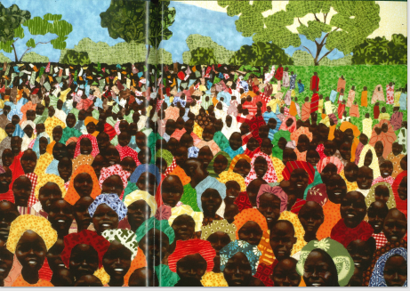
French – Practice your parts of your face on Linguascope https://www.linguascope.com/

Wednesday
Maths – Adding and subtracting 10s, 100s and 1000s sheet.
English – Pobble (it is free) - https://www.pobble365.com/ *Don’t forget to use adverbs and adjectives.
Science – Make a poster about different environmental changes and the consequences on living things and their habitats.

Thursday
Maths – Adding two 4 digit numbers 1
https://vimeo.com/461778690
English – Reading for pleasure discussion
Write or tell your adult or sibling about the book you are reading or your favourite book.
Skills Builder – skillsbuilder.org/homelearning

Friday
Maths – Adding two 4 digit numbers 2
Worksheet – Add two 4 digit numbers no exchange.
English – (SPAG) Practice your handwriting by writing adjectives to describe nouns and adverbs to describe verbs. Choose any noun and any adjective / any adverb and verb e.g., monstrous ant, tiny elephant, slowly crawled, swiftly ate.
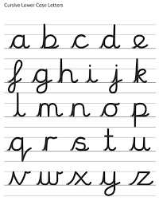
Mind up/PHSE– Talking about perseverance.
Find out what perseverance means and why it is important.

Daily
Hit the button – Times table practise

Keep reading a range of fiction and non-fiction!
Read a magazine/newspaper article.
Arithmetic (20 minutes a day) – Practise your 4 and 8 times tables – try writing flashcards and testing yourself.
PE

Visit YouTube and do a session 5 times a week of Joe Wicks/Go Noddle/Cosmic Kids Yoga.

