This week’s learning 14.03.22
Monday
Maths – Watch link and complete – Counting in tenths
Spelling – Write a sentence for each word in the spelling list - 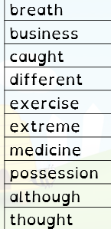
Spelling - Practice your spelling by writing them out in your best handwriting – a row for each word.

Tuesday
Maths – Watch link and complete – Add fractions
English – Complete the sheet on conjunctions - Painted wolf - screen 1 - Natural Curriculum
History - Do you agree with what Emmeline Pankhurst or do you think they were wrong. Emmeline Pankhurst - Suffragette - BBC Bitesize

Wednesday
Maths – Watch link and complete – Subtract fractions
English – Read and complete a reading comprehension about the Emily Pankhurst.
French – Practise how to say and write I like – J’aime / I dislike – Je n’aime pas certain hobbies Linguascope – password Moonfish

Thursday
Maths – Watch link and complete – Fractions greater than one
English – Look at this image from Pobble – can you continue the story.

Science – Read the powerpoint about string telephone and complete the task.

Friday
Maths – Complete – Compact multiplication worksheet – remember to write the numbers clearly in each column.
English – Sentence structure - To revise our understanding of simple and compound sentences (thenational.academy)
RE – What is Lent? - BBC Bitesize
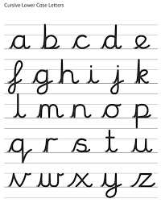

Daily
Hit the button – Times table practice

Keep reading a range of fiction and non-fiction!
Read a magazine/newspaper article.
Arithmetic (20 minutes a day) – Practise your 4 and 8 times tables – try writing flashcards and testing yourself.
PE

Visit YouTube and do a session 5 times a week of Joe Wicks/Go Noddle/Cosmic Kids Yoga.

