This week’s learning 21.03.22
Monday
Maths – Watch link and complete – Subtracting fractions
Spelling – Write a sentence for each word in the spelling list - 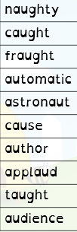
Spelling - Practice your spelling by writing them out in your best handwriting – a row for each word.

Tuesday
Maths – Watch link and complete – • Subtract from whole amounts
English – Watch this link - The Present - THE LITERACY SHED - Write descriptive speech for mum and boy - remember new speaker – new line
DT - Design a reading area – think about what would be useful and helpful for readers.

Wednesday
Maths – Watch link and complete –Fractions of quantity
English – Based on the same link as yesterday – write some expanded noun phrase + prepositional phrase
Thnk about what nouns you can see then describe them with an expanded noun phrase.
French – Practise how to say and write I like – J’aime / I dislike – Je n’aime pas certain hobbies Linguascope – password Moonfish

Thursday
Maths – Watch link and complete – Calculate quantities
English – Based on the same link as yesterday – think about adverbials.
Adverbial – how, when, where, how often
Mum came through the door – when?
The puppy jumped out of the box – how?
The boy pushed the puppy away – where?
The boy was playing video games – how often?
Task – write your own sentences.

Science – Soundproof a cup – see worksheet.

Friday
Maths – Complete – Compact multiplication worksheet – remember to write the numbers clearly in each column.
English – 3rd person worksheet
RE – What is Easter? - BBC Bitesize
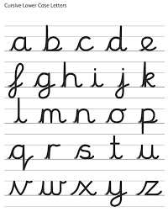

Daily
Hit the button – Times table practice

Keep reading a range of fiction and non-fiction!
Read a magazine/newspaper article.
Arithmetic (20 minutes a day) – Practise your 4 and 8 times tables – try writing flashcards and testing yourself.
PE

Visit YouTube and do a session 5 times a week of Joe Wicks/Go Noddle/Cosmic Kids Yoga.

