Home Learning- Year 2
If you are feeling well enough, please pick an activity from maths and English. Then choose one other lesson to enjoy each day. Please send some photos or bring any work you are able to complete back to school with you.
Daily
Keep reading!
Read a magazine/newspaper article.
Watch Newsround
Maths
https://classroom.thenational.academy/units/time-77d2
Power Maths- Textbook C and Workbook C
Times Tables – practise your times tables as much as you can!
Useful websites for times tables:
https://www.topmarks.co.uk/maths-games/7-11-years/times-tables
https://www.timestables.co.uk/
English
Use this picture to write a narrative including the following:
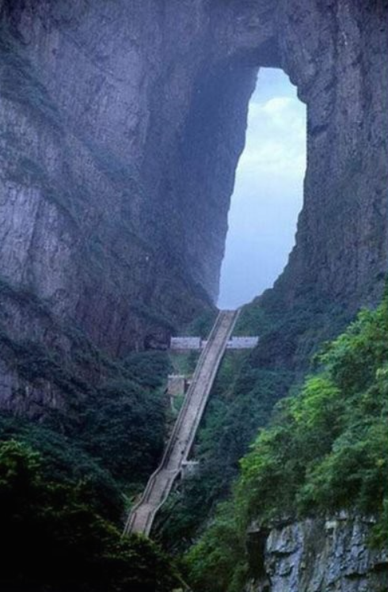
-Full stops and capital letters
-Conjunctions e.g. and, but, because, so, if, when, that, even though
-Commas in lists
-Expanded noun phrases
-Contractions e.g. I am – I’m
Challenge: inverted commas for speech
Grammar, Punctuation and Spelling:
https://www.bbc.co.uk/bitesize/topics/zkxxsbk
https://www.topmarks.co.uk/english-games/5-7-years/letters-and-sounds
https://spellingframe.co.uk/
https://sentenceplay.co.uk/games/dropping-in
Text Types/Genres:
https://classroom.thenational.academy/subjects-by-key-stage/key-stage-1/subjects/english
Phonics – Play a phonics phase 3 and 5 game on phonics play.
https://www.phonicsplay.co.uk/resources/phase/3

History
Research the history of Buckden High Street. Can you compare it to now? Can you make a model?
P.E
Do some warm ups (with an adult) to stretch your muscles and get your heart pumping.
Then, to ensure you get some exercise visit YouTube and do a session 5 times a week of Joe Wicks/Go Noddle/Cosmic Kids Yoga.
Can you make your own dance routine?
French
- Practise numbers 1-31 in French. Have a go playing these games and familiarising yourself with the spelling/reading of the words. You can play interactive games, watch videos or create posters/flashcards to help you.
https://wordwall.net/resource/3027772/french/french-numbers-1-30
https://www.bbc.co.uk/bitesize/topics/zpy8q6f/resources/1
- Revise months of the year in French
- Revise foods- can you make a menu?
https://www.youtube.com/watch?v=acvUtipaC5Y
Geography
Can you find your village/town on Google Earth? Can you identify places of employment? Why do you think more people live in cities than in villages? Can you describe the employment opportunities in Buckden?
https://earth.google.com/web/
Art
Research different artists. Can you review their work- what do you like and dislike? Can you create a piece of artwork similar to the artist you have chosen?
DT
In DT we will be making cookies. See if you and your adult can have a go at making it!
We will also be linking our science learning to make our own shoes out of suitable materials.
RE
Why does the Torah bring joy to the Jewish community?
https://kids.britannica.com/kids/article/Judaism/353327
Science
Look around your home, can you collect a range of everyday materials and sort these? What are the properties of these materials- trying using this vocabulary to write about your observations: strong, shiny, flexible, dull, twisting, bending, squashing and stretching.

