Week beg: 26.09.22
We have had another lovely week in school where the children have enjoyed learning about a range of different topics.
Seb enjoyed Science and learning about Aristotle’s theory that the earth is an approximate sphere.
Chiquera, Jack and Cole enjoyed computing and researching Mars and Venus in anticipation of writing a fact file in the next couple of weeks. They learned some very interesting facts.
Ella enjoyed reflecting on her mind apples and writing down the things that make her happy.
Aiden enjoyed art with Mrs Schmidt, they have been working towards creating a collage.
Remy has enjoyed Football and is demonstrating real control of the ball while dribbling and passing.
In English, Isla has found the changes in Bradley’s personality quite interesting to think about. Next week, we are going to write a diary entry from his perspective.
I really enjoyed sharing European Day of Languages with the class. We learned about France and even managed some French tongue twisters.
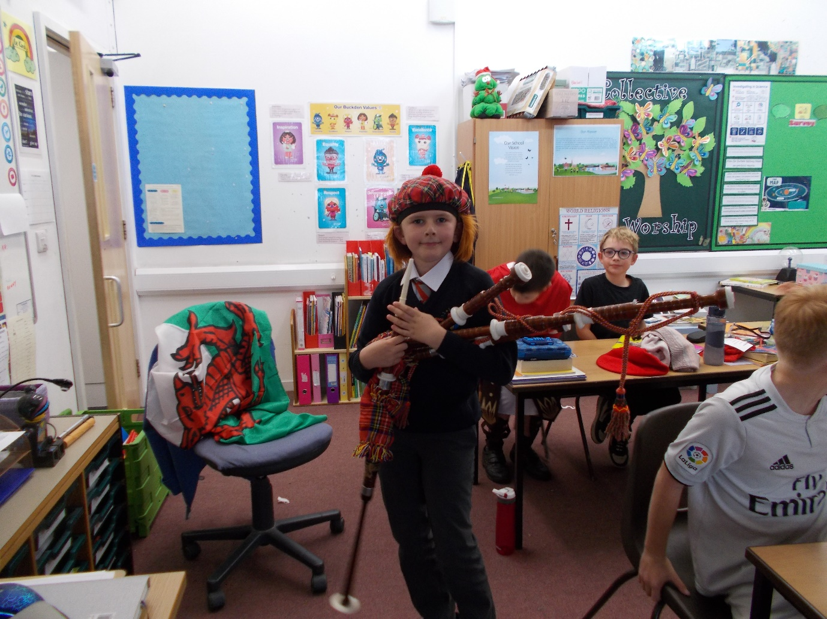

We hope you have a lovely weekend.

Bluebell class

