Science mini Knowledge Organiser

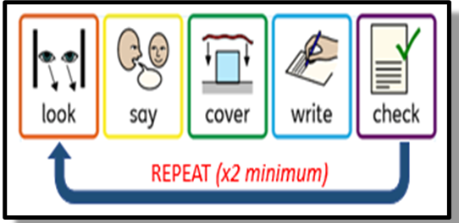
 | Term | Definition
1 | Controlled investigation | A fair test
2 | Hypothesis | Making a prediction based on science explanation
3 | Independent variable | The thing we change in an experiment to see what will happen
4 | Dependent variable | The thing we measure in an experiment to see what has happened
5 | Control variables | The things we keep the same in an experiment

English mini Knowledge Organiser

 | Term | Definition
1 | Adverb | A word to modify a verb (e.g. she ran quickly)
2 | Pronoun | A word to replace a noun (e.g. he, she, they, it)
3 | Determiner | Comes before a noun and helps define it (e.g. a boy, the tree)
4 | Simple sentence | A sentence with a subject and a verb
5 | Compound sentence | A sentence of two simple clauses linked (e.g. The dog growled and its owner frowned at it.)

Maths mini Knowledge Organiser

 | Term | Definition
1 | Integer | Whole number
2 | Inverse | An operation to undo another (e.g. addition is the inverse of subtraction)
3 | Factor | An integer that divides into another integer leaving no remainders
4 | Multiple | An integer that is in the times table of another integer
5 | Prime | A number that only has two different factors – itself and 1

PE mini Knowledge Organiser

 | Term | Definition
1 | Coordination | The ability of parts of your body to work together to move smoothly and accurately
2 | Reaction time | The time taken to respond to a stimulus
3 | Flexibility | The ability to move all joints through their complete range of movement
4 | Muscular endurance | The ability of the muscular system to work efficiently
5 | Aerobic endurance | The ability of the cardiorespiratory system to work efficiently

Geography mini Knowledge Organiser

 | Term | Definition
1 | Seven Continents | Africa, Antarctica, Asia, Australia/Oceania, Europe, North America and South America
2 | Five oceans | Arctic, Atlantic, Indian, Pacific and Southern
3 | Nations of the United Kingdom | England, Northern Ireland. Scotland and Wales
4 | Physical Geography | The study of the natural environment
5 | Human Geography | The study of how humans interact with the natural environment

History mini Knowledge Organiser

 | Term | Definition
1 | Cause | Something which makes something else happen
2 | Consequence | Something which happens because of something else
3 | Change | When something is different to how it was before
4 | Continuity | When something hasn’t changed over time
5 | Evidence | Something we can use to find out about the past

Art mini Knowledge Organiser

 | Term | Definition
1 | The formal elements | The building blocks used to create 2D art
2 | Form | Refers to 3D objects
3 | Tone | How light or dark something is
4 | Texture | How the surface looks or feels
5 | Composition | How artwork is arranged on the page

Design Technology mini Knowledge Organiser

 | Term | Definition
1 | Design specification | A list of conditions a product should meet
2 | Client | A person or business the product is sold to
3 | Function | What the product does
4 | Aesthetics | The way the product looks
5 | Manufacturing | How to make the product (by hand or machine)

Drama mini Knowledge Organiser

 | Term | Definition
1 | Still image | Freeze in a key position during a performance to mark the moment or draw attention to something.
2 | Levels | The way vertical space is used to help tell the story.
3 | Rehearsal | The preparation and development stage that leads to your final performance. In a rehearsal you have to collaborate with each other effectively.
4 | Performance | The final product of rehearsals, often performed to a group of people known as an audience.
5 | Teamwork | Working and communicating effectively together.

RPE mini Knowledge Organiser

 | Term | Definition
1 | Religion | The belief in and worship of a superhuman power
2 | Philosophy | The study of knowledge, reality and existence
3 | Theology | The study of God, religion and religious beliefs
4 | Values | The ideas about right and wrong that are important to us
5 | Discipline | A branch of knowledge / a way of learning

Music mini Knowledge Organiser

 | Term | Definition
1 | Dynamics | Volume - how loud or quiet
2 | Tempo | Speed
3 | Rhythm | The result of a combination of different note values
4 | Pitch | How high or low a sound is
5 | Structure | How it is organised into different sections

House System mini Knowledge Organiser



