Dear Year 6,
I hope you have all enjoyed another week at home. We have continued to enjoy dry weather so I hope you have managed to get out and spend some time walking or cycling with your families.
This week is the last week before our half-term break – hopefully the sun will continue to shine and we can enjoy some warmer days too.
The theme of our learning this week is: Food.
Have fun and enjoy your half-term break!
Mrs Masters x

Suggested Timetable:

45 mins | PE/Walk/Cycle Ride
45 mins | Maths Activity
10.30am | Break
45 mins | English Activity
45 mins | Online Learning Games/Activities
12.30am | Lunch
30 mins | Reading
45 mins | General Activity

Reading
It is really important that you try to read every day. There is some additional guidance for your parents to support your reading at home (attached to the blog).
Remember you can read silently to yourself, listen to audiobooks or ask your parents to read to you.
AR Quizzes
I have looked at and updated your reading targets on AR. Well done to those of you who have taken quizzes
The login for you to take AR quizzes is accessible for you from home and is:
https://ukhosted43.renlearn.co.uk/2152328/default.aspx
You will need your login and password which you should know. Email the office if you can’t remember them and I will send them out to you.

Maths Activities
The areas of Maths that you need to practise every week are listed below. You do not need to do them all every day; pick one or two per day. These will be ongoing and you can complete them in any fun ways you can. Some ideas are suggested in brackets for you to try.

Number:
- read, write, order and compare numbers up to 10 000 000

(practise reading and writing large numbers; put large values in order, e.g. house prices – which is the most expensive?)

Times Tables:
- know multiplication and division facts up to 12 x 12

(use online apps and websites such as Hit the Button and Times Tables Rockstars; have a ‘table of the week’ and put post-it notes up around the house with this table on them – constantly recite and practise them and then get an adult to test you – reward yourself with a treat if you get them all right; time yourself to write out or recite your tables – can you get faster each week?)

Measures :
- convert between different units of metric measure - kilometre and metre; centimetre and metre; centimetre and millimetre; gram and kilogram; litre and millilitre
- convert between miles and kilometres
(a great excuse for lots of cooking and baking – convert the values given in recipes; plan a day trip out for when lockdown is over – how far will you travel in miles/km?)

Money:
- estimate costs, add and calculate change in £ and p
- when shopping, calculate 10%, 20%, 25% and 50% off amounts

(use an online grocery website to plan a week of family shopping – can you stick to a budget? Can you use estimation to predict what your final bill will be? How much of your budget would be left over?; Plan a family holiday – where would you like to go? Plan a budget for travel, accommodation & food. Add up the total cost of your holiday.)

Time:
- tell the time using analogue, digital, 12 and 24 hour clocks.
- read and interpret a variety of timetables including, bus, train and TV guides

(practise telling the time, all the time! – work out how long it will be until TV time/bedtime; plan a train journey from St Neots – use online timetables to work out the times of your trains, where you would need to change trains and how long you would have to wait at each station?; plan a family 12-hour telethon using the TV planner – what could you watch and when?)

Task 1:
Plan a three course meal to cook for your family. Make a list of all the ingredients and the quantities of each ingredient you will need. Use an online shopping website to work out how much each of your ingredients will cost. How much will your meal cost in total? Can you make a three course meal for your family with a budget of £20? How much change will you have left over?
Some of your parents might then let you make and serve your meal to your family

Task 2:
Choose eight items of packaged food from your kitchen cupboards. Look carefully at the food labels. Do you understand what the information on the food labels means?
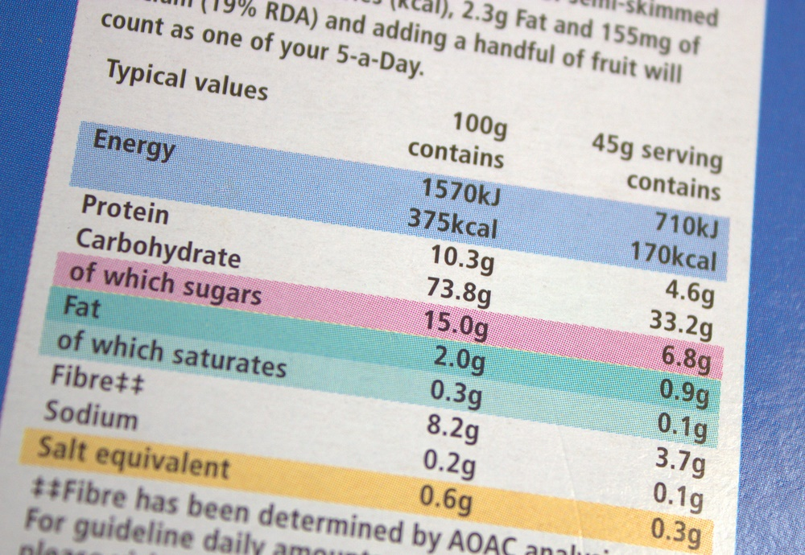
For example, this food contains 1570KJ of energy per 100g of food.
Find out how much energy is in each of your foods per 100g. Can you draw a graph to show how much energy is in each of your foods?
What about the amount of fat? Or sugar? How could you compare your foods and decide which food is the healthiest option?

Task 3:
Another Arithmetic paper attached to the blog – feedback is that you are all enjoying doing these

English Activities
Task 1:
Continue with your daily journal to capture what you are doing during these unprecedented times.
In your daily journal, you could write:
- How you are feeling.
- What you have done at home - this might be any of the work you have done from the blog or anything else that you have done with your family.
- What you have enjoyed about each day.
You might want to include photographs and drawings to decorate your writing.

Task 2:
Design a menu for your three course meal (from the Maths tasks). How could you present your menu? Think about how you could use text and pictures to present your menu in an attractive way.

Task 3:
Write a set of instructions explaining how you would make one of the dishes on your menu. Or write a set of instructions to explain how you would cook or bake your favourite food. Remember to include a list of ingredients and a step-by-step method. You could use diagrams to support your instructions.

Task 4:
Write a story about your life as a food. Choose carefully. Imagine you are the food yourself. Think about where you originally come from. Or how are you made? Where and when are you eaten? What happens to you then?
For example, you might be a cheese sandwich. You are made in a factory – you could describe how the bread and cheese meet and how they feel when they are pushed together into the sandwich box. How would they feel as they are transported onto the shelf in the shop, and when someone puts them into their trolley? Let your imaginations run wild and be as creative (and crazy) as you like!

Task 5:
Many people are reliant on our local foodbanks, especially at the moment. However, many foodbanks are finding that the number of donations have decreased during the lockdown.
Write a persuasive leaflet to convince people to donate to foodbanks. Explain what foodbanks do and why it is so important. Some of you were able to visit our local foodbank earlier in the year so you could use information from your visit as well.
https://godmanchester.foodbank.org.uk/

Online Learning Games/Activities
Times Tables
https://ttrockstars.com/
https://www.timestables.co.uk/
Power Maths
https://www.activelearnprimary.co.uk/login?c=0
All the activities for Year 6 are now unlocked and available.
Remember the password is: year6 and the school code is: kmm7

French (you can also use this to practise spellings and vocabulary in English)
https://www.linguascope.com/
Username - buckden Password – starfish

ICT
Have a go at learning a bit of touch-typing!
https://www.bbc.co.uk/bitesize/topics/zf2f9j6/articles/z3c6tfr

Coding
https://www.rodocodo.com/
All the activities are now unlocked and available. Remember the password is Radcliffe.
You might also want to look at:
https://scratch.mit.edu/
General Activities

Science:
Task 1:
Earlier this year, we learnt about the heart and our blood. Blood carries oxygen and carbon dioxide but it also carries food.
Find out how our food is absorbed into our blood from our digestive system. In which part of the digestive system does absorption occur? Can you find out what villi are? Where does the food go once it enters the blood? How is it carried in our blood? What is the food used for?
You might like to produce a presentation of your research – maybe a poster or a Powerpoint.

Task 2:
Have a go at growing your own food. You might have some seeds already but if not, you could try and grow seeds from peppers or tomatoes. You can also plant apple seeds, plum seeds or lemon seeds. Have a go at planting other seeds from fruits – do any of them grow?
You may want to record what you have planted and when. It is best to plant the seeds in a small pot rather than directly into the garden.
Here are a couple of websites that might help you to get started:
https://www.bbcgoodfood.com/howto/guide/easy-crops-kids-grow
http://kidsinthegarden.co.uk/plants-for-kids/growing-vegetables-with-children/

Geography:
Task 1:
Where does our food come from? Explore the idea of food miles. Have a go at the ‘Food Miles’ activity attached to the blog.
How can we help to reduce our food miles? Why is this important for the environment?

Task 2:
Many countries have a National Dish – for example, in Spain this is paella. Can you find out which countries have the following National Dishes?
- Goulash
- Bobotie
- Haggis
- Fondue
- Doner kebab
- Bacon and egg pie
- Ackee and saltfish
- Sushi
- Moussaka
- Amok trey
- Cawl
- Pastizz
See if you can locate the countries in an atlas or on a map. You may even want to label a map of the world with your National Dishes.
Can you find out about any other National Dishes eaten around the world?

Art/DT:
Task 1:
Design your ultimate birthday cake. What would you want it to look like? What colours, shapes and flavours would you use?
Draw a picture of your cake and add labels to explain the ingredients and decorations that you would use.
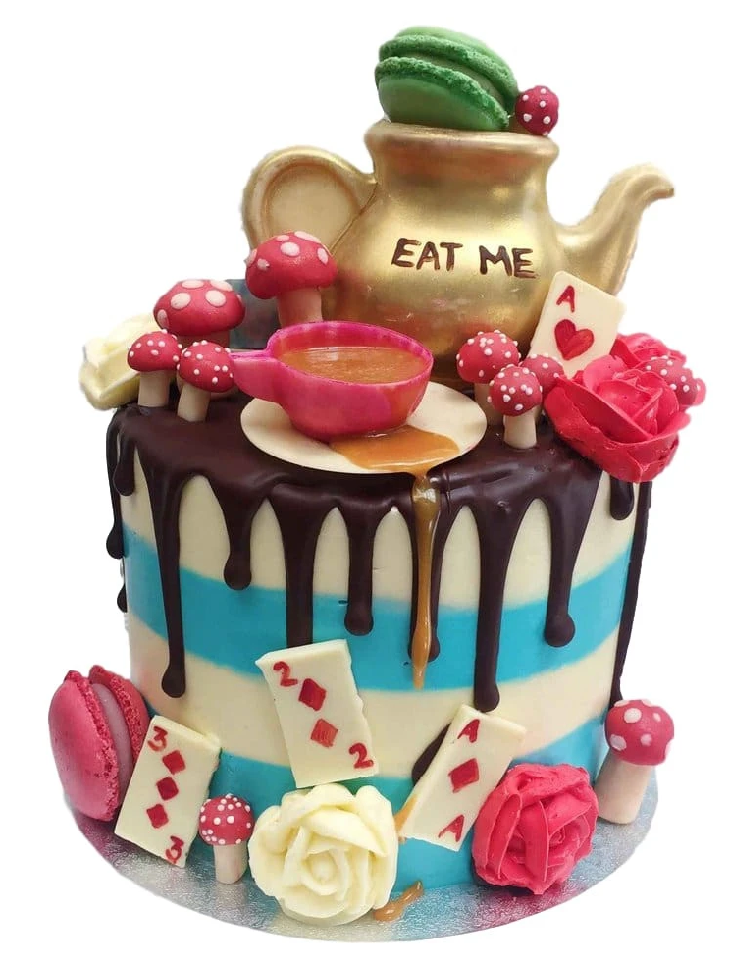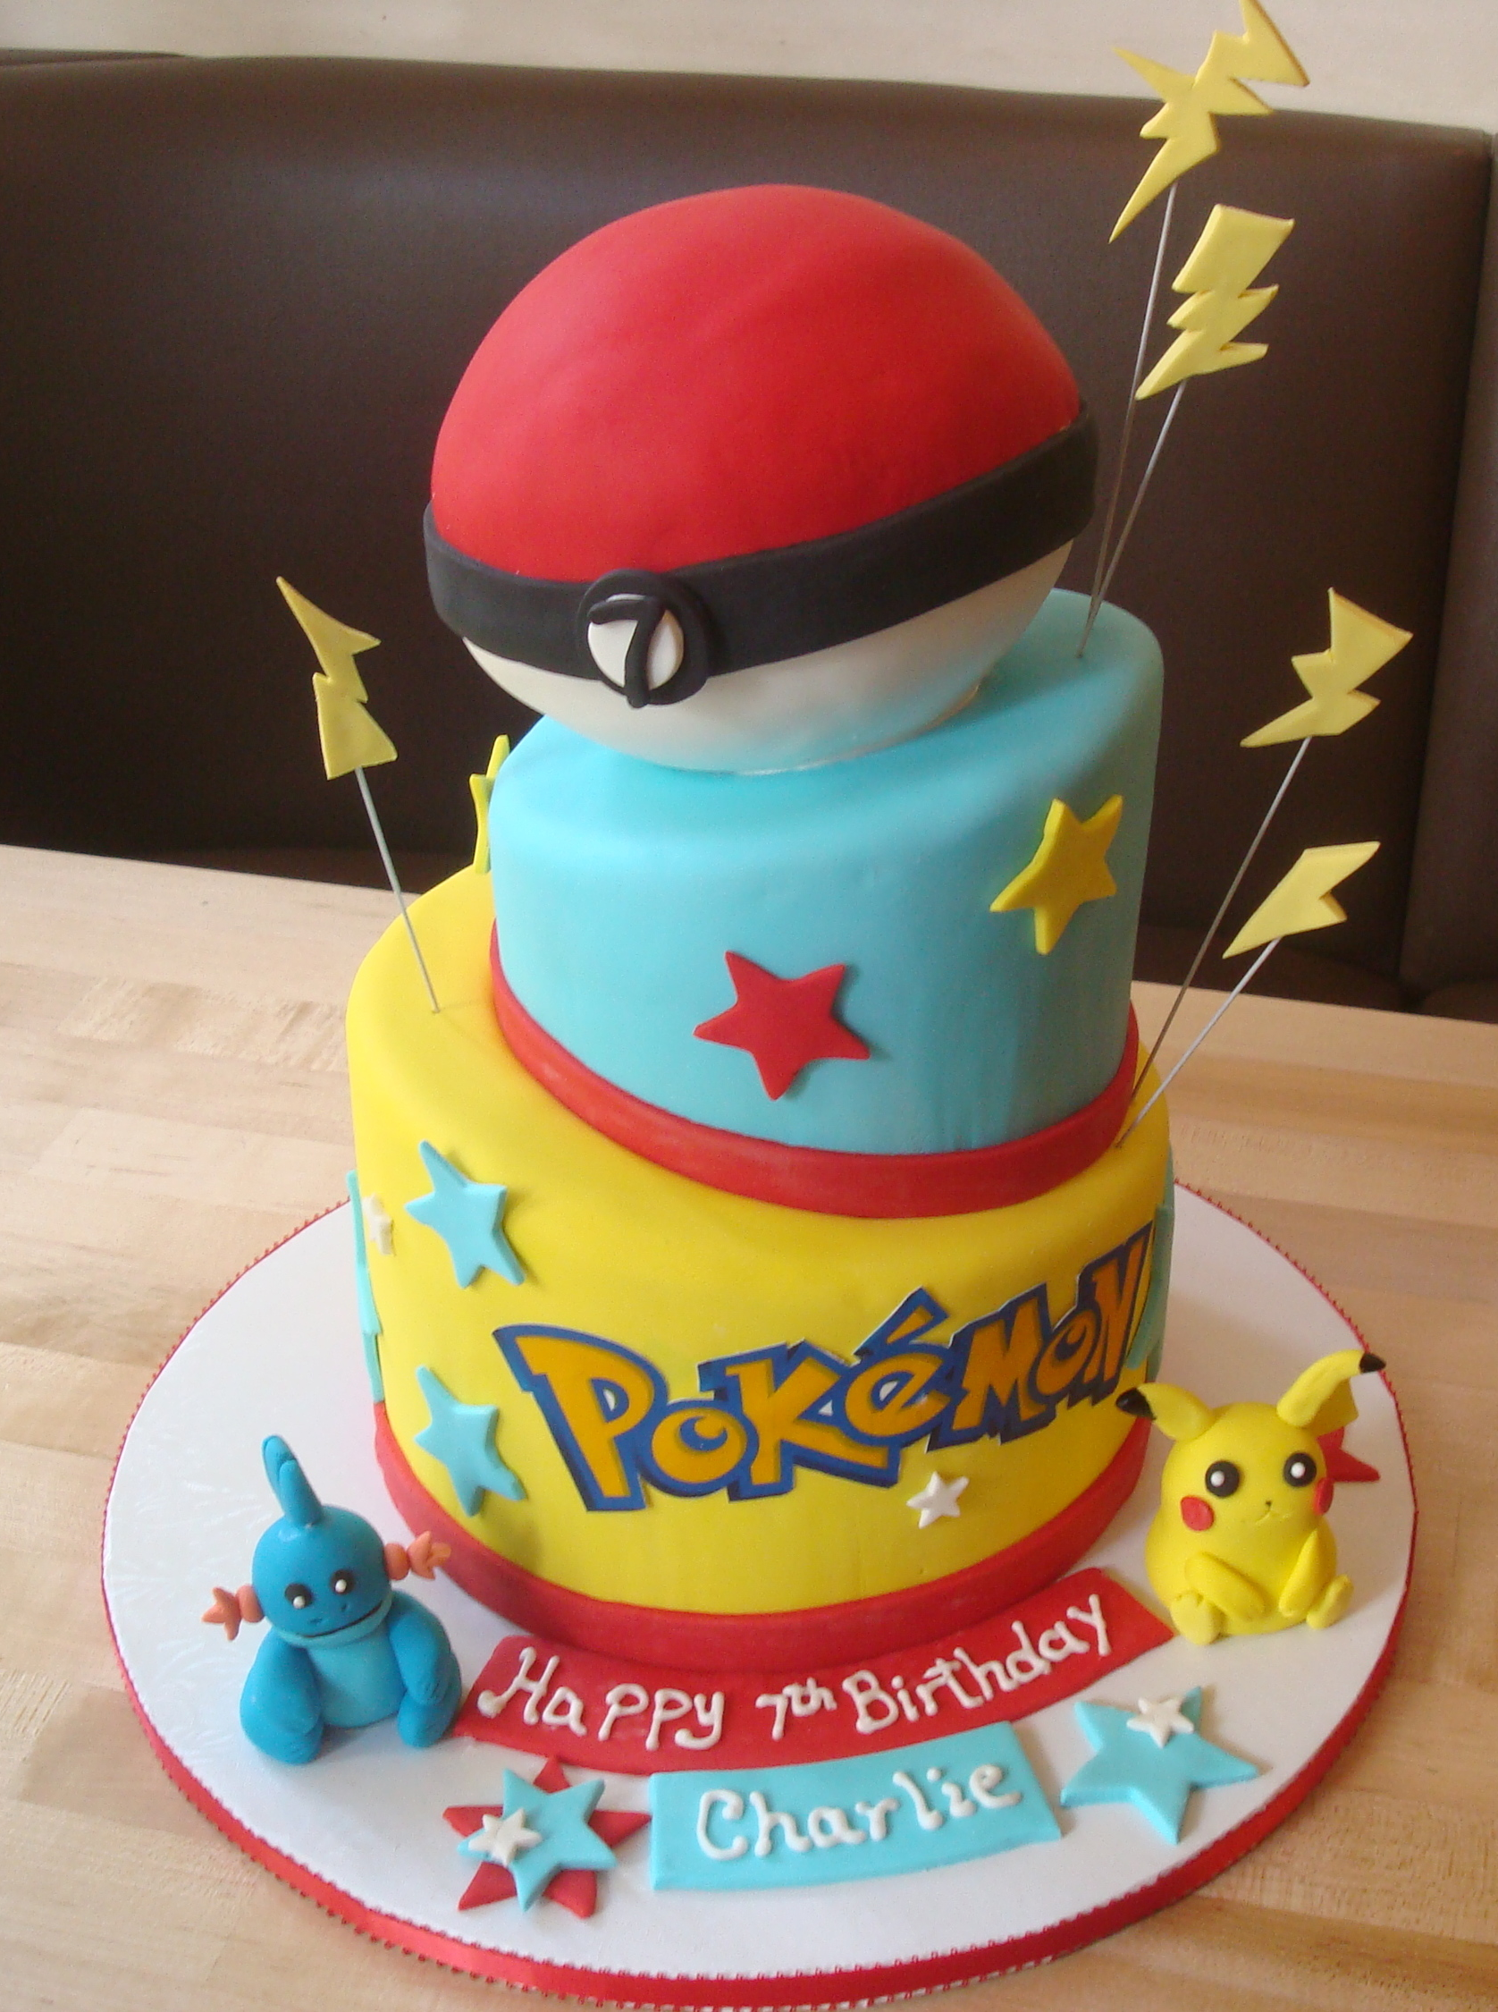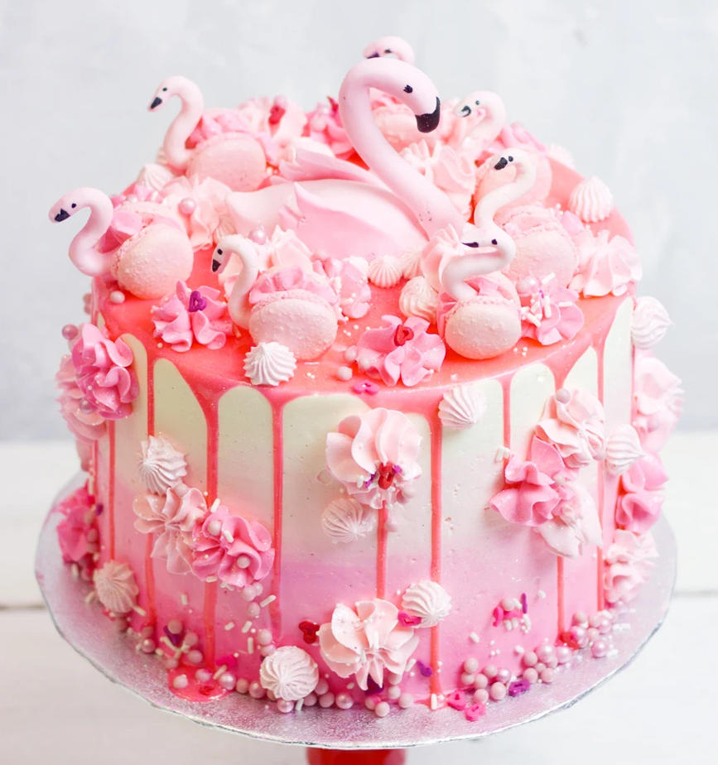

Task 2:
Throughout history, paintings of food have been created as ‘still-life’ works. Have a go at creating your own piece of artwork using food as your subject. You might just choose one item of food or you might want to arrange a few.
Here are a few ideas to get you started:
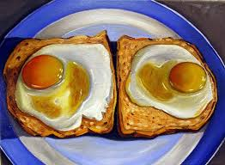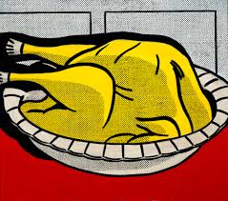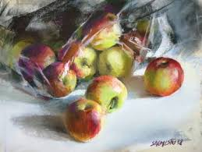

Music:
How many song titles can you think of that have an item of food in the title?
e.g. Strawberry Fields Forever by The Beatles

