Friday 6th March
We hope you have enjoyed doing the Skills Builder Sessions and I hope you will consider how you will bring the skills you have learnt back into the classroom.
The skills challenges are same across the school, so that for families with more than one child in school, there is the opportunity to do the challenge together.
If appropriate upload a photograph for your teacher to see and answer the reflection questions at the level you feel you are, this will change for different skills.
Plan an indoor picnic. Work with members of your household to decide when and where you will have the picnic, what food you will need to prepare and what you will sit on. Make sure everyone has a job.
Reflection Questions
Beginner: When do you find it easier or more difficult to work with others in a positive way?
Intermediate: How have you contributed to the group decision making?
Advanced: What does it mean to support other people?
Expert: How can you ensure that you think about others’ ideas and recognise the value in them?
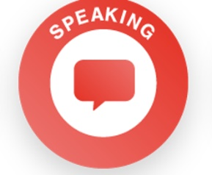 | Imagine you are the prime minister and are going to deliver a speech at a press conference about schools reopening.  What would you say? Think carefully about making your points in a logical order and being clear so your audience will understand your message.  Extension: Challenge your family to do the same - would you all say something similar?  Reflection Questions  Beginner: How do we know if we are speaking clearly?  Intermediate: What is meant by your expression? How does expression affect the meaning of what someone is saying?  Advanced: How can you use tone, expression and gesture to make your speaking engaging?  Expert: How can you adapt the content of what you are saying, in response to listeners?
Organise a family quiz.
Choose a theme you know your family will enjoy. Make sure everyone has a job as you prepare for the quiz. You may need someone to set the questions, to ask the questions, to keep scores and to organise snacks. You could invite other friends and family to join in too over the internet.
Extension: Think about everyone's strengths - what job would they be best at? Manage any disagreements carefully.
Reflection Questions
Beginner: What are different emotions? When have you felt these today?
Intermediate: How can you identify strengths and weaknesses in others?
Advanced: Why is it important for a leader to be able to manage time and resources?
Expert: What are good leaders able to do?

