This week’s learning 13.12.21
Monday
Maths – Subtraction through finding the difference.
Watch the video https://vimeo.com/470964093
Complete the sheet ‘Monday Maths Practical Sheet’ to find the difference between the red and the blue counters. You can use toys or objects at home to help you line up the amounts to spot the difference!
English – Writing a Christmas Letter to Santa.
It’s time to put everything we have learned about letter writing into practise!
Write a letter to Santa telling him how good you have been and write a list of things that you would like for Christmas. You can use the letter writing template attached ‘Monday Letter to Santa Template’. Don’t forget to write his address at the top of the letter which is:
Santa’s Grotto
The North Pole
Lapland
Write who the letter is to, why you are writing and to sign off at the end of your letter.
Use your phonics to help you sound out and write the items on your list, and don’t forget to include your capital letters, finger spaces and full stops at the end of your sentences!
RE
Re-watch the Nativity Story https://www.youtube.com/watch?v=FrTFAZPQxpE.
See attached sheet ‘Monday RE Nativity Ordering Sheet’. Put the Nativity story in order. There are two sheets, one where you can cut and order the pictures and writing, the second sheet is a bit more of a challenge – match the picture with the sentences and then put them in the order of the story. You can of course colour the pictures too! 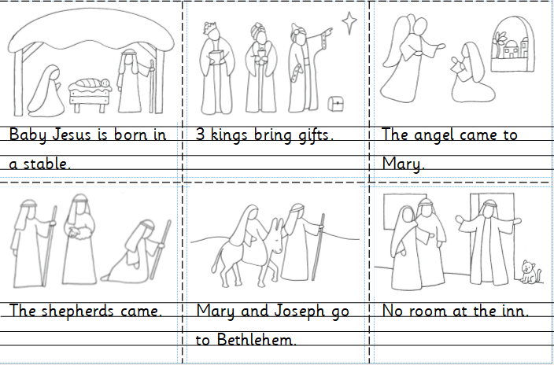
Tuesday
Maths – Subtraction through finding the difference.
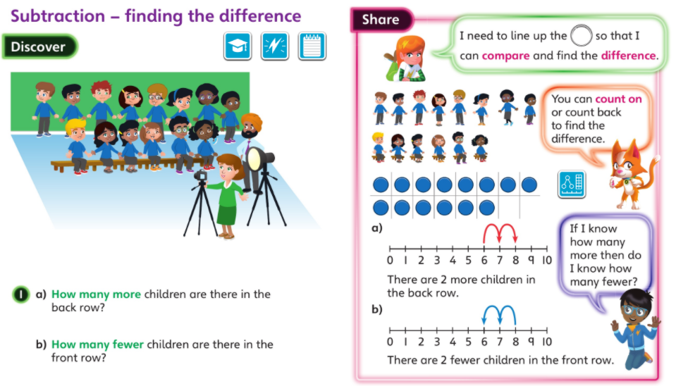
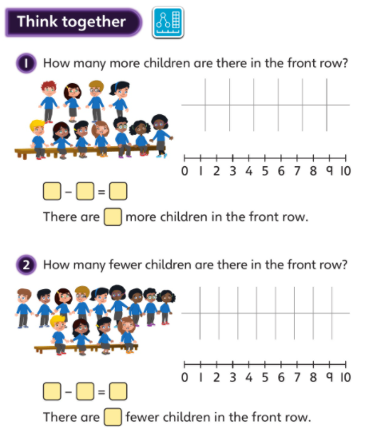
Complete the sheet attached ‘Tuesday Maths Independent’ by circling the difference, writing the subtraction number sentence and by counting forward/backwards on a number line to show the difference.
English – Writing to describe.
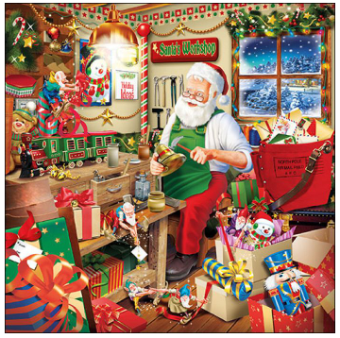
Look at the picture above. What can you see? What toys are there? Write some sentences to describe what you can see. Use some different describing words to talk about the colours, sizes, shapes of the objects in the picture.
Think about different ways to start your sentences, such as:
I can see…
There are…
There is a…
On the table is…
Use your phonics to sound out your words, and don’t forget capital letters, finger spaces and full stops at the end of your sentence. Re-read your sentences to check that they make sense – can you read them aloud to an adult?
Global Learning – Practise singing your Christmas Carols and signing them using Makaton. Follow the links below to the songs:
https://youtu.be/a-PBixyD_GU https://youtu.be/VhA5NRacmLc
We Wish You a Merry Christmas Little Donkey
If you are feeling brave, maybe your adult could perform you singing them and email your performance to year1@buckdenacademy.org.
Wednesday
Maths – Follow the link to a video lesson from The Oak National Academy on linking subtraction to problem solving contexts.
https://classroom.thenational.academy/lessons/linking-subtraction-equations-to-problem-solving-contexts-cdjkgc?activity=video&step=2&view=1
Now follow this link to put what you have learned into practise by answering some questions.
https://classroom.thenational.academy/lessons/linking-subtraction-equations-to-problem-solving-contexts-cdjkgc?step=4&activity=exit_quiz
English – Designing a Christmas Hat!
We would like you to design your very own Christmas hat! Your hat can be made out of paper, with Christmas pictures on and coloured in with felt tip pens/pencils, or your hat could be made out of some recycled materials that you have at home (old fabrics, egg boxes, plastic parts, buttons/beads/gems/glitter, or anything that you can find!).
Before you make it we would like you to draw a picture of your design and write some labels to tell us what you materials you will be using to make it with, how it will be made (glue/staples?) and write any words to describe your hat.
Please see Miss Freeman’s example below to help you if you are stuck!
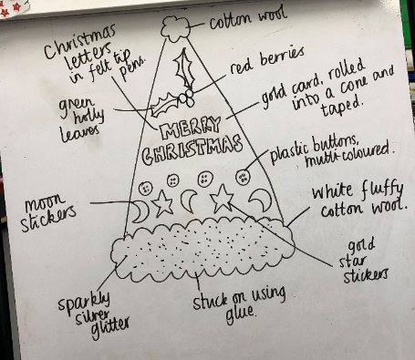
Art/DT
Now it is time for you to make your Christmas hat! Gather all of your resources and materials together, look carefully at your design and get creative! Please take pictures of you wearing your creation when it is dry and ready to wear!
Thursday
Maths – Today we are focusing on solving word problems using cubes/objects using a chosen method.
Here is an example question:
Miss Freeman has 8 cubes. She gives away 4. How many does she have left?
Firstly, what would the number sentence be? 8 – 4 =
Then, choose a method to solve the number sentence.
You may choose to:
Use objects to represent the cubes and take them away physically
Draw the cubes and cross out the number we are taking away
Use a number line to start on the whole and count back the number we are taking away
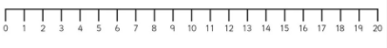
Please see the attached files ‘Thursday Maths Cube Problems’ which vary in difficulty to have a go at solving. Don’t forget to write the number sentence and the answer!

English – Instruction writing.
Think back to yesterday when you made your Christmas hat! How did you make it? What did you do first? What did you do next? What about after that?
Write a set of instructions to tell us how you made your Christmas hat. Use the template attached to help you – don’t forget to use your bossy verbs to tell us how you made it i.e. stick, cut, roll, etc.
French – Watch the video https://www.youtube.com/watch?v=lsc3qLMaCu8 about counting from 1-10 in French.
Practise counting in French out loud. Can you tell your adults how to count from 1-10 in French? Can you say your age in French?
Friday
Maths – Practise your maths skills by playing some games on your Abacus account. There are lots to choose from! https://www.activelearnprimary.co.uk/login?c=0 (Log ins are in the children’s reading diaries and the school code is kmm7).
English – (SPAG) Practice your handwriting using the year 1 common exception words. Don’t forget to use your cursive letter formation!
PE – Perform the transport dance that we have been learning about in our Dance lesson. Follow the link to see the dance: https://www.youtube.com/watch?v=fGEyttZb5Qk
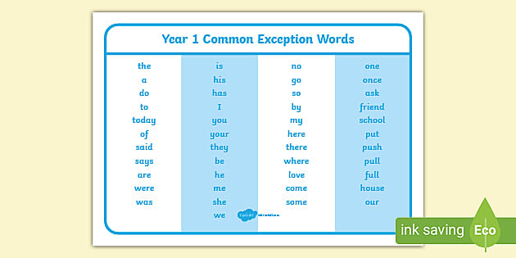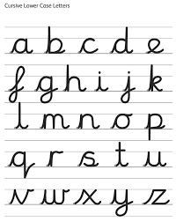
Daily
Abacus - https://www.activelearnprimary.co.uk/login?c=0 (Log ins are in the children’s reading diaries and the school code is kmm7).
Daily reading! Please record this in your child’s reading record.
Arithmetic (20 minutes a day) – Count in 1s to 20 forwards and backwards. Count in 10s to 100 forwards and backwards. Count in 2s to 20 – practise counting in these jumps lots as they can be tricky!
Phonics – Revise all phase 2, 3 and 5 sounds so far.
Can they read each sound? Can they write each sound when you say them out loud?
s a t p i n m d g o c k ck f
h b l r u e ff ll ss

j v w x y z zz ch sh th qu ng ai ee
igh oa oo ow oi ar or ur air ear ure er

ou ay ea i-e ir ew ue

Play some phonics games including some of these sounds.
https://www.phonicsplay.co.uk/resources/phase/2/picnic-on-pluto

PE
Visit Youtube and do a session 5 times a week of Joe Wicks/Go Noodle/Cosmic Kids Yoga.

Handing in Home Learning

PLEASE SEND EVIDENCE OF YOUR HOME LEARNING TO THE YEAR 1 EMAIL ADDRESS year1@buckdenacademy.org
You may also choose to send your child into school with their home learning when they come back.
All home learning will be marked/responded to by a member of the Year 1 team.

Thank you for your hard work at this very tricky time!
Year 1 Team

