This week’s learning 13.09.21

Monday
Maths – Oak Academy - follow the links and complete the activities.
https://classroom.thenational.academy/lessons/counting-sets-within-10-c4w30t

English – Draw a picture of what you think the alien looks like from the spaceship that crash landed in school.
RE – Watch the creation story and draw a picture of your favourite part.
https://www.youtube.com/watch?v=teu7BCZTgDs
Tuesday
Maths – Oak Academy - follow the links and complete the activities.
https://classroom.thenational.academy/lessons/representing-numbers-within-10-71jkec

English – Look at the picture and talk about what has happened.
Global Learning – look through ‘Schools in the past’ Powerpoint and talk to a grown up about the things you use now and the things from the Victorian times. Look at the attached sorting activity and choose two things to draw from the past and the present.

Wednesday
Maths – Oak Academy - follow the links and complete the activities.
https://classroom.thenational.academy/lessons/recognising-number-bonds-to-five-and-six-cmw3jt

English –

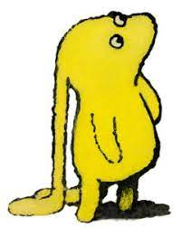
Draw a picture of Beegu and write in a thought bubble how she might be feeling.

French – Practice saying hello and goodbye in French.
https://www.youtube.com/watch?v=NXkJ88ygPY0
Thursday
Maths – Oak Academy - follow the links and complete the activities.
https://classroom.thenational.academy/lessons/recognising-number-bonds-to-seven-and-eight-60r6cc

English – (Comprehension) Oak Academy - follow the links and complete the activities.
https://classroom.thenational.academy/lessons/to-listen-and-respond-to-a-story-6cr66e

PSHE – Get a mirror and create as many different faces as you can to represent different emotions and write them down.

Friday
Maths – Oak Academy - follow the links and complete the activities.
https://classroom.thenational.academy/lessons/recognising-number-bonds-to-nine-and-ten-c8v3ec

English – (SPAG) Practice your handwriting using the year 1 common exception words.
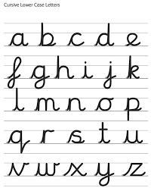
Science – Sing head, shoulders knees and toes. Finds different objects around your house to measure and compare the length of your body parts.

Daily
Abacus - https://www.activelearnprimary.co.uk/login?c=0 (Log ins are in the children’s reading diaries and the school code is kmm7).
Keep reading!
Read a magazine/newspaper article.
Arithmetic (20 minutes a day) – Count to 100 aloud whist doing body percussion.
Phonics – Play a phonics phase 2 and 3 game on phonics play.
https://www.phonicsplay.co.uk/resources/phase/2/picnic-on-pluto

PE

Visit youtube and do a session 5 times a week of Joe Wicks/Go Noddle/Cosmic Kids Yoga.

