Good Morning,

Today is as follows:

English- In our English today we are reading from page 29 to 39 of our story Claude in the City. We will be discussing what Claude has seen and done in the gallery. We will be thinking about special places that we like to visit, asking questions such as, what can you do there?, are there any rules? What do you need to know? Why do you enjoy going? The independent activity is to complete a mind map for a special place that you like to visit. There is a template if needed in the files section and attached to the assignment.

Maths- In maths today we will be subtracting by crossing over the 10. We will be thinking about how we can split numbers in order to make subtracting a little easier through making the number smaller and using what we know about numbers. Some children may find this tricky but just try your best, we will do this again later in the year.

Example:
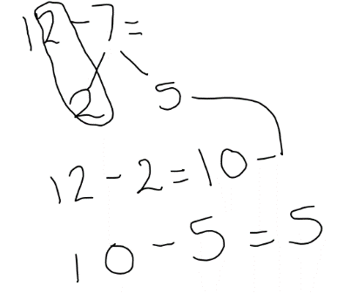
12-7=
First we will look at the ones part of the whole number 12. There are 2 ones.
The using our part whole model we can have 7 as a whole one part is 2 the
other is then 5.
12-2= 10 we have now reduced our number so we can cross the 10
We then have to take away the second part of 7 that we haven’t used yet which is 5
10-5=5
Therefore 12-7=5
We are trying to use our knowledge of numbers to break them down and make subtraction a little easier.
Independent task is to use the activity cards in the file section and demonstrate how you have crossed the 10 by showing this on a number line, tens frame or part whole model. Please remember to only complete 20 minutes of independent work.

Phonics- Todays phonics is le in bubble

https://lettersandsounds.org.uk/for-home/year-1
Please find todays date video link

Please then complete one activity from the challenge sheet in the file section.

RE- This half term in RE we will be exploring Hinduism. In our session today we will be continuing with our book ‘This is my faith’ (power point in the file section). We will be reading pages 10 to 13 and thinking about the God Ganesh (power point in files). Our independent activity will be to create our own sketch of Ganesh- please do this in topic books as you will need your sketch the following week.

Class Assembly:
Stuck on the ark- we will be reading the story which will be found in the files section.
Some points to ask the children may be:
I wonder which part of the story you like best?
I wonder what Naamah found hard about being on the ark?
I wonder what Naamah enjoyed about being on the ark?
I wonder what it might feel like to see a rainbow?

Prayer:
Dear God, Please help us to manage when there are difficult times. May we always find signs of hope. Amen

