This week’s learning 13.12.21
Please return any work that you complete back to school.
Monday
Maths – https://classroom.thenational.academy/lessons/recognising-decimal-tenths-part-1-ctgkcd
English - https://classroom.thenational.academy/lessons/to-introduce-the-text-and-author-6ww32e
RE – Create a comic strip or booklet retelling the Nativity, you can use your creative skills here to create a really beautiful version of the story.
Tuesday
Maths – https://classroom.thenational.academy/lessons/comparing-decimals-61j38d
English – https://classroom.thenational.academy/lessons/to-infer-from-images-and-make-comparisons-70tp4d
Global Learning: History – Watch this short video about the Christmas Truce of 1914 https://www.youtube.com/watch?v=NWF2JBb1bvM
Research about the Christmas Truce, what happened on this day? Create an information page about it, aim high to include everything that you’d expect to see on an information page, and think creatively about how you can organise it to interest the reader.
Wednesday
Maths – https://classroom.thenational.academy/lessons/rounding-decimals-part-1-crvk6c
English – https://classroom.thenational.academy/lessons/to-use-images-to-make-comparisons-and-predictions-75gp6c
Art – Using items you can find at home (and are allowed to use) create a Christmas decoration that can be hung on your Christmas tree, here are some pictures that might inspire you in what you make:
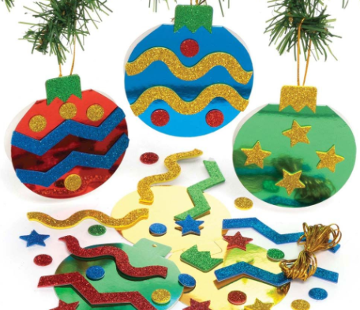
Thursday
Maths – https://classroom.thenational.academy/lessons/decimal-number-bonds-c8vk4t
English – https://classroom.thenational.academy/lessons/to-use-images-to-make-comparisons-and-links-between-the-two-stories-6gu3et
Global Learning – WW1 ended 6 weeks before Christmas 1918. Research how they celebrated, was Christmas extra special this year?

Friday
Maths – https://classroom.thenational.academy/lessons/recognising-decimal-hundredths-part-1-c4v3ed
English – https://classroom.thenational.academy/lessons/to-identify-the-themes-and-messages-of-the-story-75h3cc
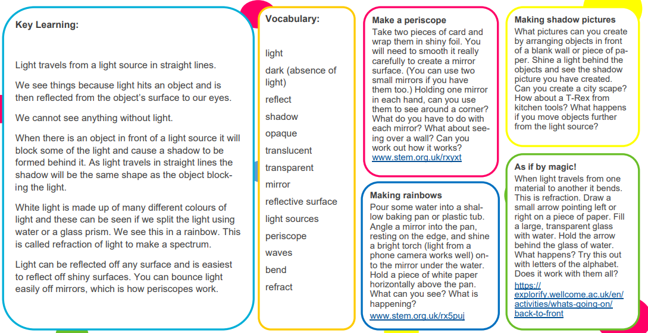
Science – Light. Read the Key learning and chose an activity to complete.

Daily
Log into SATs Companion and do any practise session.
TT Rockstars: https://ttrockstars.com/
Keep reading – at least 20 minutes every day. As well as your reading books try to look at a newspaper/magazine article, recipe or non-fiction book.

PE
Visit YouTube and do a session of Joe Wicks.

French
Use Linguascope to learn the names for different family members in French.

