Create a weekly exercise programme for somebody of your age.
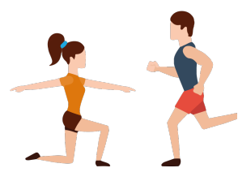

Create a weekly exercise programme for somebody of your age.

Create a weekly exercise programme for somebody of your age.

Create a weekly exercise programme for somebody of your age.

