Home Learning- Year 2
If you are feeling well enough, please pick an activity from maths and English. Then choose one other lesson to enjoy each day. Please send some photos or bring any work you are able to complete back to school with you.

Maths
Monday
Log in to PowerMaths Active Learn (Log in details are in your Reading journal) https://www.activelearnprimary.com.au/login?e=-1&c=0
Click on Resources>powermaths on the green banner, click on year 2 and under TYPE choose Textbook 2B for explanations and Workbook 2B for questions.
PowerMaths Making Equal Groups Textbook 2A Unit 6 lesson 1 p8-11, Workbook 2B Unit 6 lesson 1 p6-8

Tuesday
PowerMaths Dividing by 2 Textbook 2A Unit 6 lesson 3 p16-19, Workbook 2B Unit 6 lesson 3 p. 12-19

Thursday
PowerMaths Dividing by 5 Textbook 2A Unit 6 lesson 5 p24-27, Workbook 2B Unit 6 lesson 5 p. 18-20

Friday
PowerMaths Dividing by 10 Textbook 2A Unit 6 lesson 6 p28-31, Workbook 2B Unit 6 lesson 1 p. 21-23.

English
Monday
Think back to when the Beast went on the news and the radio. Make notes on the following.
Why did he think it would help him to be interviewed? What do you think he talked about to the reporters? What questions did the reporters ask him? What would you like to ask the Beast if you were to interview him?
Hot seat- act out this scene or ask a family member to play the Beast/reporter. Use your notes to ask and answer questions. Write a script to show the conversation between the beast and the reporter.

Tuesday
Have a look at the front of a newspaper- this can be paper copies or online. What features do you notice? Label or make notes on these. https://www.bbc.co.uk/bitesize/topics/z2yycdm/articles/z2gk9qt Newspapers have headlines- these are catchy titles to get the reader interested. Can you think of a catchy headline to help the Beast find Beast friends?
Next week we will be writing our own newspaper article to help the Beast find friends. Now consider what is needed in our opening paragraph- who, what, why, when, where?

Thursday
Newspaper- what is its purpose?
Can you highlight all the features of a newspaper? Newspaper name, headline, introduction (who, what, why, when, where), picture, quotes, caption.
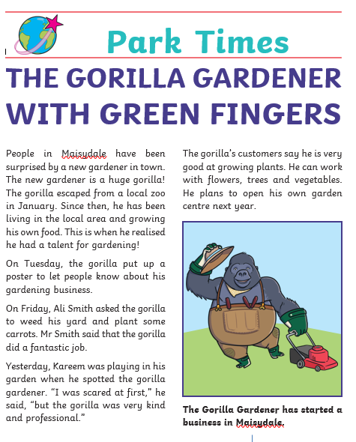
Friday
Conjunctions: https://www.bbc.co.uk/bitesize/articles/z6rvbdm
Watch the video and complete the activities.
Can you write your own sentences using conjunctions?
‘because’, ‘but’, ‘so’ or ‘as’.

Grammar, Punctuation and Spelling:
https://www.bbc.co.uk/bitesize/topics/zkxxsbk
https://www.topmarks.co.uk/english-games/5-7-years/letters-and-sounds
https://spellingframe.co.uk/
https://sentenceplay.co.uk/games/dropping-in
Text Types/Genres:
https://classroom.thenational.academy/subjects-by-key-stage/key-stage-1/subjects/english
OR
Practise writing sentences: use correct punctuation and extend them using ‘because’, ‘but’, ‘so’ or ‘as’.
Wednesday Global Learning day- Music
Predict what you think these words mean and then research them to see if you are correct: pitch, beat and rhythm.
Understanding and practising recognition of pitch: https://www.bbc.co.uk/teach/bring-the-noise/understanding-pitch/z4hw47h
How many percussion instruments can you name? https://www.youtube.com/watch?v=0vrK1POQPiE
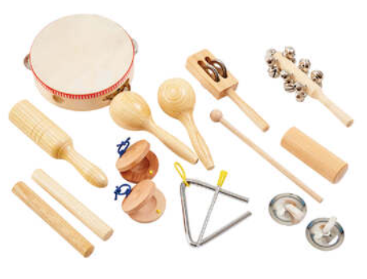
Can you use some objects in your house or percussion instruments to create your own rhythm?
Pick a musical activity of your choice. https://www.bbc.co.uk/teach/bring-the-noise/half-term-music-activities/zmmpxyc/

Tuesday P.E
We will be learning to dance.
Do some warm ups (with an adult) to stretch your muscles and get your heart pumping.
Use this website to watch the dancers, dance to 3 pieces of classical music based on water (remember we watched this last week).
https://www.bbc.co.uk/teach/class-clips-video/physical-education--music-ks1-water/zbm2t39
Try to walk in time to the music just like we did last week.
Can you create a routine combining everything we have learnt so far. Think about different sea creatures, speeds and movement through water.
Cool down by lying flat on the floor for 2 minutes. Close your eyes and sink into the floor.

Thursday- Science
Continuing our learning of food chains, choose a habitat of your choice. Research and create a food chain within this habitat. You could create a model, use playdough or create a poster. Can you remember the meanings of these words and identify these in your food chain?
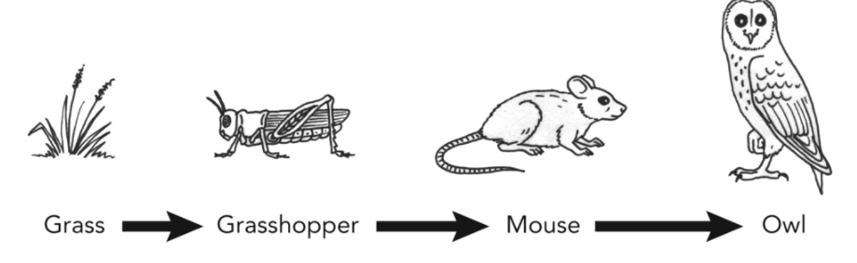
Producer
Consumer
Predator
Prey
Energy

Friday - RE
This half term we will be learning about Islam. Last week in school we explored the importance of compassion. Muslims say the prophet Muhammad was a messenger from God. He taught about the one God. He delivered Allah’s messages. His life was a bit like a message too. Muslims listen to stories of his life to help them follow Allah’s straight path What is a messenger?
Read this story. Answer these questions.

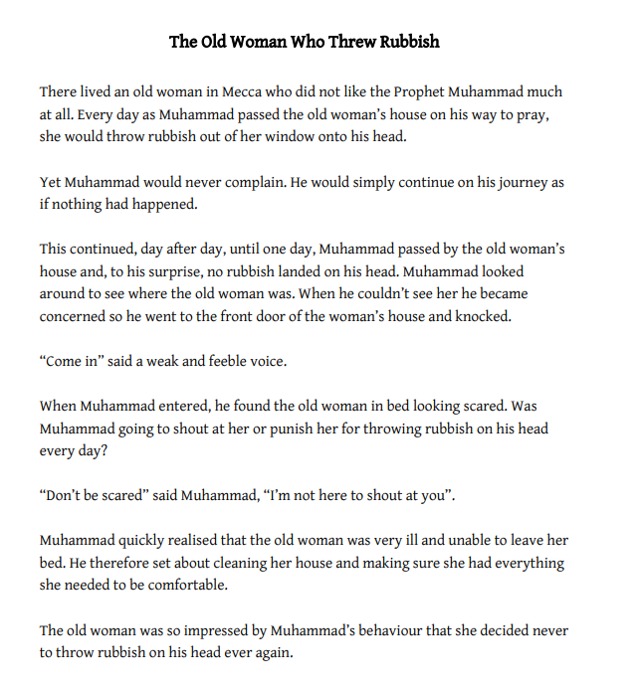

Why might the woman in the story have disliked Muhammad?
Did Muhammad have the right to retaliate and should he have done so?
Why did Muhammad decide to knock on the woman’s door?
Why was the woman so impressed by Muhammad’s actions?
How important are Muhammad’s deeds and actions to Muslims across the world?

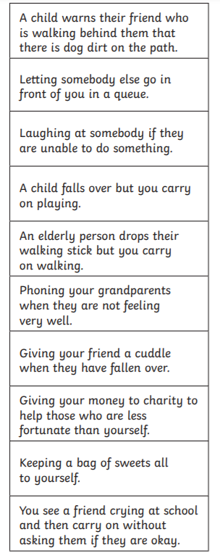
PSHCE:
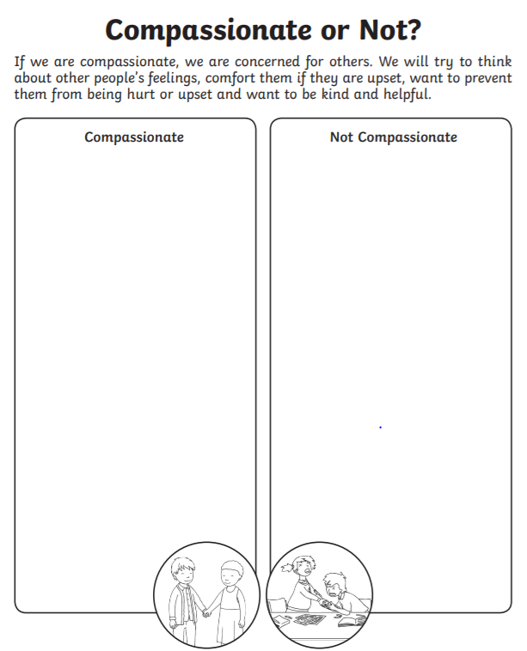

Daily
Keep reading!
Read a magazine/newspaper article.
Arithmetic (20 minutes a day) – Count in 2s 5s and 10s
Watch Newsround
Phonics – Play a phonics phase 3 and 5 game on phonics play.
https://www.phonicsplay.co.uk/resources/phase/3

Times Tables – practise your times tables as much as you can!
Useful websites for times tables:
https://www.topmarks.co.uk/maths-games/7-11-years/times-tables
https://www.timestables.co.uk/

PE

Visit YouTube and do a session 5 times a week of Joe Wicks/Go Noddle/Cosmic Kids Yoga.

French-
- Practise numbers 1-31 in French. Have a go playing these games and familiarising yourself with the spelling/reading of the words. You can play interactive games, watch videos or create posters/flashcards to help you.
https://wordwall.net/resource/3027772/french/french-numbers-1-30
https://www.bbc.co.uk/bitesize/topics/zpy8q6f/resources/1
- Revise months of the year in French
- Revise colours in French
https://www.youtube.com/watch?v=acvUtipaC5Y

