This week’s learning 29.11.21
Monday
Maths – Use the menu below to create word problems, just like we did last week. Then answer the problems.
Menu:
Strawberries - £4 a punnet
Cherries - £2 a punnet
Apples - £ 3 a pack
Oranges - £2 a pack

Mrs Anderson buys 4 packs of apples. How much does she spend? Write your calculation and answer the question.

English – Are there any further inventions or inventors that you have discovered that you would like to learn more about. Choose one invention or inventor that interests you (for example: Thomas Edison; Marie Curie; Louis Braille). In your opinion what is the most exciting invention? Who invented it? Write down as much as you can about your inventor and the invention.
Global learning – We have been working on our skills builder and engineering project all of last week. Design your invention for our skills builder/engineering project. Remember to draw a picture of what it looks like and an explanation of how it will help the environment.
Tuesday
Maths – We have finished our first unit on multiplication and division. We are going to use the rest of this week to practise some of the learning from previous units.
Ordering 3 digit numbers. Complete the worksheet attached.
English – Using your notes from yesterday, create a fact file on your chosen inventor. Remember to include lots of amazing facts about his life and his invention. Remember to use headings and sub headings to organise your information.
French – Learn the first verse to Silent night in French
https://www.youtube.com/watch?v=pu55DXQTz0I

Wednesday
Maths – 100 more or less. Complete one of the worksheets that will challenge you. Check your answers against the answer sheet.
English – Complete Pobble 365. Answer the questions on ‘The Underwater Man’.
RE – We have been learning about The Holy Trinity in RE. Write a paragraph to explain what The Holy Trinity is. Who it refers to? What symbols are used to represent The Holy Trinity. It might help to think back to some of the art we looked at.
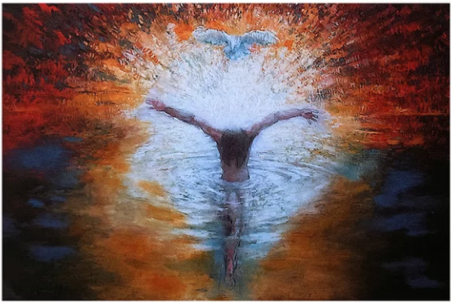
Thursday
Maths – Column addition – without regrouping. Complete the worksheet.
English – Read one of the reading comprehensions and read all about famous inventors. Next, answer the questions. Remember to use full answers and to include our non-negotiables.
Science – We have been learning about forces and magnets in Science. If you have access to a magnet, explore whether all materials are attracted to magnets. If not, can you identify which materials are? If you don’t have access to a magnet, predict which materials are or are not attracted to magnets. Make a list of your predictions, ready to test next week.
Friday
Maths – Column subtraction – without exchanging. Complete the worksheet.
English – Possessive apostrophe. Choose one of the worksheets to complete on possessive apostrophes. Check you have got it right, using the answer sheet.
Mind up/PHSE/Online Safety – Draw the outline of a person on an A4 piece of paper – like our gingerbread person. Think of all the qualities that make a good friend and write them down. Think about why friends are so important i.e. They stop us feeling lonely. Write a paragraph, explaining why your friends are so important to you.
Daily
Hit the button – Times table practise

Keep reading a range of fiction and non-fiction!
Read a magazine/newspaper article, watch newsround.
Arithmetic (20 minutes a day) – Practise your 5 and 10 times tables
PE

Visit YouTube and do a session 5 times a week of Joe Wicks/Go Noddle/Cosmic Kids Yoga.

