Year 6 – Home Learning Week Beg 11.01.21

Please find a timetable below for our weekly Lessons on Microsoft Teams. The input for the sessions will be no longer than 30 minutes and then you will be set independent tasks to do.

 | 9.30am | 11am | 2pm
Monday | Maths (Mrs Purser) | English (Mrs Purser) | Afternoon Lesson  (Mrs Purser)
Tuesday | Maths (Mrs Purser) | English (Mrs Purser) | PE (Miss Lizell)
Wednesday | Maths (Mrs Purser) | English (Mrs Purser) | RE (Mrs Purser)
Thursday | Maths (Miss Conlong) | English (Miss Conlong) | Afternoon Lesson  (Miss Conlong)
Friday | Maths (Mrs Purser) | English (Mrs Purser) | Afternoon Lesson  (Mrs Purser)

Please visit Miss Lizell’s you tube channel for access to the morning wake up PE session which is at 9am everyday.
https://www.youtube.com/channel/UCo1Ce6-TzdWlBNvvJEF1K5w

Weekly Independent Project:
Please spend no more than an hour on this project a day. We will share your work at the end of the week.
- Research the artist David Hockney, make notes in your draft books.
- Create a Fact File about David Hockney. Use bullet points, fact bubbles, you could also include a photo of him or his work.
- Look at these pictures and any others you can find online to observe how David Hockney represents water. What different media could you use to create these effects of water?
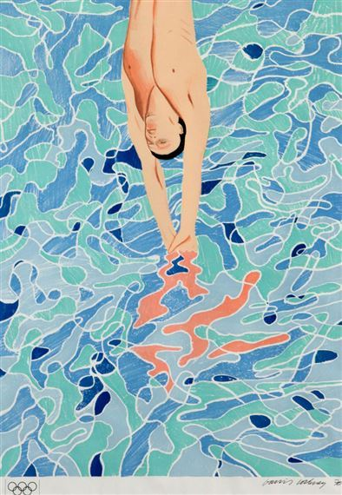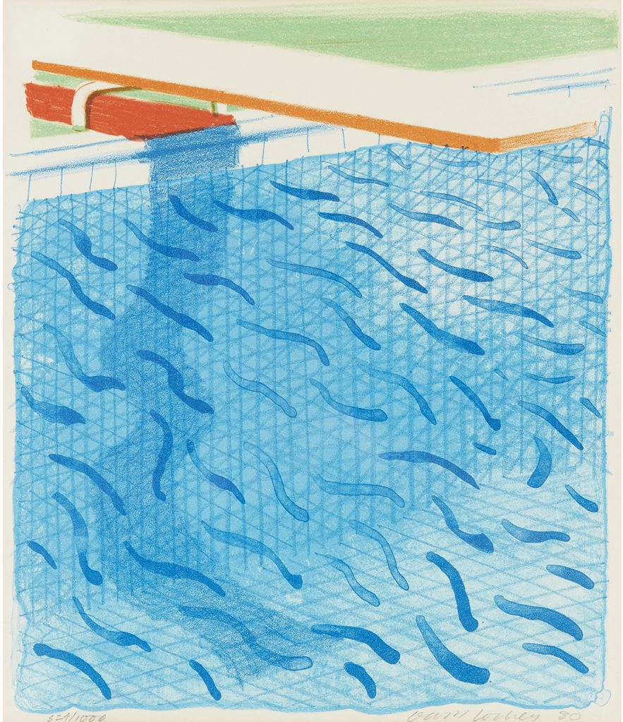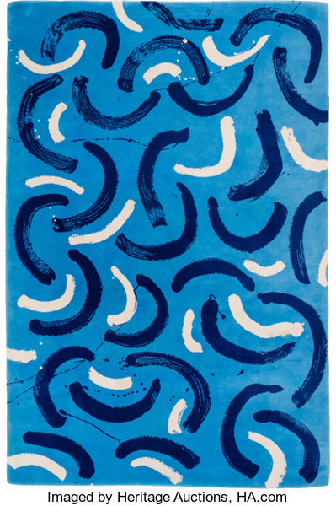

- Create your own piece of artwork in the style of David Hockney. Ensure your piece includes ‘water’. Think about the different media you could use. Take a photo of your work and upload to Teams.

Mathematics
Please go onto teams every day at 9.30am.
The independent work which is set following the lesson input is accessible through the Abacus Website – The children have their own log in details and the school code is kmm7 in the bottom box.
https://www.activelearnprimary.co.uk
Make sure you are practising your times tables as much as you can.
Times Tables Rock Star
https://play.ttrockstars.com/auth/school/student/76329
https://www.topmarks.co.uk/maths-games/7-11-years/times-tables
https://www.timestables.co.uk/

English
We are following a sequence of learning based on the book ‘The Song from Somewhere Else’ by A.F Harrold.
Please go onto teams every day at 11am. Independent work will be set following the lesson.

Spelling
Your spelling words for this week are: interrupt, interfere, intercept, internal, interest, interject.
In your handwriting books try the following spelling activities:
- Choo Choo Words – write your whole list of spelling words end-to-end as one whole word. Write each new word in a different colour.
- UPPER and lower – write your words once with all uppercase letters and one time with all lowercase letters.
- Rainbow Write – first, write the words in pencil. Then trace over them in two different colours.
- Other Handed – first, write your words in the way you usually do. Then, write the list using your other hand.
- Magazine Words – Use an old magazine or newspaper and find your words or letters that make up words. Glue them down.
- Hidden Words – draw and colour a picture. Hide your spelling words inside the picture. See if someone can find your hidden words.

Reading
Keep reading! Remember to read EVERYDAY.

The Accelerated Reader (AR) programme is also accessible from home during this time too, so once you’ve finished your books make sure you log on and take a quiz.
https://ukhosted43.renlearn.co.uk/2152328/default.aspx

Global learning (Geography, History, DT, Art)
This will be taught in an afternoon lesson on Microsoft Teams. Our topic this half term is ‘Clean Water and Sanitation’.

Science
This will be taught in an afternoon lesson on Microsoft Teams. Our topic this half term is Living Things and their Habitats - Classification.

PE
Please visit Miss Lizell’s you tube channel for access to the morning wake up PE session which is at 9am everyday.
https://www.youtube.com/channel/UCo1Ce6-TzdWlBNvvJEF1K5w

Miss Lizell will be setting challenges for you in a Live Lesson at 2pm on a Tuesday on Microsoft Teams.

Take part in a Joe Wicks session on YouTube:
https://www.youtube.com/watch?v=Rz0go1pTda8

Mind Up
https://mindup.org.uk/families/

French
Our topic is Occupations. On Linguascope go to Beginner, click the French Flag, click Le Monde Du Travail, Metiers 1. Play the games to learn the names for different occupations.
(Log in – Username - Buckden Password – octopus)
https://www.linguascope.com/

