This week’s learning 22.02.21
Daily PE Live with Miss Lizell at 9AM every weekday!
https://www.youtube.com/channel/UCo1Ce6-TzdWlBNvvJEF1K5w

Mathematics – Power Maths – Please log on to Power Maths (Same as Abacus), school code kmm7.
22.02.21
Maths – Live lesson at 10.30 AM Textbook
Independent work - Practice book 4B – Unit 10, lesson 1, Tenths (1), pages 120-122. Hand in assignment with work attached.
English Live lesson at 12.00 PM
Independent work – Design a poster advertising Oliver and the Seawigs. Don’t forget to add your favourite part to encourage others to read it.
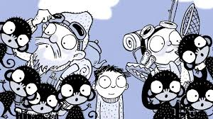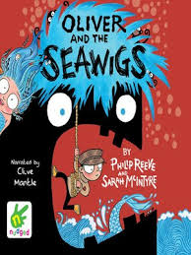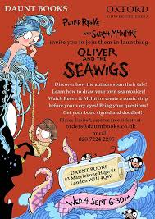
Hand in assignment with work attached.
Science Live lesson at 1.30 pm.
Independent task – Complete a sound survey round your home.

---------------------------------------------------------------------------

23.02.21
Maths– Live lesson at 10.30 AM Textbook
Independent work - Practice book 4B – Unit 10, lesson 2, Tenths (2), pages 123-125. Hand in assignment with work attached.
English Live lesson at 12.00 PM
Independent work – write down your first impressions of Michael, Josie and Tom. You may want to divide your page into 3 sections or write a mini paragraph for each character.
Hand in assignment with work attached.
Class catch up - Live at 1.30 pm.
News/catch up meeting – These will be held on our Class Teams NOT the Year 4 home learning.
Maathai with Mrs Romaine – In the live meeting channel
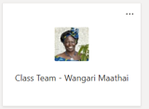
Ceesay with Mrs Gill – In the catch up channel.
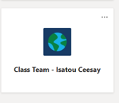

----------------------------------------------------------------

24.02.21
Maths Live lesson at 10.30 AM Textbook
Independent work - Practice book 4B – Unit 10, lesson 3, Tenths (3), pages 126-128. Hand in assignment with work attached.
English Live lesson at 12.00 PM
Independent work – draw an outline of Ahmet, like on the front cover of the book. Write around the outline what you think this character might look like. Underneath, tell me what the way this character looks like might suggest.
Hand in assignment with work attached.
PE Live lesson at 1.30 pm.
------------------------------------------------------------------

25.02.21
Maths Live lesson at 10.30 AM Textbook
Independent work - Practice book 4B – Unit 10, lesson 4, Dividing by 10 (1), pages 129-131. Hand in assignment with work attached.
English– Live lesson at 12.00 PM
Independent work – SPAG – expanded noun phrases. Complete the sheet in your English books.
Hand in assignment with work attached.
Global learning Live lesson at 1.30 pm.
Independent work – Create a suffragettes timeline.
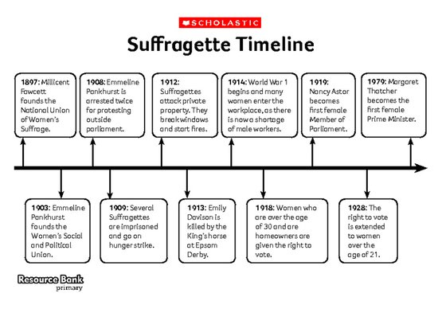

Hand in assignment with work attached.
--------------------------------------------------------------------

26.02.21
Maths Live lesson at 10.30 AM Textbook
Independent work - Practice book 4B – Unit 10, lesson 5, Dividing by 10 (2), pages 132-134. Hand in assignment with work attached.
English Live lesson at 12.00 PM
Independent work – Comprehension Millicent-Fawcett – Complete the quiz
https://forms.office.com/Pages/ResponsePage.aspx?id=WWP7dCZlx0CYxtFo2XQsHE2yuTaVqEVEogH--g2LAStUMkhJOTBXTkdLN1JJN05IRkJXNlNWSkVYRC4u
Skills builder afternoon
Find this in the Friday channel, files tab at the top of the page.
--------------------------------------------------------------------------------
Arithmetic (20 minutes a day)
Make sure you are practising your times tables as much as you can.
Times Table Rock Star
https://play.ttrockstars.com/auth/school/student/76329
https://www.topmarks.co.uk/maths-games/7-11-years/times-tables
https://www.timestables.co.uk/
Spellings
Practice your spellings in which every creative way you like. I have uploaded the spelling menu to give you some ideas.
Spellings
This week’s spelling rule - homophones
1) medal
2) meddle
3) missed
4) mist
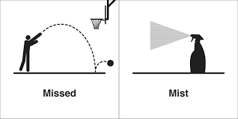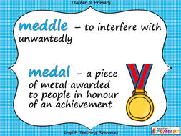
Reading
Keep reading!
Read a magazine/newspaper article.

Remember to read EVERYDAY.
The Accelerated Reader (AR) programme is also accessible from home during this time too, so once you’ve finished your books make sure you log on and take a quiz. https://ukhosted43.renlearn.co.uk/2152328/default.aspx

Nessy (20 minutes a day)
https://www.nessy.com/uk/

Mind Up
https://mindup.org.uk/families/

GenR8
Please use the below link or download the video as required.
https://youtu.be/4Pk6-khf21g
Other GenR8 Reflect videos can be found at https://genr8.org/prayer-spaces Along with other Inspire Prayer Space resources specifically for use at home.
GenR8 Connect videos can be found at https://genr8.org/videos
Rev Jes
Assembly now uploaded on to 'St Mary's Buckden' YouTube channel. St Mary's Buckden - YouTube

Visit youtube and do a Joe Wicks session/Cosmic kids/Go noodle

Young Artists' Summer show – This is something fun and creative to take part in if you wish.
As a school we have registered for the Young Artists' Summer show. This is an opportunity for the children to explore and create a piece/s of artwork overtime and at their own pace. The Young Artists’ Summer Show is a free, open submission exhibition for young artists aged 5 - 19 years studying in the UK and British schools overseas. To take part, students or their parents/guardians can submit artworks. These artworks are then judged by a panel of artists and arts professionals with selected artworks displayed online and on-site at the Royal Academy of Arts. https://youngartists.royalacademy.org.uk/get-involved Artworks can be submitted until 26 April 2021 at 5pm.

Submitting your work
Type your work or take photos of any work you would like us to see and upload them in the assignment for that lesson.

