This week’s learning 19.04.22
Monday – Bank holiday!
Tuesday
Maths – Comparing weight – use some scales and compare the weight of a range of objects at home. (Use the vocabulary – lightest and heaviest).
English – Look at the attached End papers from our new text – discuss the following questions –
Where is this place? o What is it like? How do you know? o Would you like to be there? Why or why not? o Have you ever been somewhere like this? Where was it? What was it like? o How might it feel to be here?
Look at the Robin –
Do they know what this bird is? o Why might it be here? o What do you think the robin might be thinking about this place?
Look at the litter –
Is this what this place should be like? o Who is responsible for this place being the way it is? How do we know? o What could be done to improve this place? o Whose responsibility is it to improve it?
Global Learning – Put out a yummy treat in your view all day. Think about what it would be like to feel hungry. What does hunger look like? Use the children’s search engine swiggle to find out how l=many local food banks there in our local area.

Phonics – Play a phonics phase 4 and 5 game on phonics play.
https://www.phonicsplay.co.uk/resources/phase/5/buried-treasure
Wednesday
Maths – Measuring mass – complete the attached sheet.
English – Watch the clips about littering and create a no littering poster.
Litter and Animals - Preventing Injury from Rubbish | RSPCA
Come Outside - Rubbish - YouTube
Come Outside - Rubbish - YouTube
Keep Britain Tidy - Love Where You Live TV Advert - YouTube
LOVEmyBEACH and beach cleans - YouTube
French - https://www.youtube.com/watch?v=pfkQ9e10sT0
Phonics – Play a phonics phase 4 and 5 game on phonics play.
https://www.phonicsplay.co.uk/resources/phase/5/buried-treasure

Thursday
Maths – Comparing Mass – complete the attached sheet.

English – Complete the attached comprehension sheet.

RE –
Write down the 12 people you would choose to change the world. Think about the qualities they would bring (Strong, kind, clever, helpful, sharing. Now watch the story from Matthew 9:9-13 The Tax collector and think about why Jesus brought good news in becoming friends with those who weren’t liked and left out. https://www.youtube.com/watch?v=0nqllVTt1bA

Science – plant a seed and make a seed diary.

Phonics – Play a phonics phase 4 and 5 game on phonics play.
https://www.phonicsplay.co.uk/resources/phase/5/buried-treasure

Friday
Maths – Practise your maths skills by playing some games on your Abacus account. There are lots to choose from! https://www.activelearnprimary.co.uk/login?c=0 (Log ins are in the children’s reading diaries and the school code is kmm7).

Phonics – Play a phonics phase 4 and 5 game on phonics play.
https://www.phonicsplay.co.uk/resources/phase/5/buried-treasure

English – (SPAG) Practice your handwriting using the year 1 common exception words and/or high frequency words.
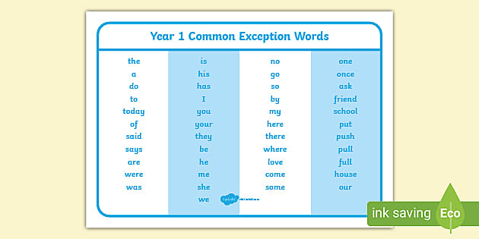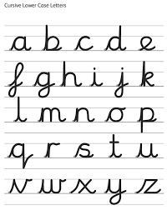
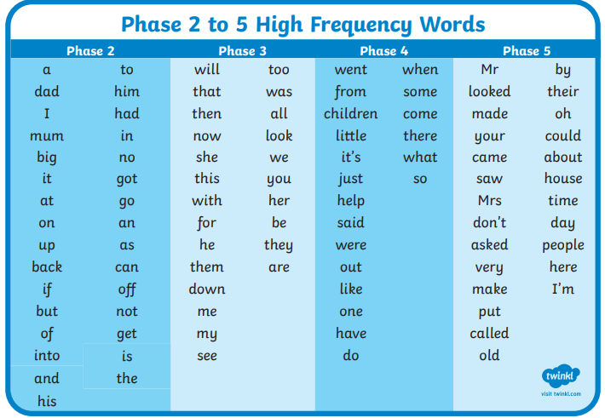
Daily
Abacus - https://www.activelearnprimary.co.uk/login?c=0 (Log ins are in the children’s reading diaries and the school code is kmm7).
Keep reading!
Read a magazine/newspaper article.
Arithmetic (20 minutes a day) – Count to 100 aloud whist doing body percussion, challenge yourself and now count in tens.
Phonics – Play a phonics phase 4 and 5 game on phonics play.
https://www.phonicsplay.co.uk/resources/phase/5/buried-treasure

Practice your typing skills
https://www.bbc.co.uk/bitesize/topics/zf2f9j6/articles/z3c6tfr

PE
Visit Youtube and do a session 5 times a week of Joe Wicks/Go Noodle/Cosmic Kids Yoga.

