Friday 12th February
Here at Buckden we have written our own Buckden School Curriculum and we have incorporated the 8 skills identified by Skills Builder into our lessons. In order to help reduce the amount of screen time, each Friday we would like you to choose 1 of the three challenges to do on a Friday afternoon (or at a convenient time) to practise your skills. The skills challenges will be the same across the school so that for families with more than one child in school there is the opportunity to do the challenge together.
If appropriate upload a photograph for your teacher to see and answer the reflection questions at the level you feel you are, this will change for different skills.
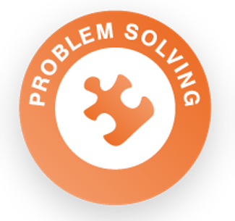 | Protect Our Planet. Research climate change and list or mindmap different things you could do at home to help protect our environment. Choose 3 simple things you will do differently as an individual this year to play your part in solving this problem.  Reflection Questions  Beginner: What are the instructions?  Intermediate: How can you use pros and cons to make a decision?  Advanced: Why is it important to consider a range of solutions for complex problems?  Expert: How might you choose between different solutions to a complex problem?
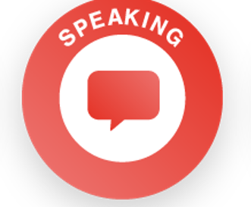 | Create a Vlog or video diary. Speak clearly as you describe your daily routine. Talk about what you are doing in lockdown and how you feel.  Reflection Questions  Beginner: How do we know if we are speaking clearly?  Intermediate: What is meant by your expression? How does expression affect the meaning of what someone is saying?  Advanced: How can you use tone, expression and gesture to make your speaking engaging?  Expert: How can you adapt the content of what you are saying, in response to different listeners?
Design a new board game.
Base the design on Snakes and Ladders, but choose a new theme. Design the board, the pieces and the rules. Show the design to a family member.
Extension: Create the game using materials you have at home. Invite a member of your family to play it with you.
Reflection Questions
Beginner: When do you use your imagination?
Intermediate: How can we come up with lots of ideas?
Advanced: How can creativity be used in different areas of life?
Expert: Where can we get different perspectives from, to develop our ideas?

