Remote Learning W/C 4th January 2021

Phonics
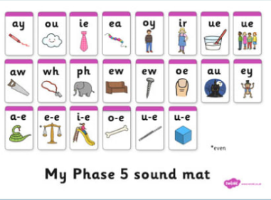
Have a recap of some of the phase 5 sounds we have learnt so far.
Choose one sound to focus on for the day and have a go at writing as many words as you can that use that sound. REMEMBER some sounds have different spellings!
https://www.youtube.com/watch?v=qfM7Hz7US0U – find the Geraldine the Giraffe video to match the days sound.
Try and play some phonics games to practice phase 3 and phase 5 at https://www.phonicsplay.co.uk/resources/phase/3

New sound we will be covering this week are:
- s making zh sound
- are
Review:
- air
- ear
- are

Mathematics
This week we are learning:
We will be recapping the different methods we can use, to add numbers together including: counting on using a number line, using objects, putting a number ‘in our head’ and counting on using our fingers.
Practice and remind yourself of some of these methods to add two numbers under 10. Eg: 7+8, 4+6. You could roll a die twice and add the two numbers together.

We are starting a new maths unit this week which is: Addition within 20.
- Please see child’s power of maths unit 7 lessons 1- 5 (text book and work book)

Please use Active Learn website and White rose website with this week’s learning objective as a focus.
Abacus - The children can access this resource via the website https://www.activelearnprimary.co.uk The children have their own log in details which can be found stuck inside their reading records and the school code is kmm7 in the bottom box.
Numbots - https://play.numbots.com/#/intro The children have their own log in details which can be found stuck inside their reading records.

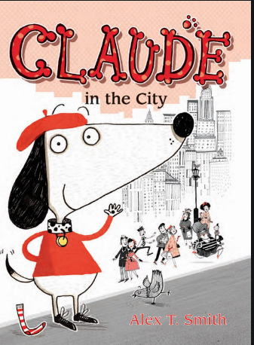
English
This week we are: Starting our new book Claude in the City. There are 4 activities for the week below.

Firstly, think about what is a city? What would you hear, see, smell, feel, taste if you were there?
- Have a look at the front cover opposite.
- Who do you think this character is? What are they like?
- Where do you think this story takes place?
- What sort of things might this character do in this setting?

- Draw a picture of this character and record some ideas of what they might get up to in a city.
- What makes a good friend as Claude has a best friend Sir Bobbysock
- Watch a video of a city from youtube and write down the things that they can see, hear, and how it may make them feel

Spelling and Grammar: Read and spell the Year 1 Common Exception Words
Practise a few at a time, little and often. Remember – Look, Cover, Write, Check!
games: https://www.topmarks.co.uk/english-games/5-7-years/letters-and-sounds
Reading
Keep reading!
Read a magazine Remember to read EVERYDAY.

Global learning (Geography, History, DT, Art)

The Global Goal we are focussing on for this half term is Sustainable Cities. The goal: To make human settlements safe, resilient, inclusive and sustainable.
We will start by looking at what a city is and what features distinguish it from a village or town. Then our focus will narrow to Buckden. We will look at the different facilities in Buckden, how it is a nice and inclusive place to live for everybody. We will then study the history of Buckden Towers, learning about The Tudors, including Henry VIII and Catherine of Aragon.

3 activities for the week are below:

- What cities can you name? Could you spot them on a map? Uk based
- What is the difference between a city, town and village.
- Draw a picture of a city- label the features.

Science
This half term our topic is: Everyday materials.
The objectives we will be working towards are:
- Distinguish between an object and the material from which it is made (eg table is an object and is made from wood).
- Identify and name a variety of everyday materials.

Please watch the following 2 lessons
https://classroom.thenational.academy/lessons/which-material-should-i-use-61jkad

https://classroom.thenational.academy/lessons/how-can-the-shape-of-solid-objects-be-changed-74uk2c

Bitesize have lots of good videos and information on this topic.
https://www.bbc.co.uk/bitesize/topics/zrssgk7

PE

Please complete 4 sessions of Joe Wicks per week. These can be found on youtube.

RE

Please watch and discuss the following:
https://www.bbc.co.uk/bitesize/topics/zh86n39/articles/zmpp92p

Mind Up
https://mindup.org.uk/families/

Skills builder
https://www.skillsbuilder.org/homelearning
French
(Log in – Username - Buckden Password – Starfish)
https://www.linguascope.com/

