Good Morning,

Today, Thursday 28th January is as follows:
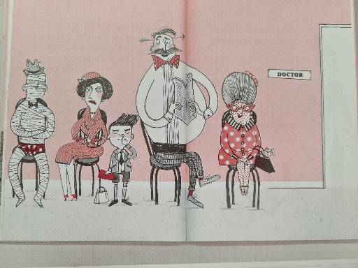
English-. Read part 2 up to page 59.
Look carefully at the people in the waiting room; imagine you are a doctor and pick one character to say what you think is wrong with them and how you think it could be cured. You could role play this if you have siblings or teddys to join in.
Write a diagnosis and treatment for them. (medical pad templates in files)
Maths- units of time
We are looking at different units of measurement (hours, minutes or seconds) for the duration of familiar events.
There are 60 seconds in a minute, 60 minutes in an hour and 24 hours in a day. We are going to look at how long these actually are. How long do you think it would take to do ten star jumps? Would it take seconds, minutes or hours? E.g. reading a book, writing your name, playing outside.
Pick some activities and estimate how long you think they might take (a lot of this is about picking the correct unit of measure rather than being close to the time so they wouldn’t pick seconds to measure the length of a film etc.) A table to record this is in files with some activity ideas but feel free to choose your own activities/tasks.

Phonics- Todays phonics is ‘ph’ phone.
Follow the link below and click on today’s date.
Thursday 28th January: Lesson 19 ph phone
https://lettersandsounds.org.uk/for-home/year-1
Please then complete one activity from the challenge sheet in the file section.
https://www.phonicsplay.co.uk/
username: jan21
password: home

Science- Seasonal changes
We are going to carry on focusing on our observational skills this week and I am going to set you a week long task. We are looking at the seasons throughout the year and have already looked at Autumn. We are now in the middle of winter so it’s time to look at what it is like in the winter and what kind of weather we could expect. Can you keep a weather diary for the next week keeping details of what the weather is like each day. We can share these next week.

Working Scientifically (KS1)
i) asking simple questions and recognising that they can be answered in different ways
ii) observing closely, using simple equipment
iii) performing simple tests
iv) identifying and classifying
v) using their observations and ideas to suggest answers to questions
vi) gathering and recording data to help in answering questions

