Watch and Understand  Where did she go?  Why did she go?  What did she see?  What did the dog do?  Where did they go together?  What did they take with them? | Watch and Understand  Role play the film and freeze frame.  How do you feel as your character now? | Focus on inference  How did the dog feel when she left?  Why? How do you know?  How was the girl feeling on the island?  Why? How do you know?  How did they both feel when she came back?  Why? How do you know?  Why did they bring a flower to the island?
8th October 2021
The silent blue book
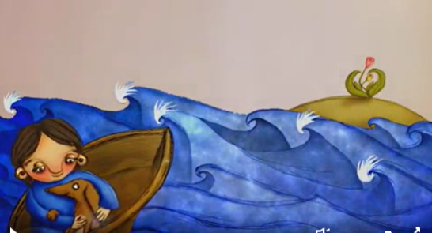
https://www.literacyshed.com/silentbluebook.html

What is the main message of the story?

Write a sentence to tell me what the message is.

- Love, friendship, better together etc

