This week’s learning 06.12.21

Monday
Maths – https://classroom.thenational.academy/lessons/describing-coordinate-positions-on-a-grid-6hgpat
English - https://classroom.thenational.academy/lessons/to-revise-our-understanding-of-simple-compound-and-complex-sentences-74t64d
RE – Make and send a Christmas Card to an elderly neighbour or relative. Take time to write a personal message inside.

Tuesday
Maths – https://classroom.thenational.academy/lessons/translating-simple-shapes-6hjpat
English – https://classroom.thenational.academy/lessons/to-understand-the-two-functions-of-apostrophes-68vk6t
Global Learning: History - Imagine you are a newspaper reporter and you are writing an article which is going to appear in a national newspaper the day after The Lusitania has been attacked. Use the mind map you created last week to plan your article. Remember to include: a headline, orientation and at least 3 paragraphs explaining the events. You could either write out your report, or type it.

Wednesday
Maths – https://classroom.thenational.academy/lessons/reflecting-simple-shapes-6mu3ec
English – https://classroom.thenational.academy/lessons/to-introduce-apostrophes-for-singular-possession-6wr66d
Art – Go outside and create a collage using natural material to depict life in the trenches for the soldiers of World War One.
Thursday
Maths – https://classroom.thenational.academy/lessons/solving-practical-coordinate-problems-part-1-c9h3ec
English – https://classroom.thenational.academy/lessons/to-revise-apostrophes-for-contraction-and-singular-possession-c9j64c
Global Learning – Find out about The Treaty of Versailles. What was it? Write a paragraph to explain. Now answer the following questions:
- If you were a leader of Britain, what would you want from the treaty?
- If you were a leader of Germany, what would you want from the treaty?
- Do you think the treaty was fair to all parties involved?

Friday
Maths – https://classroom.thenational.academy/lessons/solving-practical-coordinate-problems-part-2-6hh34e
English – https://classroom.thenational.academy/lessons/to-explore-using-apostrophes-for-plural-possession-cgvk2d
Science -
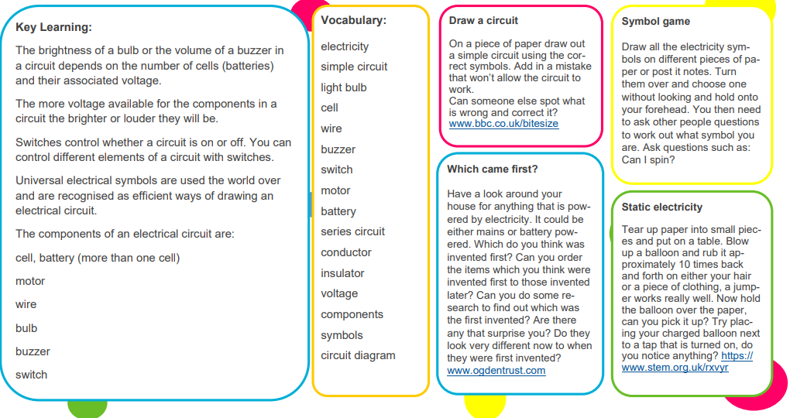
Daily
Log into SATs Companion and do any practise session.
TT Rockstars: https://ttrockstars.com/
Keep reading – at least 20 minutes every day. As well as your reading books try to look at a newspaper/magazine article, recipe or non-fiction book.

PE
Visit YouTube and do a session of Joe Wicks.

French
Use Linguascope to learn the names for different family members in French.

