Week commencing : 4th January 2022 EYFS Enhancements Continuous Provision Plan
Story: Mothergoose Nursery Rhymes edited by Iona Opie |  | Skills Builder: |  | Enhancement: (4 day week)
RE Theme:
Area | Learning Intention |  | Enabling Environment |  | Adult Questioning/ Support/ Vocabulary
Writing | To practise reading and writing all letters and digraphs qu, ch, sh |  | 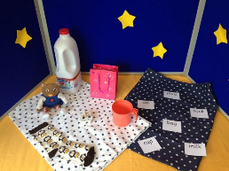  Children match the words with the objects, then write the words on paper supplied. Include: queen, ship and chick. |  | Assist to use a tripod grip.  Teach to write from left to right.  What can you hear? (initial sounds)  Letter formation rhymes/sound mat  What are the sounds?  Can you blend the sounds?  What object matches that word?
Reading | To respond to the Question of the week: Can a dog hiss?  To retell familiar nursery rhymes |  | 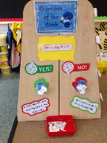  Children find their name and put it in the ‘yes’ or ‘no’ container to answer the question.  Collection of toys, puppets and other story props, e.g. trains, a bucket, a dish and a spoon, some farm animals and a toy farm. |  | Can you read the question?  What are the sounds?  Can you blend them to say the word?  Can you reread the sentence?  Do you think the answer is yes or no?  Can you find your name?  Which pot should you put your name in?  What nursery rhyme do you think match these props?  Can you remember the nursery rhyme?
Maths | To practise conceptual subitising |  | Laminate photos of objects. Children circle what they see and how they see it. Provide 5 and 10s frames to see if they can then use them frames to help them determine the final number. |  | What can you see?  How do you see them?  Can you draw a circle around what you see?  How can we use a 5 frame/10 frame to help us find out how many there are?
PD | To practise throwing skills using bean bags |  | Subitising hopscotch. |  | How can you throw the beanbag to land in the squares?  What do you need to change so that you hit the target next time?  Do you know the number without counting?  How could we keep score?
EAD | To create a drawing of an experience from the holidays  To explore Lottie Reigner films/stories and Jan Pienkowski silouhettes |  | Give children a template to fit a drawing and write some words about their holiday memories.  Provide a table with copies of books and pictures copied from books for children to look at silouhettes. |  | Tell me about your drawing.  What do you think about these silhouettes?  How do you think the artist created them?  What do the pictures show?  Do you like them?  Why? Why not?
UW | To share how they celebrated the holidays with their families. |  | (See EAD above)
PSHE | To review behaviour and expectations when at school/class rules. (Emphasise looking after equipment.) Create rules for mud/rain. |  |  |  | The weather will be changing. What can we do to stay comfortable outside?
C+L  French | To learn colours in french |  | https://www.youtube.com/watch?v=fZR66TjjrDc
Music | To listen to music and move body in response. |  | Learn the Grand Old Duke of York. Use musical instruments to sing and perform. |  | Beat, pulse, volume, crescendo.
Nature School | Make mud paint to use outside. |  | 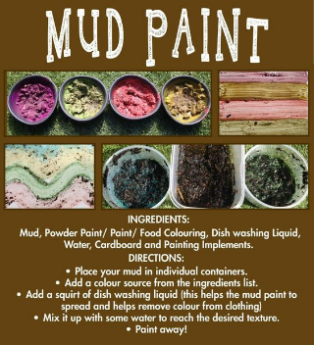 |  | Can you help me make mud paint?
Mind Up | Reset and emphasise technique of brain breaks.
Skills Builder | To identify own strengths and areas for development within skills builder. |  | Discuss the skills; listening, speaking, aiming high, staying positive, creativity, problem solving and ask children to give examples of when they have done these. Identify skills they feel confident with and those which they need to work upon. |  | Write skills children are confident with on pink post it with reasons/ examples if possible and those to improve at on a green post it and add to skills builder floor book.
Oak academy links for literacy lessons in case of Covid absence https://classroom.thenational.academy/units/little-red-hen-2e6d
For maths https://classroom.thenational.academy/units/numbers-within-6-9e95

