Good Morning,
Today, Friday 29th January is as follows:
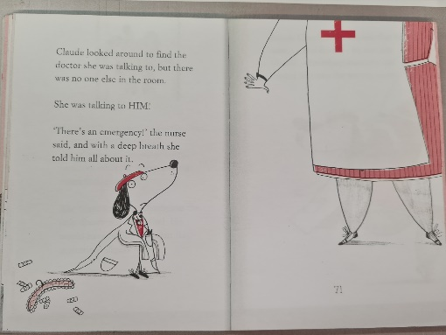
English- Read to page 71
What is his expression telling us? Do you think Claude should tell the nurser he is not a doctor? What could happen is he does/doesn’t tell the truth?
Come up with arguments for and against telling the truth. Write Claude a note telling him what you think he should do and why.

Maths- Compare, describe and solve practical problems for: time (for example, faster, slower, earlier, later).
Children compare amounts of time using the language of faster, slower, earlier and later. They build on writing and measuring time by comparing different amounts of times using time language. Children can understand that when someone wins a race the length of time will be shorter and if someone takes longer the length of time will be longer.
Children are to use this language to compare e.g Teddy is faster than Mo.
Phonics- Todays phonics: a review of the week.
Follow the link below and click on today’s date.
Friday 29th January: Lesson 20 Review the week
https://lettersandsounds.org.uk/for-home/year-1
Phonics play is also free throughout January so you could explore some of the games on there. https://www.phonicsplay.co.uk/
username: jan21
password: home

Skills builder-

Assembly – Mrs Heathers celebration assembly, look out for the link.

