Wk beg: 13.09.21:
Good afternoon to you all. We have had a lovely week together. The children are learning the routines really quickly and have done some lovely outdoor learning.
We have been learning the numbers in French, more about the creation story, practising NESSY and our times tables.
This week, Arya enjoyed reading The Pebble in my Pocket. She loved finding out about the journey of the pebble so far. We used this to create some fabulous sentences. I was so impressed by their vocabulary choices that Mrs Heather popped in to have a look at their work.
Alfie, and in fact everyone, had a great time building dragonflies outside. We used as many different materials as we could find to create lots of different designs.
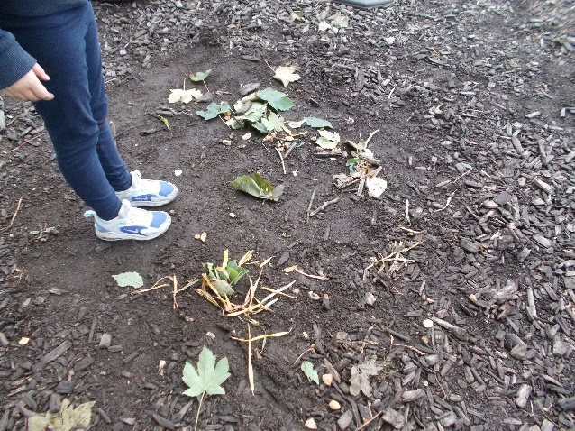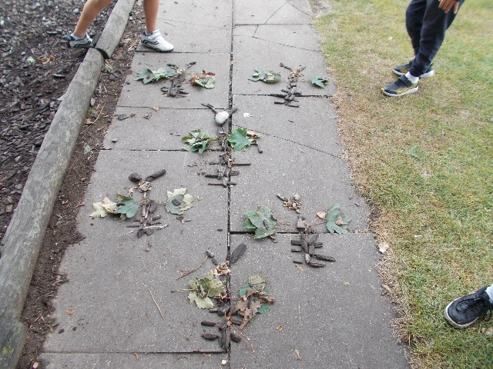
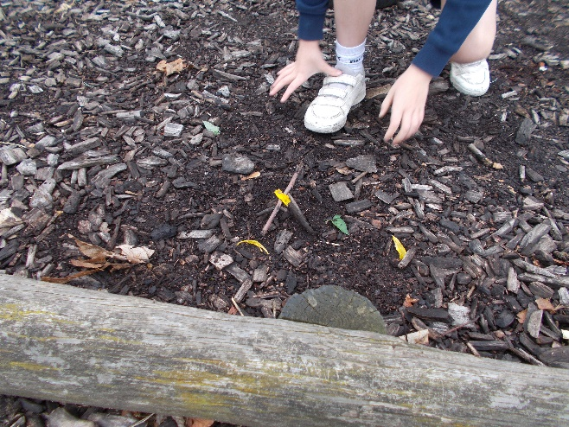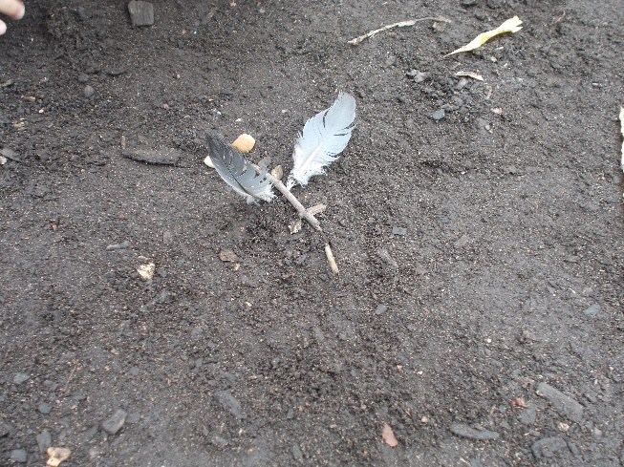
Lucas enjoyed Maths and learning to use the symbols for greater than and less than. He used them to compare numbers to 1000. Sofia is really confident with comparing numbers now.
The children have also been getting to grips with the new Accelerated Reader program we use. Nearly everyone has managed to quiz on their reading book and they find it quite an easy system to use. The books are banded completely differently to our KS1 books; therefore the colours do not correlate to what they might have been reading last year.
Reenie enjoyed Science. We have been learning about the three different types of natural rocks and we wrote down explanations of how they are formed.
We hope you have a lovely week.

Kind regards

Hawthorn Class

