Week commencing ^{9th} May 2022 EYFS Enhancements Continuous Provision Plan
Story: The Very Hungry Caterpillar  Tales of From the Ouse Valley |  | Skills Builder: Problem Solving |  | Enhancements: Paxton Pits visit Tuesday all day  Hopefully caterpillars will arrive this week.
RE Theme:
Area | Learning Intention |  | Enabling Environment |  | Adult Questioning/ Support
Writing/ C&L | To write short, simple sentences using phonics and tricky word knowledge. |  | Write their own versions of ‘The Very Hungry Caterpillar’.  Use precut mini books with segmented pages. |  | What animals are born in eggs?  Where do they live?  What do they eat?  What changes do they go through?
Reading | To enjoy nonfiction and fictions stories exploring mini beasts, birds, plants etc and be able to explain the key elements of the story. |  | Make a variety of fiction and nonfiction books covering Down at the Bottom of the Garden topic available for reading. |  | What have you learned from this book?  Is it fiction or nonfiction? How do you know?  Would you recommend it to a friend? Why or why not?
Maths | To explore the composition of 10 using part whole models and 10 frames. Also to continue to practise writing number sentences using + sign. |  | Allow children to play with collections of items and practise using the language of addition and subtraction with a ten frame.  Leave 10-frames in both indoor and outdoor spaces, and encourage the children to fill them with objects. |  | How many more do you need?  How many have you taken away?  How many objects do you have here? And here?  What is the total altogether?  Vocab: addition, total, altogether, more add on
EAD | Safely use and explore a variety of materials, tools and techniques, experimenting with colour, design, texture, form and function. |  | Tissue paper Collage  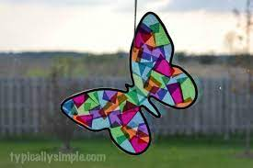  Symmetry butterflies  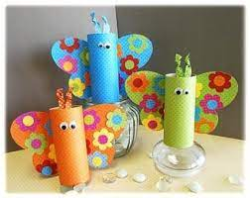  Use all the resources demonstrate the life cycle of a caterpillar using a variety of mediums |  | Can you build a mini beast?  Which shapes would work?  How many legs do you need?
PD | To develop fine motor control, hand strength and hand/ eye coordination. |  | See EAD. Using scissors, children to cut paper into shapes of their own choosing to create butterfly and caterpillar creatures. |  | Are you holding the scissors correctly?  Are those the best scissors for you?
UW | To respect nature and the natural habitat. |  | Paxton Pits trip  Monday- Show children the images of the trip and discuss potential hazards.
PSHE | To understand what money is used for and the importance of it. |  | Continue with Garden Centre Role Play and add real coins and purses/ wallets. |  | Teach value and importance of money and how to keep it safe and spend wisely.
French | To learn song in French |  | https://www.youtube.com/watch?v=xBpHkMgWld8  – very hungry caterpillar  Days of the week in French
Music | To listen to a minibeast story and learn a song. |  | Learn song Fuzzy Wuzzy Caterpillar
Nature | To explore animal habitats and learn what different animals eat. |  | What do the wildlife eat?  Look at the environment and try to discover food sources. |  | Introduce idea of food chains.  Use non fiction texts and research online to learn more.

