Week beg: 14.03.22
Talk homework – Tell an adult all the different ways a seed can be dispersed.
Hawthorn class have had a very productive week. We did our STAR reader at the beginning of the week and performed really well.
We have been learning about Paris in Geography. We looked at the similarities and differences between the French capital and London. We used digital mapping to locate different landmarks in the city. We learned so many facts about Paris, including that it has 830 libraries.
In Science, we studied seed dispersal and demonstrated a great deal of knowledge of how seeds move.
Freddie really enjoyed music composition. We learnt about notation, then we composed our own pieces of music which we then went on to play.
Sofia and Kitty enjoyed PE with Lizell in the rain!
Maths has been a challenge this week. We have been converting length. We need to practise multiplying and dividing by 10 and 100.
To end the day, we went outside in the glorious weather and did a nature hunt. We visited the pond and saw frog spawn and are very excited to see how they develop. We went plant and tree spotting, visited the nature area and finally the tranquil garden. We concluded that our school is very biodiverse and are very proud of all that we do to help nature.
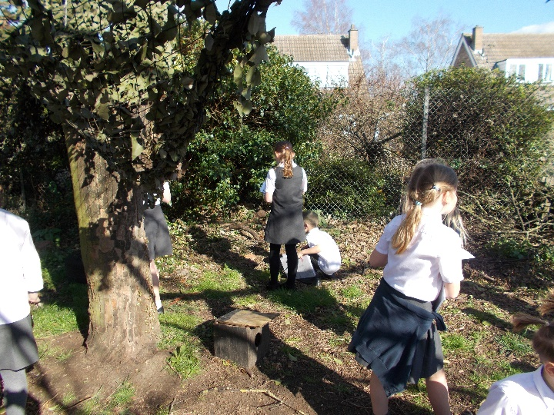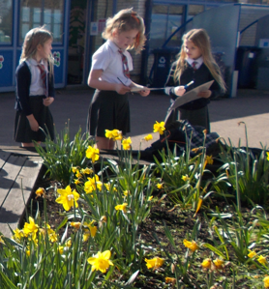
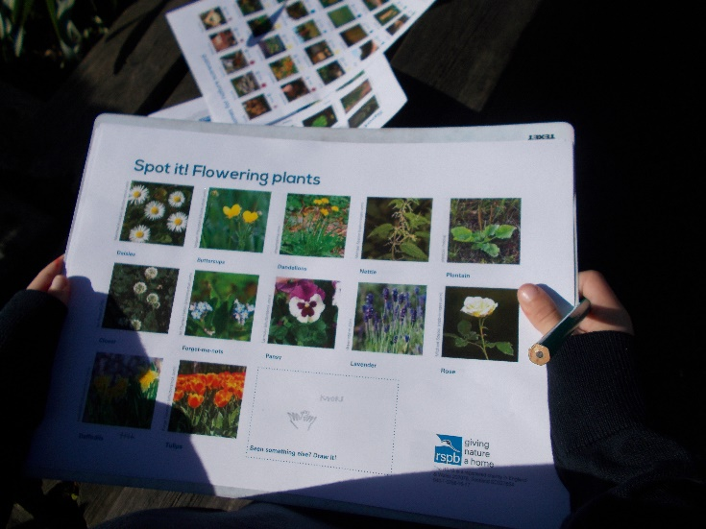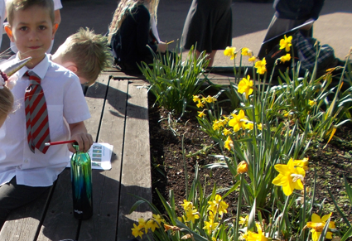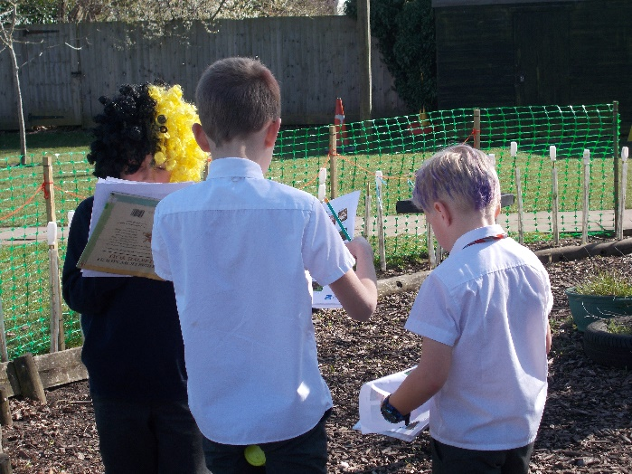
We hope you have a lovely weekend.
Hawthorn class

