This week’s learning 14.03.22
Spellings - This week’s spellings are – very, happy, party, five, family

Your spelling rule – Some words end with an e sound spelled y. English words hardly ever end with the letter v, so if a word ends with a v sound, the letter e usual.

Monday
Maths – Ordering objects and numbers. Please complete the attached worksheet.
English – Write a range of descriptive sentences about Claude and Sir Bobblysock.
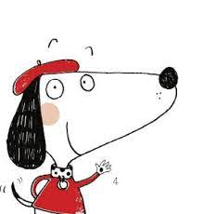

Science – Draw a tree and if you have paint do finger print blossom growing for a spring tree picture.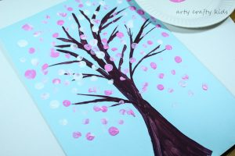

Phonics – Play a phonics phase 4 and 5 game on phonics play.
https://www.phonicsplay.co.uk/resources/phase/5/buried-treasure
Tuesday
Maths – Make an exercise routine for counting in 2s.
English – Go back to your sentences from yesterday and improve them by adding some exciting adjectives about both of the characters.

Global Learning – Research ways you can look after the environment including composting, recycling, reusing, waste disposal etc. Now make a poster showing everyone how you could look after our world.

Phonics – Play a phonics phase 4 and 5 game on phonics play.
https://www.phonicsplay.co.uk/resources/phase/5/buried-treasure
Wednesday
Maths – Counting in 5s – write your multiples of 5 (up to 50) on small bits of paper, hide them around the house and then go and find them. When you have found them all order them and jump in 5’s as you count aloud.
English – https://www.bbc.co.uk/bitesize/topics/zgqxwnb/articles/zrjqpg8
Look at the above website and plan a leaflet for a café in encourage Claude to visit it on his tour of the city.

French - https://www.youtube.com/watch?v=pfkQ9e10sT0
Phonics – Play a phonics phase 4 and 5 game on phonics play.
https://www.phonicsplay.co.uk/resources/phase/5/buried-treasure

Thursday
Maths – Counting in 5s. Complete the attached sheet.

English – Make your leaflet. Don’t forget your subheading, map, contact details and to make it bright and colourful.

RE – Watch the Easter story, what can you remember about why it is such an important event for Christians. https://www.youtube.com/watch?v=Wnbo2AmS3OI

Phonics – Play a phonics phase 4 and 5 game on phonics play.
https://www.phonicsplay.co.uk/resources/phase/5/buried-treasure

Friday
Maths – Practise your maths skills by playing some games on your Abacus account. There are lots to choose from! https://www.activelearnprimary.co.uk/login?c=0 (Log ins are in the children’s reading diaries and the school code is kmm7).

Phonics – Play a phonics phase 4 and 5 game on phonics play.
https://www.phonicsplay.co.uk/resources/phase/5/buried-treasure

English – (SPAG) Practice your handwriting using the year 1 common exception words and/or high frequency words.
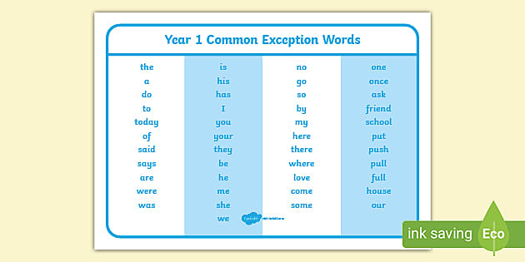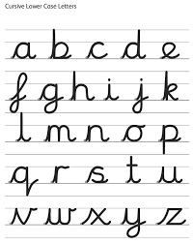
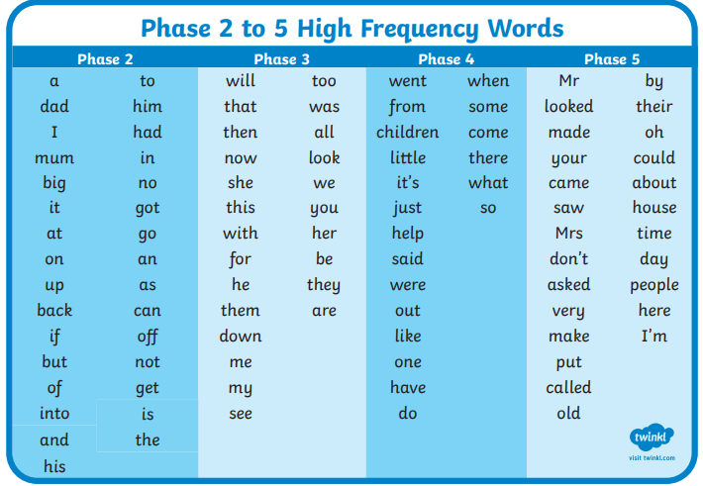
Daily
Abacus - https://www.activelearnprimary.co.uk/login?c=0 (Log ins are in the children’s reading diaries and the school code is kmm7).
Keep reading!
Read a magazine/newspaper article.
Arithmetic (20 minutes a day) – Count to 100 aloud whist doing body percussion, challenge yourself and now count in tens.
Phonics – Play a phonics phase 4 and 5 game on phonics play.
https://www.phonicsplay.co.uk/resources/phase/5/buried-treasure

Practice your typing skills
https://www.bbc.co.uk/bitesize/topics/zf2f9j6/articles/z3c6tfr

PE
Visit Youtube and do a session 5 times a week of Joe Wicks/Go Noodle/Cosmic Kids Yoga.

