This week’s learning 10.01.22
Monday
Maths – Counting and writing numbers to 20. Complete the attached worksheet.
English – Draw a picture of the four seasons and write words that describe each season around your picture.
Science – Look through the attached Powerpoint about comparing animals and complete the attached worksheet.
Tuesday
Maths – Tens and Ones (1) Look at the attached Powerpoint and complete the attached sheet.
English – Look at the front cover of our new text.
Make some predictions about what you think the text might be about. Who do you think is going on a journey? Where do you think this journey will take the fish? What sort of things might she see on the way? Do you think it will be an easy or difficult journey? Why?
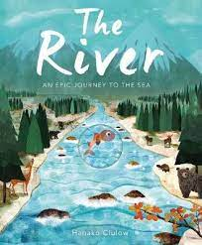
Global Learning – Read the first page of the attached information sheet about Captain James Cook and complete a factfile about him on the template, using the word mat to help you.

Wednesday
Maths – Tens and ones (2) Look at the attached Powerpoint and complete the attached sheet.
English – Draw a picture of the river and the fishes journey. Add adjectives onto your picture to describe what the fish might see.
Music – Look at the ‘Story of a raindrop’ attached and add your own homemade instruments or body percussion to show the journey of a raindrop.
https://www.chw.net.au/mvc/k12webapi/media/education_sustainability/education%20resources/school%20program/the-story-of-a-raindrop.pdf
Thursday
Maths – Counting one more one less – Complete the attached dice game.
English – SPAG – Click the links to practice your phonics and sentence structure. https://www.topmarks.co.uk/Interactive.aspx?cat=40
https://www.topmarks.co.uk/Interactive.aspx?cat=44

RE – Watch the video explaining what a Puja is. Draw a picture of how you welcome into your home.

Friday
Maths – Practise your maths skills by playing some games on your Abacus account. There are lots to choose from! https://www.activelearnprimary.co.uk/login?c=0 (Log ins are in the children’s reading diaries and the school code is kmm7).
English – (SPAG) Practice your handwriting using the year 1 common exception words.
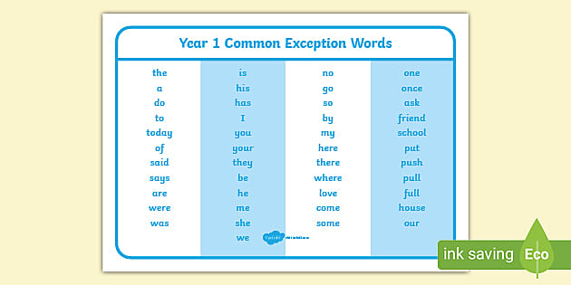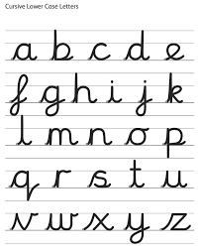
Daily
Abacus - https://www.activelearnprimary.co.uk/login?c=0 (Log ins are in the children’s reading diaries and the school code is kmm7).
Keep reading!
Read a magazine/newspaper article.
Arithmetic (20 minutes a day) – Count to 100 aloud whist doing body percussion, challenge yourself and now count in tens.
Phonics – Play a phonics phase 2 and 3 game on phonics play.
https://www.phonicsplay.co.uk/resources/phase/2/picnic-on-pluto

Practice your typing skills
https://www.bbc.co.uk/bitesize/topics/zf2f9j6/articles/z3c6tfr

PE
Visit Youtube and do a session 5 times a week of Joe Wicks/Go Noodle/Cosmic Kids Yoga.

