Wk beg 03.05.21
Talk homework: Discuss some of the words we looked at in Literacy this week. Can you use them in context?
Daily reading 15-20 minutes
NESSY 40 minutes a week, if appropriate
TT Rockstars/Abacus/ Mathsframe/Topmarks (Hit the button) – as often as possible.
Here is this week’s learning. Any additional reading and support would be welcomed.
English –Lob –The Green Man mythology
Maths –Mass
Science –Animals including humans –Nutrition and healthy eating
SDG –Zero hunger – Responsibility of Government to help the people
RE – Christianity – People of God –Covenants in real life – UN pact
Good afternoon all,
It has been another lovely, sunny week. We have really enjoyed being outside this week.
In Maths, Harry and Joshua have enjoyed learning about mass.
In Science, Freya had a great time learning about nutrition and what healthy eating means. They were able to use their knowledge to devise a healthy, balanced meal.
In French, Jack enjoyed listening to the story of Elmer and we used our knowledge of colours to complete a colouring activity.
Florrie has been enjoying listening to Irish music. We have looked at features of traditional Irish music. We also drew and noted the key facts about the instruments that might be used.
Noah enjoyed learning about the legend of The Green Man. We spent some time outdoors with nature and designed our own version of what we think he might look like.
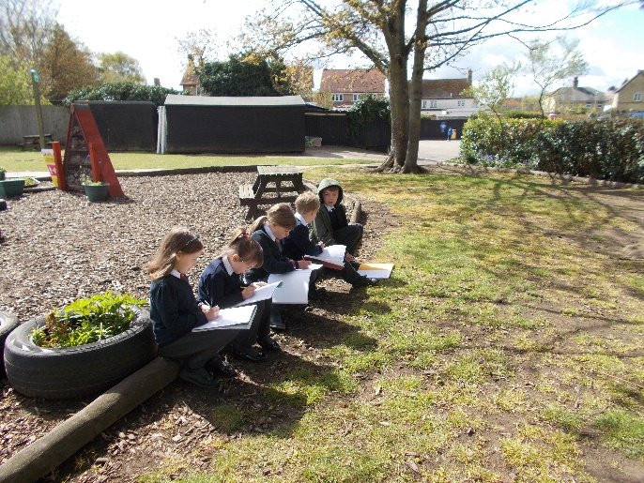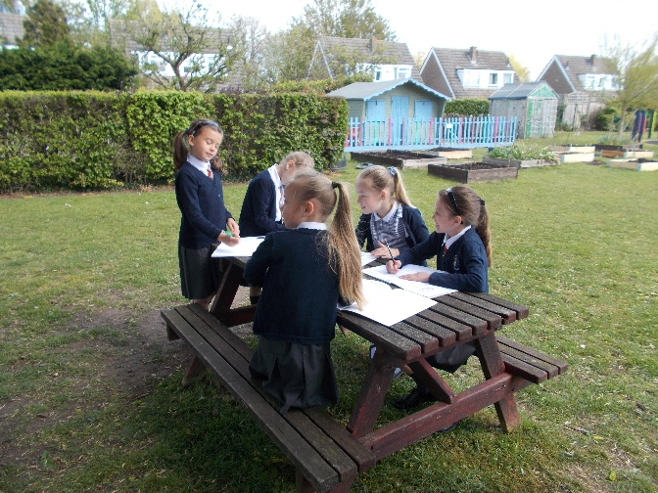

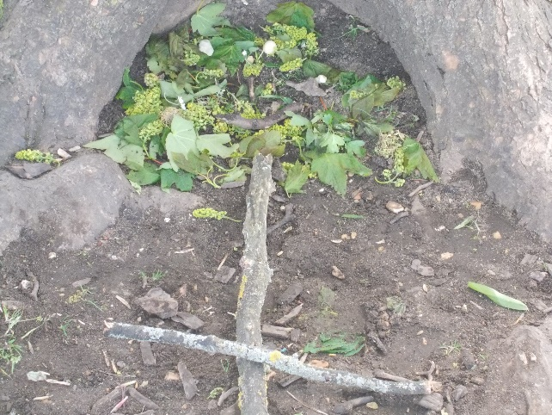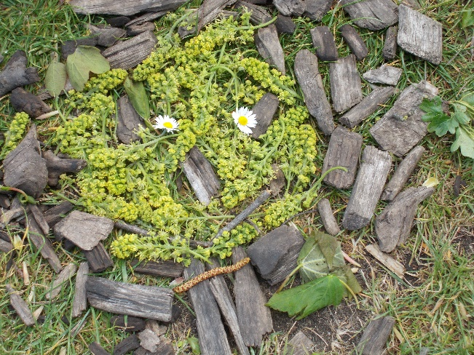
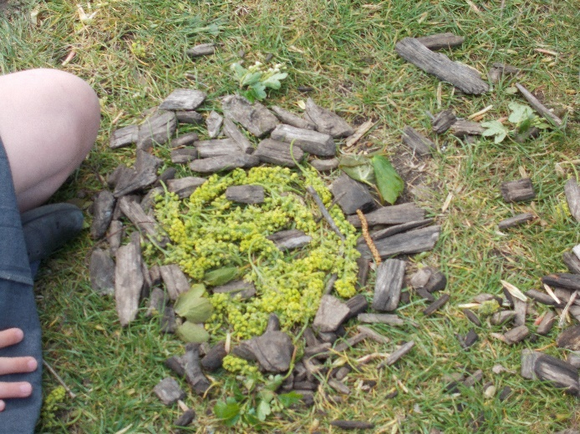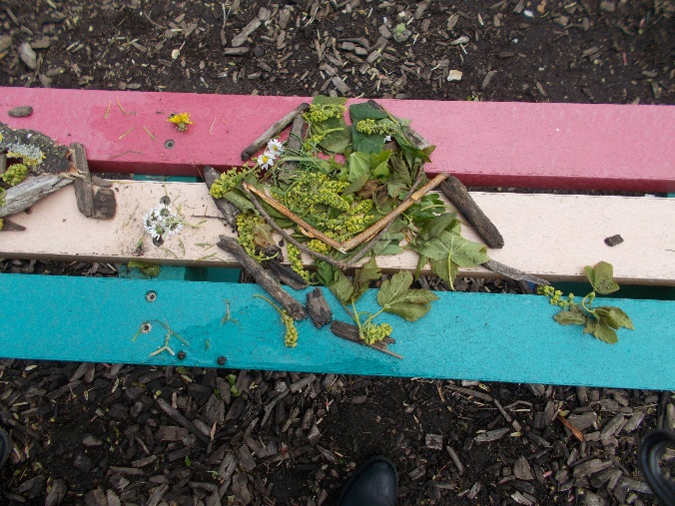
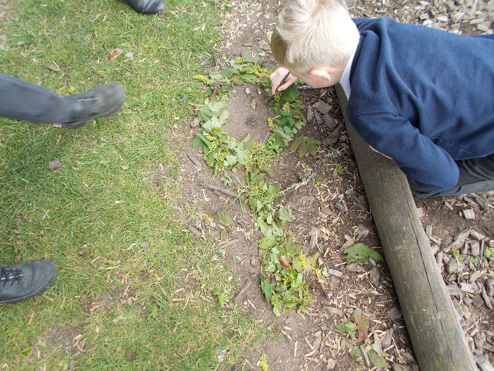
Seb enjoyed and is proud of the letter he wrote to Sir Robert Peel. The children included an awful lot of knowledge about the potato famine.

From
Sylvia Earle

