Immersive reader and Dictation Crib Sheet
Immersive reader is available on MS Teams in the assignments and on the word documents.
Assignments:
Open your assignment.
There is a button which looks like a book with a speaker. Click on this.
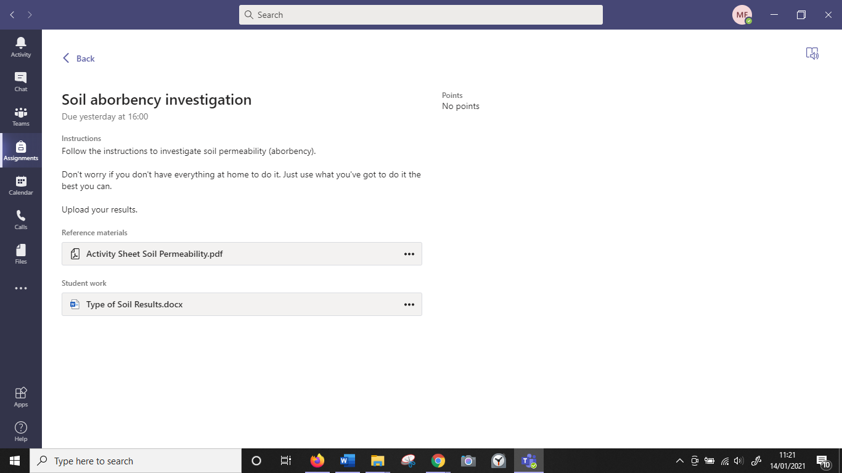
It will open like this:
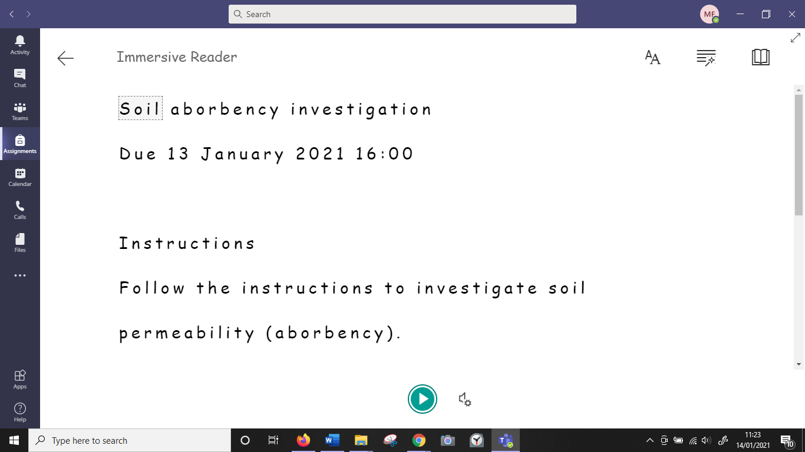
To change the font and size of the text click on the AA button.
Adjust your settings here.
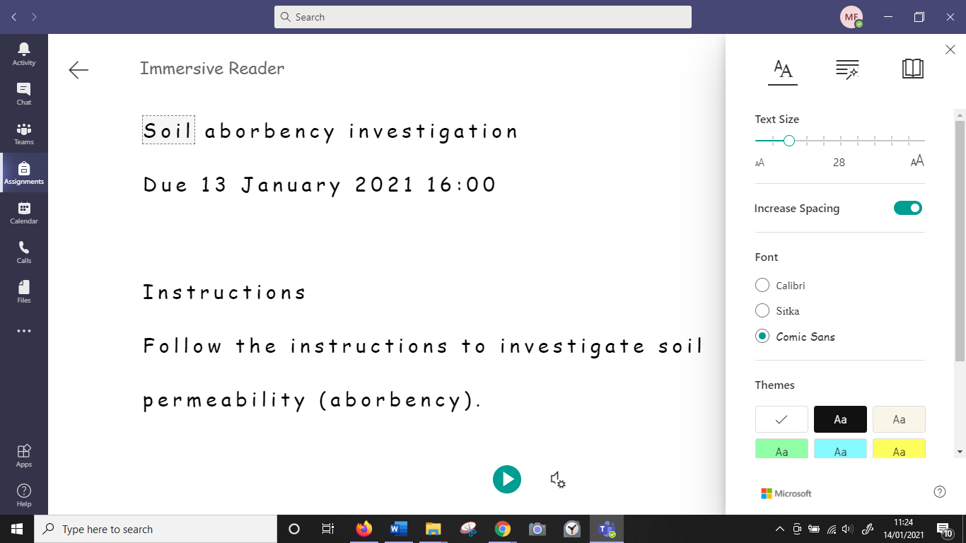
To show the line-by-line view click on the book button. Adjust your settings here.
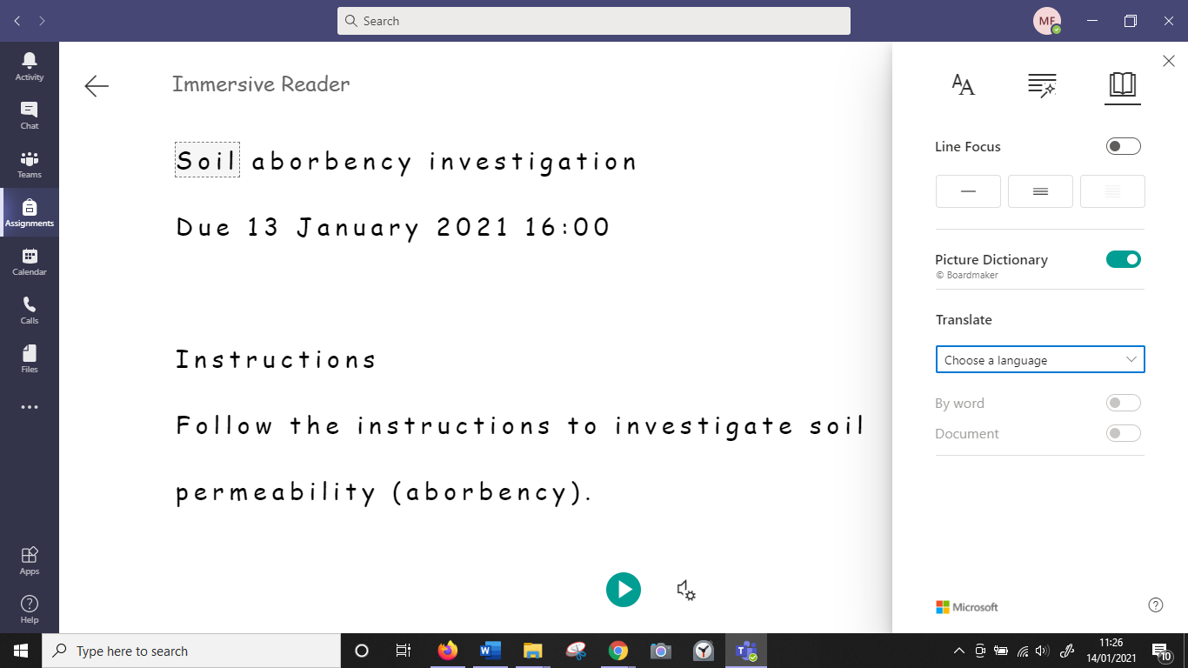
To hear the text being read, click the play button.
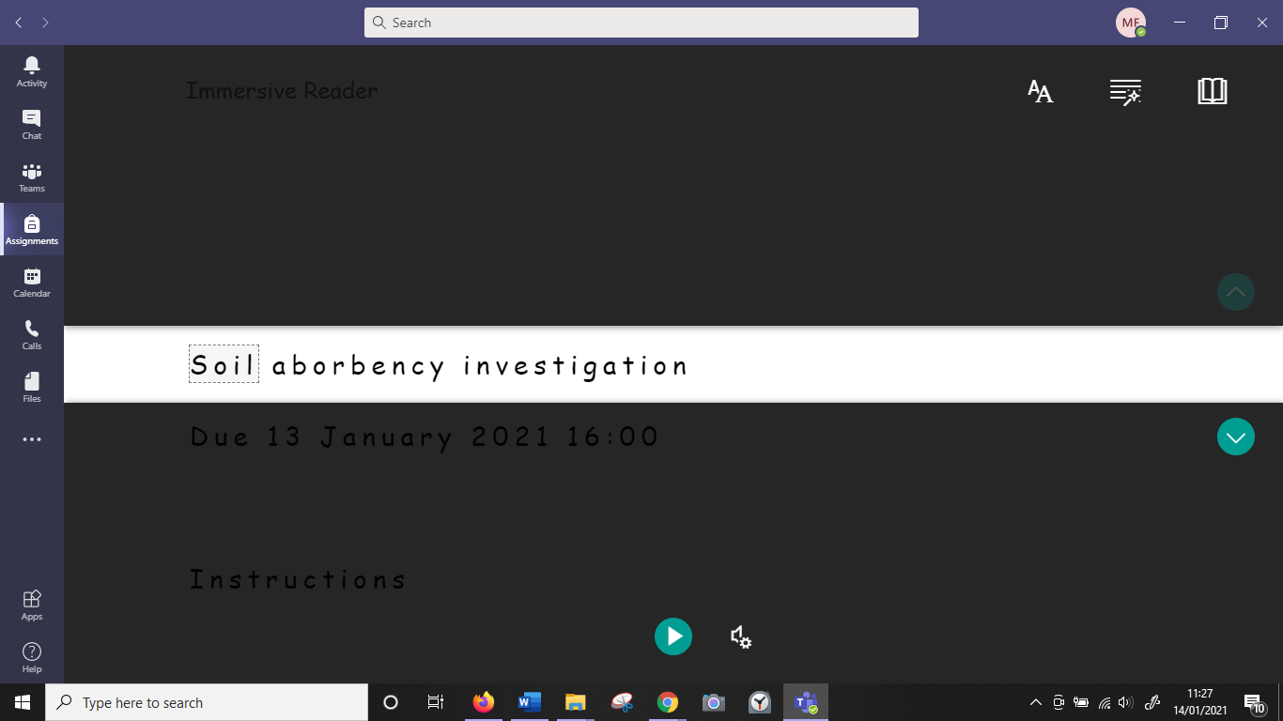
To exit immersive reader click the back button.
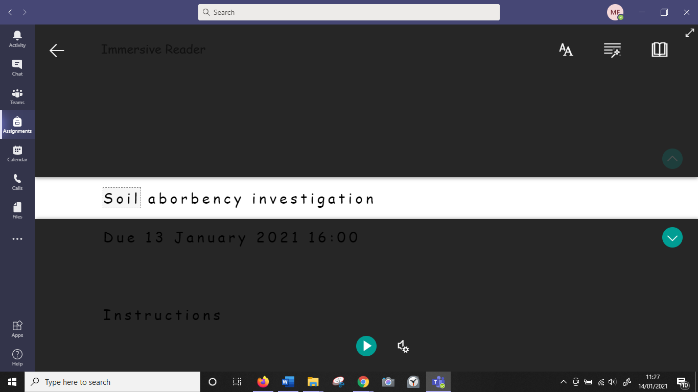
Word:
When you open a word document, click on the view part of the menu bar.
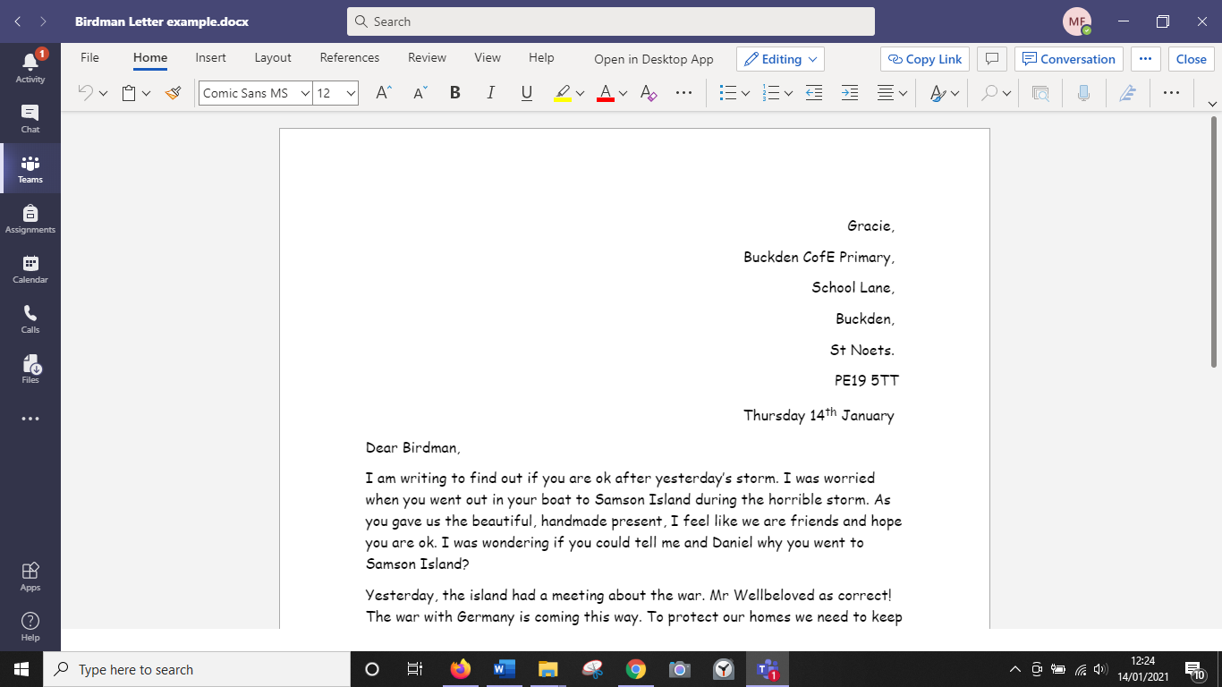

Then click on immersive reader. All previous instructions apply.
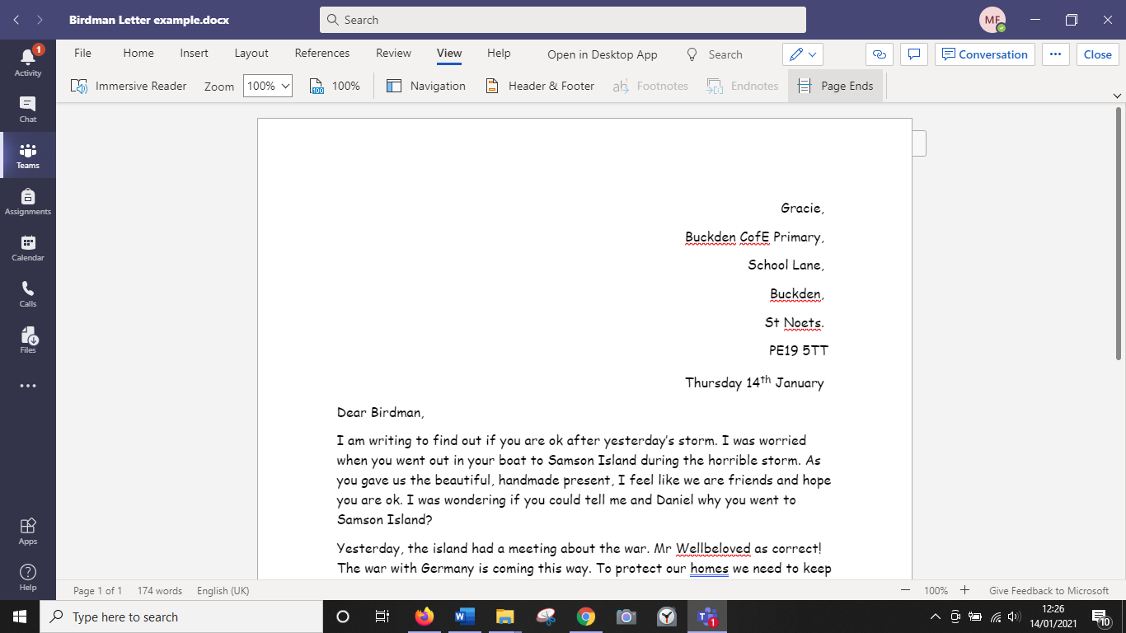
Dictation
When you open a document, you can use the dictation function to write rather than typing. There is a little microphone symbol in the menu bar. Click on that to open it.
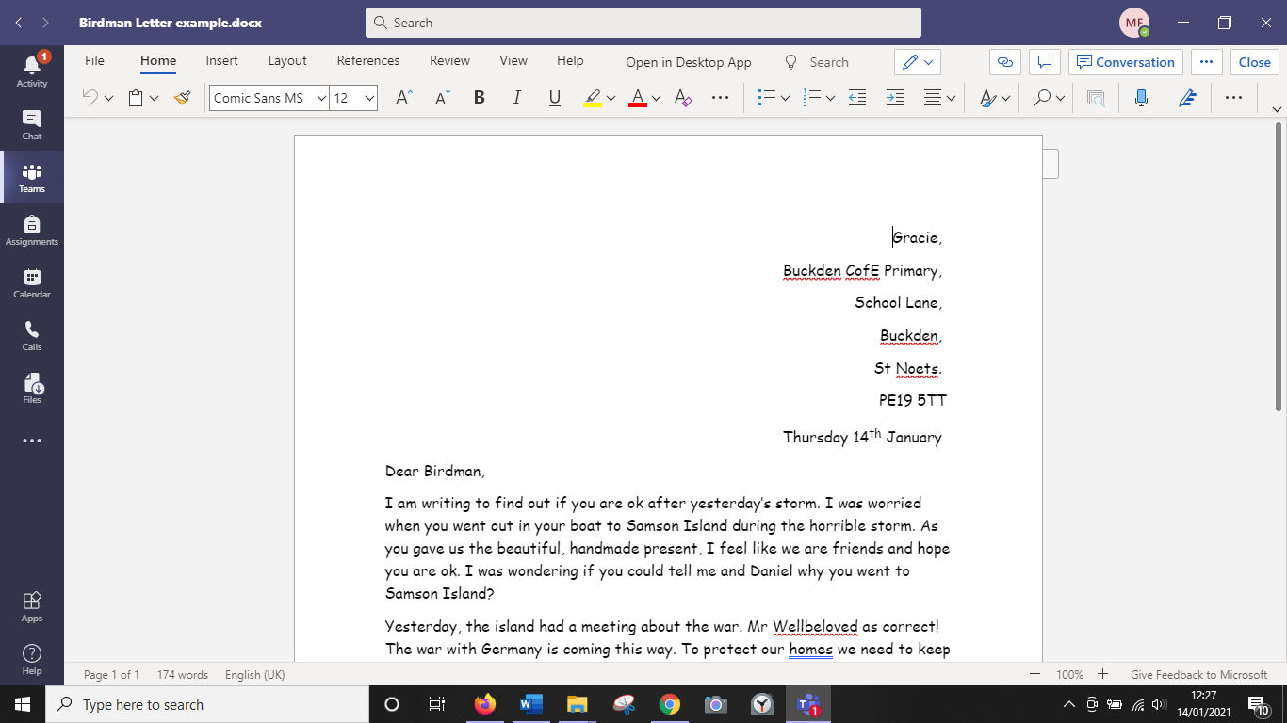

When it opens a microphone or button will appear red on your screen. This means it is hearing your voice. Say what you want to write. When you have finished, click on the red microphone or button to stop the dictation.
