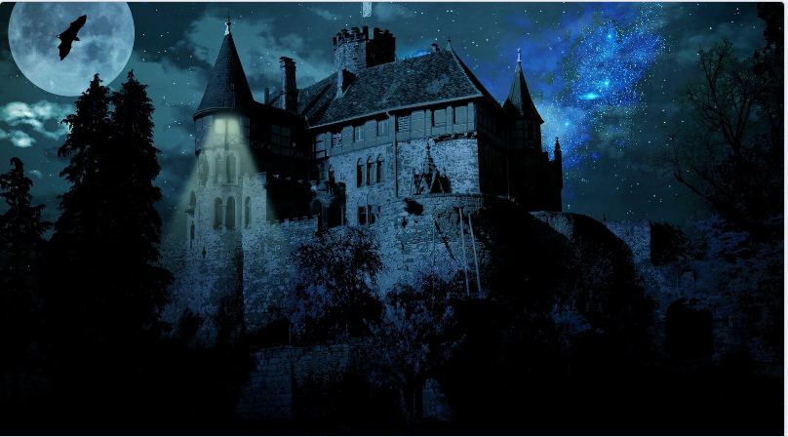

Story starter
It was the dead of night.
All that could be heard was the muffled beating of the creature’s enormous wings as it soared through the inky-black sky. Behind it, at the end of a frayed length of rope, sat the coachman. Coat wrapped tightly around his broad shoulders, his mission tonight was a straightforward one: to escort the two strangers to Castle Midnight. It all seemed straightforward to him. Even if it wasn’t, he always did as the Master bade. No one ever dared to disobey the Master, especially on a night such as this…

Question time
What kind of person do you think the coachman is?
Why do you think everyone fears the Master?
Who are the two strangers in the back? Why do you think they are going to Castle Midnight?
What kind of place do you think Castle midnight is?
Where is the light coming from?
Where/when do you think this story is set?

Picture it
Draw or describe what everything in the picture would look like in the daylight.

