This week’s learning 13.09.21

Monday
Maths – Oak Academy - lesson 7
https://classroom.thenational.academy/lessons/representing-2-digit-numbers-part-2-69hkac
English – Can you retell the story of Little Red Riding Hood? See if you can remember it and tell it to an adult or to your Teddies. Can you draw the story mountain that we used in school to help you?
PSHE – What would our classroom and school be like if there were no rules? Draw a picture of a classroom where there are no rules. How would you feel in a classroom like this?

Tuesday
Maths – Oak Academy - lesson 8 https://classroom.thenational.academy/lessons/comparing-numbers-within-100-on-a-number-line-6wv64r
English – Look at this picture of Little Red.
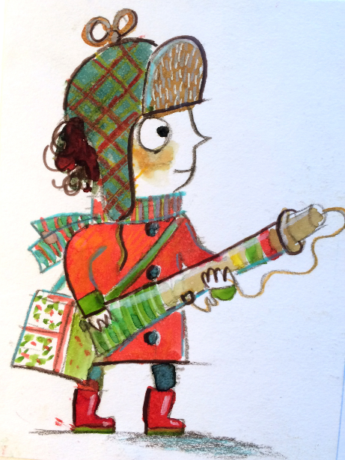
Using the picture what do you think she is like as a little girl? Can you describe her personality?
Global Learning – We have been thinking about why trees are important. Today we will be thinking about the structure of a tree and using our sketching skills to draw a tree. If you can go outside and find a tree to draw. In class we will be using charcoal but use a pencil if you don’t have charcoal.

Wednesday
Maths – Oak Academy - lesson 9 https://classroom.thenational.academy/lessons/comparing-2-digit-numbers-c4t38e
English – Grammar Today we will be writing sentences and making sure we understand every sentence starts with a capital letter and ends with a full stop. First can you write your alphabet out with each letter as a capital and lower case letter.
Now write three sentences making sure each one starts with a capital letter.
When else do we always use a capital letter?
Science – Living and non-living things
https://classroom.thenational.academy/lessons/what-are-the-characteristics-of-living-things-70u30c

Thursday
Maths – Oak Academy - lesson 10 ordering numbers within 100
https://classroom.thenational.academy/lessons/ordering-numbers-within-100-c4vkec
English – https://www.bbc.co.uk/bitesize/articles/z942kty
Activity 3 Three Billy Goats Gruff
French- Practise numbers 1-31 in French use this video to help you https://www.youtube.com/watch?v=DnrTrbJ6mYs

Friday
Maths – Choose a two digit number e.g. 35 Can you make a poster showing everything you know about it. You could include:
- Is it even or odd?
- Put it in a part part whole
- Show it in a place value grid
- Write it in words
- Draw it in dienes
- Draw it on a bead string
- What is one more?
- What is it greater than?
English – https://www.bbc.co.uk/bitesize/articles/z942kty
Choose an activity

R.E. – Can you recall what happens on days 1-7 in the Creation story? If you can’t remember them all use this to help you, https://www.youtube.com/watch?v=qsQHClXz6VA

Daily
Keep reading!
Read a magazine/newspaper article.
Arithmetic (20 minutes a day) – Count in 2s 5s and 10s
Phonics – Play a phonics phase 3 and 5 game on phonics play.
https://www.phonicsplay.co.uk/resources/phase/3

Times Tables – practise your times tables as much as you can!
Useful websites for times tables:
https://www.topmarks.co.uk/maths-games/7-11-years/times-tables
https://www.timestables.co.uk/

PE

Visit youtube and do a session 5 times a week of Joe Wicks/Go Noddle/Cosmic Kids Yoga.

